Griffin Timoney
Quinnipiac Polling Institute held a poll on September 19-22, 2013 to see how Governor Christie is doing in relation to State senator Barbara Buono.
It seems that based off of their results the public supports Christie over Buono.
I think that this poll did a good job touching all aspects that would matter when considering who you want to vote for. For example, the questions included who would be better for the states economy, property taxes as well as asking them if they know enough about the candidates to choose whether they think they would be good or bad.
This poll also covered the topic of Governor Christie possibly running for President in 2016. Multiple questions had to do with this topic and what the public thought about how it can affect them and the state of NJ and if it will affect the amount of votes he does get for Governor.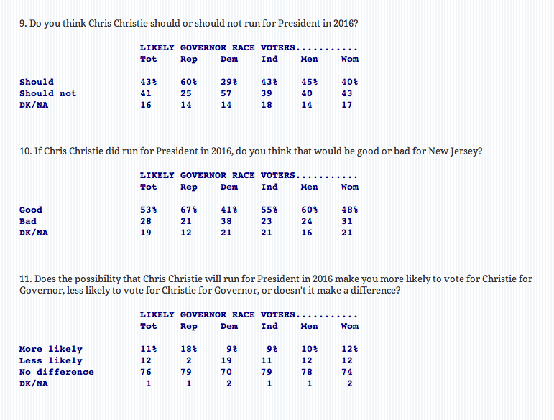
In my opinion being from NY, I hear governor Christie’s name a lot from the work he has done for the state of NJ and how he has been the face of the “stronger than the storm” campaign and did what he had to for NJ. Unfortunate for Buono, I feel like her name just isn’t well known enough.
This poll has a lot to do with the public because it is based off their public’s opinion of the candidate that they will have to decide who they will vote for and then who will win.
I also don’t think the sample size was large enough. The amount of people that were interviewed was 1249 and these were “likely” voters.
It does not mention which political party they are apart of.
The margin of error for this poll was +/- 2.8 Percent Points
http://www.quinnipiac.edu/institutes-and-centers/polling-institute/new-jersey/release-detail?ReleaseID=1957

