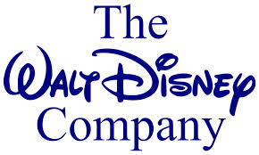



The Walt Disney Company

MBA 648 Company Research Project

Megan Burke, Candace Longo, Irini Pertesis

Table of Contents
Executive Summary 3
Products and Services 4

Financial Planning and Analysis 6
Operating Performance of the Firm 6
Financial Statement Analysis 7
Financial Forecasting………..………………………………………….…………………...11
Sustainable Growth Rate………...………………………………………………………....13
Additional Funds Needed…………………………………………………………………...13
Cost of Capital……………………………………………………………………………….14
WACC………………………………………………………………………………………..14

Dividends and Stock Policies………………………………………………………………….15

Objectives of Business Corporations 16

Working Capital Management: 19

Cash and Marketable Securities Management: 21

Accounts Receivable Management…………………………………………………………….26
Financing Activities…………………………………………………………………………...26

Overall Analysis………..……………………………………………………………………….27

Executive Summary
“I knew if this business was ever to get anywhere, if this business was ever to grow, it could
never do it by having to answer to someone unsympathetic to its possibilities, by having to
answer to someone with only one thought or interest, namely profits. For my idea of how to
make profits has differed greatly from those who generally control businesses such as ours. I
have blind faith in the policy that quality, tempered with good judgment and showmanship, will
win against all odds.”—Walt Disney

The Mission: The Walt Disney Company's objective is to be one of the world's leading producers and providers of entertainment and information, using its portfolio of brands to differentiate its content, services and consumer products. The company's primary financial goals are to maximize earnings and cash flow, and to allocate capital toward growth initiatives that will drive long-term shareholder value.

The Walt Disney Company, commonly known as Disney, is the world’s largest media and entertainment conglomerate with assets encompassing media networks, studio entertainment, parks and resorts, and consumer products. The Walt Disney television and media network include the ABC television network, 10 broadcast stations and cable networks that include: ABC Family, Disney Channel, Toon Disney, and ESPN. The Walt Disney studio produces films through various lines such as Walt Disney Picture, Touchstone, Pixar, Marvel Entertainment, and most recently Lucasfilms. Walt Disney Parks and Resorts includes the operations of theme parks and resorts of 11 parks, 43 resorts and 4 cruise lines.

Disney was founded on October 16th, 1923, by Walt Disney and Roy O. Disney and was first known as the Disney Brothers Cartoon Studio, and established itself as a leader in the animation industry before then going into live-action film production, television and theme parks. The company became The Walt Disney Corporation in 1986, when it then expanded into a wider market including theater, radio, music, publishing, merchandising, and online media.

Walt Disney created a company where “magical moments” could happen for all his “guest”. The Disney culture and brand has exceeded all original expectations through tight control over how the brand image is perceived. Disney has become one of the most recognized brand names in the world by the development of famous characters such as Mickey, Minnie, Goofy, Donald and Pluto, along with famous movies that have become timeless and classics all over the globe.
Disney’s biggest asset to their firm is their ability to stay diversified. It is a conglomerate firm with a domination in both theme parks and the entertainment industry. Disney also has multiple opportunities to grow and increase their outsourcing and globalization, by expanding into Europe and Asia. It has great growth potential by expanding around the global and increasing their online presence.

Walt Disney Company’s Products and Services:
Walt Disney has a wide variety and range of products and services under numerous divisions making it the largest media conglomerate in the world. It first began in 1923 when they specialized in short animation films. They found success by creating a brand of characters that became known around the world. With this brand power they later expanded into five main areas.

- Disney Media Network: Is the reporting segment and the primary unit of The Walt Disney Corporation that contains the company’s various networks and cable channels. They own ABC network along with cable television networks such as Disney Channel, ESPN, A&E Networks, and ABC Family. The revenue from this division of the company in the 2013 fiscal year was $20.356 billion.

- Walt Disney Parks and Resorts: also one of The Walt Disney Corporations business segments. Founded in 1971 after the opening of Magic Kingdom at Walt Disney World in Florida. Disney now has 11 parks, 43 resorts, and 4 cruise lines that travel around the world. The revenue from this division of the company in 2013 was $14.087 billion.

- The Walt Disney Studios: This is the movie sector of the Walt Disney Corporation and one of the five main major divisions of the corporation. It is one of Hollywood’s major film studios and produces a variety of live action and animated motion pictures, direct-to-video content, musical recording and live stage plays. During the 2013 fiscal year the revenue for the division was $5.979 billion.

- Disney Consumer Products: This includes all of the merchandise that the Disney Company sells that ranges from clothing, toys, Disney Publishing Worldwide, and even furniture that began with the licensing the image of Mickey Mouse. During the 2013 fiscal year the revenue for this division was $3.555 billion.

- Disney Interactive: Is the last and newest division of the Walt Disney Corporation that began in 2008. It includes Disney.com, online and media games, and “virtual worlds”. During the 2013 fiscal year the revenue for this division was $1.064 billion.

Financial Planning and Analysis
Operating Performance of The Walt Disney Corporation:
 | 2013 | 2012 | 2011 | 2010 | 2009
NOPAT | 6.263 billion | 6.253 billion | 5.228 billion | 4.314 Billion | 3.546 Billion
Free Cash Flow | 5.330 Billion | 3.110 Billion | 2.680 Billion | 3.820 Billion | 2.660 Billion
EVA | 6.253 Billion | 6.253 Billion | 5.227 Billion | 4.314 Billion | 3.546 Billion
MVA | 68,936.44 | 51,447.96 | 26,222.86 | 36,384.55 | 14,3392.08

NOPAT is the company’s potential cash earnings if its capitalization were unleveraged. It is a more accurate look at operating efficiency for leveraged companies. It does not include the tax savings many companies get because they have existing debt. The increase in NOPAT over the past 5 years exemplifies that the firm has an increase in cash earnings.
NOPAT= EBIT(1-tax)
Free Cash Flow are the cash flows available for distributions to all firm’s investors after the firm has paid all expenses and has made the required investments in operations supporting growth.
FCF=NOPAT-Net investment in operating capital= current year total net operating capital - previous year total net operating capital.
According to the Data above, the Walt Disney Corporation’s growth rates have steadily increased. There was a drop in 2009 that was probably due to the recession and also due to the acquisition of Marvel Comics.
The Free Cash Flow for the company started to increase in 2010 and 2011 as the firm began to experience profits from the investments but then decreased in 2012 after the acquisition of Lucasfilms. Then greatly increased to 5.330 billion in 2013 after Disney started to experience profits from all their recent investments.
EVA is a performance measure developed by Stern Stewart & Co that attempts to measure the true economic profit produced by a company and provides a measure of economic success. This measure is useful for investors, and it can be compared against the company’s peers for quick analysis. Over the past 5 year EVA has increased exemplifying that economic profit is increasing.
EVA= NOPAT – (total net operating capital) (WACC)
MVA: is the difference between the current total market value of the company and the capital contributed by investors, it is a wealth metric measuring the level of value a company measuring the level of value a company has accumulated over time. Such as EVA MVA is also increasing exemplifying that the value of The Walt Disney Corporation is increasing.

Financial Statement Analysis
Liquidity Ratios:
 | 2013 | 2012 | 2011 | 2010 | 2009
Current Ratio | 1.17 | 1.13 | 1.12 | 1.08 | 1.05
Quick Ratio | .84 | .79 | .79 | .78 | .76

The current ratio measures the company’s ability to pay its short-term obligations. It is used to see how well a company can pay back its short-term liabilities and other short-term assets. Over the past 5 years the current year has been greater then 1 meaning that Disney’s assets can cover its liabilities. Although, Disney’s ratio is below that of the industry and its competitors.
The quick ratio or known as the acid test ratio measures Disney’s ability to meet its short-term obligations with its most liquid assets. It is more conservative then the current ratio because it excludes the inventory from the current assets. Disney’s low quick ratio numbers show that it does not hold a lot of inventory but that is most likely due to the fact that Disney has a large service section where a large amount of the revenue comes from. Disney’s quick ratio is less then its competitors Time Warner Cable indicating that they hold less inventory then their competitors. Which is true since a significant percentage of Disney’s businesses are in the service industry and do hold a lot of inventory.

Asset Management Ratios:
 | 2013 | 2012 | 2011 | 2010 | 2009
Total Asset Turnover | .56 | .57 | .58 | .58 | .59
Fixed Asset Turnover | 2.1 | 1.96 | 2.07 | 2.13 | 2.05
Days Sales Outstanding | 56.46 | 56.46 | 55.18 | 55.47 | 49.01
Inventory  Turnover | 21.74 | 23.85 | 28 | 32.18 | 35.37

The total asset turnover ratio measures the sales generated for every dollar of asset, in this ratio the higher the number the better for the firm. Disney is currently below the industry average stating that Disney could do a better job to use its assets to produce revenue.
The fixed asset turnover ratio measures a company’s ability to generate net sales from fixed-asset investments – specifically property, plant and equipment. Disney’s fixed asset ratio of 2.1 is high and shows that the company has been effective in using the investment in fixed assets to generate revenues.
Days Sales Outstanding is a measure of the average number of days that a company takes to collect revenue after a sale has been made. A low DSO number means that is takes a company fewer days to collect its accounts receivable. Disney’s DSO is lower than the average stating that they are working efficiently at collecting their accounts receivables.
The inventory Turnover ratio shows how often Disney’s inventory is sold and replenished over a given period. Inventory is a liquid asset high ratios imply a strong sales and effective buying procedure at the firm. The Walt Disney Corporation has the highest inventory turnover in the industry exemplifying a very strong sales and effective buying procedures.
The Inventory policies over the last five years have been growing stronger. One aspect to keep in mind is that The Walt Disney Corporation is largely a service industry and does not hold inventory in many of its divisions. Keeping this in mind the inventory turnover ratio has been decreasing over the past five years indicating that they are selling the assets faster and have great inventory management.

Debt Management Ratios:
 | 2013 | 2012 | 2011 | 2010 | 2009
Debt-to-assets | 19.21 | 20.38 | 21.56 | 22.21 | 23.37
Debt-to-equity | 35.82 | 38.62 | 41.32 | 42.37 | 45.40
Market debt | 3.53 | 2.78 | 2.40 | 1.45 | .79
Liquidities-to-assets | .44 | .46 | .48 | .45 | .45
Times-interest-earned | 23.40 | 17.26 | 16.12 | 9.68 | 10.48

The Debt-to-Asset ratio that defines the total amount of debt relative to assets, it enables comparisons of leverage to be made across different companies. Disney’s Debt-to-Asset ratio is lowering meaning that they are having a lower degree of leverage and less financial risk.
The Debt-to-equity ratio indicates what proportion of equity and debt the company is going to finance. Disney has a low amount with only 19.21% of their assets being financed with their liabilities. This indicates that Disney takes a less aggressive method to finance its growth with its debt.
The Market Debt Ratio measures the level of debt of a company relative to the current market value of the company and their Market Debt ratio has been rising over the past five years.
The Times Interest Earned ratio is a measure of the firm’s ability to meet its debt obligations through interest payments. It is a higher ratio and indicates it can meet its debt obligations.
Profitability Ratios:
 | 2013 | 2012 | 2011 | 2010 | 2009
Net Profit Margin | 11.68 | 11.29 | 11.24 | 10.86 | 10.36
Profit Margin | 18.88 | 18.60 | 18.22 | 17.61 | 16.65
Return on Assets ROA | 7.61 | 7.12 | 7.20 | 7.11 | 6.92
Return on Common Equity ROE | .1351 | .1429 | .1286 | .1056 | .98

The Net Profit Margin tells how much of sales the company keeps in its earnings. The 11.68% means that Disney has net income of approximately $0.12 for every dollar of sales.
The Profit Margin ratio indicated how much of the sales Disney keeps as earnings. The higher the profit margin indicates a more profitable firm that have good control over its costs. Disney’s profit margin is high and higher than the industry average at $0.19 net income for every dollar of sales.
The Return on Assets (ROA) ratio exemplifies how profitable a firm is relative to its total assets, while Return on Equity (ROE) measures a company’s profitability by showing how much profit a firm makes with the money the actual shareholders have invested. Disney’s ROE and ROA are at the average.
Market Value Ratios:
 | 2013 | 2012 | 2011 | 2010 | 2009
Price/earnings | 16.87 | 13.49 | 14.41 | 14.85 | 11.71
Price/Cash Flow Ratio | 14.56 | 12.2 | 9.3 | 10.8 | 10.6
Book Value per Share | 25.43 | 22.09 | 20.14 | 19.62 | 18.15
Market/Book | 2.54 | 2.37 | 1.5 | 1.69 | 1.51

The Price Earnings Ratio indicates the company’s current share price compared to is per-share earnings. Disney’s ratio falls right with the industry, and only slightly above average, Disney’s P/E of 16.87 shows that investors are not expecting a lot of growth from Disney in the near future. The Price Earnings of Time Warner and News Corp are very similar to Disney’s and shows a rather dull forecast.
The Price-Cash Flow Ratio is the ratio of a stock’s price to its cash flow per share and is an indicator of a stock’s valuation. This ratio is a little higher then the industry average.
The Book Value per Share Ratio is a measure used by owners of shares to determine the level of safety associated with each individual share after all the debts are paid.
The Book-To-Market Ratio is used to find the value of a company comparing the book value of a affirm to its market value. It is calculated by looking at the firm’s historical cost, or accounting value. Market value is determined in the stock market through its market capitalizations.

Financial Forecasting
In recent years The Walt Disney Corporation has not seen much of a change in revenue. The Walt Disney Company has revenues for the 2013 fiscal year of $45.04 billion. That was a 6.54% above the prior year. The estimated growth rate for The Walt Disney Corporations for the next 5 year is 5-8% annual revenue growth.

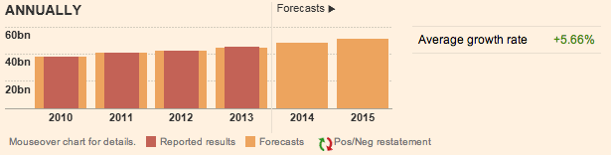

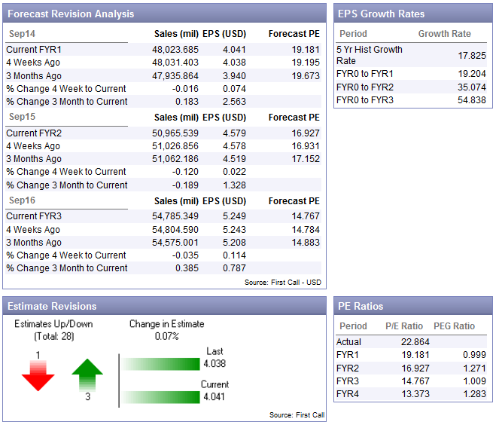
The above chart shows the forecasted and actual reported results for revenue for 2010, 2011, 2012, and 2013. The forecasted was either exact or slightly lower then the actual results. The forecasted amount of revenue for 2014 is $48.042 billion and the forecasted amount for 2015 is $51.053 Billion, with an average growth rate of +5.66%.

The latest consensus on the forecast of The Walt Disney Corporation is that as of April 25, 2014 the firm advises that the company will outperform the market, this has been the consensus since the May 2010 and all results thus far have agreed with it.

As for the earnings per share forecast those are also supposed to increase according to the Thomson Report above, as of February 05, 2014 The Walt Disney Company reported 1st quarter 2014 earnings of 1.04 per share. This result exceeded the .91 consensuses of the 32 analysts covering the company and exceeded last year’s 1st quarter results by 31.65%. By 2016 the EPS is forecasted to be $5.249 that is a growth rate of +16.99%.

The Dividends forecast for The Walt Disney Corporation is also expected to increase at a rate of +14.67%. In 2013, Walt Disney Co. reported a dividend of .86, which represents a 14% increase over last year. Analysts expect similar dividend growth rates for the upcoming fiscal years.

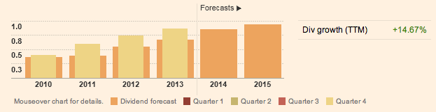

Over all aspects of The Walt Disney Corporation are expected to increase in the upcoming five years in all aspects of the firm’s income statement and balance sheet.

Sustainable Growth Rate:
The sustainable growth rate is how much the firm can grow by using internally generated funds and issuing debt to maintain a constant debt ratio.
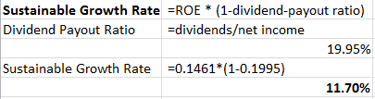

The Sustainable Growth Rate for The Walt Disney Corporation is 11.70% it indicates the maximum growth rate the company can achieve without having to increase its financial leverage or debt financing. This amount has been steadily increasing since 2009 when it was a low of 8.42% which was due to the depressed economy and recession at the time.

Additional Funds Needed:
Additional Funds Needed is the amount of money a company must raise from external sources to finance the increase in assets required to support increased levels of sales it is also called external financing needed. Disney’s current AFN is (6,525). The calculations are explained below.
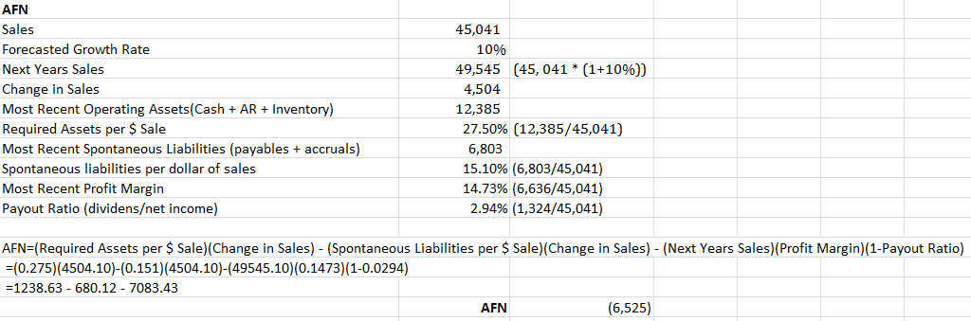

Since The Walt Disney Corporations AFN is a negative number it indicates that the company does not need any additional sources to finance any increased assets. A negative AFN actually means that the action would generate extra income that could be invested elsewhere.
Cost of Capital – Debt & Cost of Common Stock
The Cost of Capital is the cost of funds used for financing a business. The cost of capital depends on the mode of financing used and refers to the cost of equity if the business is financed solely through equity, or in the cost of debt if it is financed solely through debt.

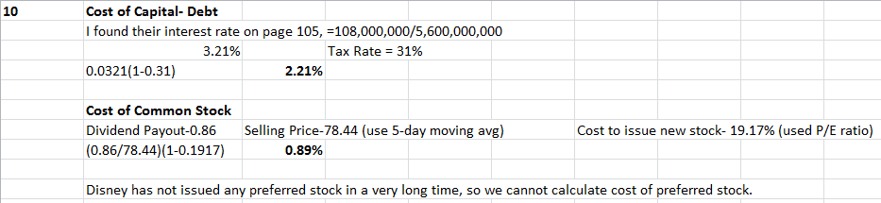

Commercial Paper
At September 28, 2013, the Company had no commercial paper debt outstanding and had bank facilities with a syndicate of lenders to support commercial paper borrowings as follows:
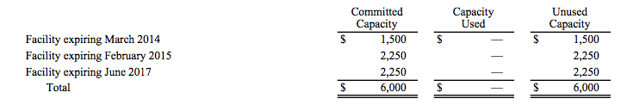
The Company may use commercial paper borrowings up to the amount of its unused bank facilities, in conjunction with term debt issuance and operating cash flow, to retire or refinance other borrowings before or as they come due.

Weighted Average Cost of Capital – WACC:
Is a calculation of the firm’s cost of capital in which each category of capital is proportionately weighted. All capital sources – common stock, preferred stock, bonds and any other long-term debt are included in the WACC calculation.

The weighted average cost of capital formula is:
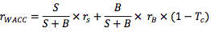

The weighted average cost of capital for the 2013 fiscal year for The Walt Disney Corporation was 14.07%.

To find Disney’s optimum capital structure is difficult because the company is so diverse with many divisions and segments. We would suggest the optimum capital structure to put the media network division on top since it can take on more risks second would be the Parks and Resort segment since they are need a lot of capital to expand and develop. Also it makes sense to put these two divisions at the top because they are the top two divisions in terms of revenue.

Determinants of Financial Leverage:
In evaluating the financial leverage of The Walt Disney Corporation, we have come to conclude that Disney should utilize more debt than they currently are have been. Their current Debt to Equity ratio is 35.82 for 2013, and the industry average is 49.20.
Disney would benefit from having more debt because currently the interest rates are very low, and given the current tax shield on US corporate income tax law this would allow Disney to waive a portion of their taxable income. Leveraging more debt would make Disney more profitable than it is currently.
Dividends And Stock Policies:
Cash Distribution Policy:
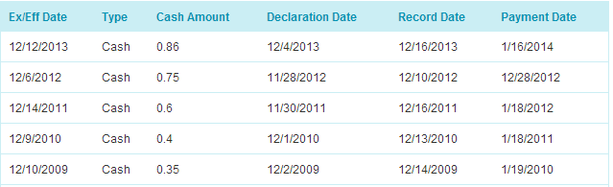
Below is the financial information concerning Disney’s cash distribution policies over the last 5 years. Disney knows that investors do not want to see dividend reductions, so they have increased steadily over this time period. Instead of issuing new common stock, they implemented stock repurchasing programs which are discussed in number 18. The dividend decisions were made during the planning process, so there is normally some uncertainty when it comes to predictions, but Disney seems to be stable and steady when it comes to financials. Disney has superior investment opportunities, and thus holds the correct amount of funds in the retained earnings part of its finances. This allows for funding for growth and dividend payouts.

Dividend Payout:
Disney’s Payout Ratio utilized is as follow:
Dividend Payout Ratio = Dividends Per Share/ Earnings Per Share
.22 = .75 / 3.38

Disney’s Forward Rate of Return is as follows:
Forward Rate of Return = Normalized Free Cash Flow / Price + Growth Rate
17.27% = 2.02 / 56.8 + 0. 1371

According to Yahoo Finance, Disney plans on repurchasing “$6 billion to $8 billion of shares in fiscal year 2014.” This is high in comparison to CBS Corp who plans on buying back $1.5 billion of shares, British Sky Broadcasting Group, PLC which plans to buy back $766 million shares, and Fuji Media Holdings Inc share repurchase program being negative because they are issuing new shares and not buying them back.

Disney’s dividend payout ratio targets shareholders in their “peak earning years who may prefer reinvestment, because they have less need for investment income and would simply reinvest dividends received.” These shareholders prefer the lower dividend policy because “the less the firm pays out in dividends, the less these stockholders will have to pay in current taxes, and the less trouble and expense they will have to go through to reinvest their after-tax dividends.” It is still a growing organization which uses funding for operations and growth. The text states that “retired individuals, pension funds, and university endowment funds generally prefer cash income, so they may want the firm to pay out a high percentage of its earnings,” which are not the type of shareholders targeted by this lower dividend payout ratio.

Dividend Policy:
As of September 28, 2012 the approximate number of common shareholders of record was 956, 025. The Walt Disney Company has switched to annual dividend payouts to cut cost and they are currently on the residual dividend policy meaning that the company first uses the cash flow to fulfill necessary capital expenditures and the remaining amount available is paid out to shareholders.
The cash dividend is important to the Walt Disney Corporation since it shows strength and growth in the corporation. In the 2013 fiscal year, the company reported its best ever revenue and net-income and their cash dividends reflected that. It showed strength in the company and attracts stock prices.

Stock Repurchase:
Disney has a strong buyback activity meaning it has faith in its own organization. It has continuously made stock repurchases in the last five years. For example, in 2013, they repurchased $4.1 billion worth of common stock. In 2012, they repurchased $3.0 billion worth of common stock. In 2011, they repurchased $5.0 billion worth of common stock. In 2010, they repurchased $2.7 billion worth of common stock, and in 2009, they repurchased $138 million worth of common stock.

Stock Splits and Dividends:
Disney has not used a stock split in the last five years. The most recent dividend was payable January 16th, 2014 to all shareholders of record of December 16th, 2013, so yes the firm used stock dividends in the last five years. I would support another dividend payout.
Disney currently pays dividends on an annual basis and this strategy seems to be effective. We cannot foresee any issues that would affect Disney’s ability to pay out dividends.

Objectives of Business Corporations
The people oriented goals and objectives are as follows (ranked in order of importance):
- “Uphold outstanding corporate citizenship.”
- Have a positive impact on the environment
- Participate in community engagement
The performance goals and objectives are as follows (ranked in order of performance):
- Remain the world leader in “high-quality family entertainment.”
- Continue “to proudly provide quality entertainment for every member of the family, across America and around the world.”
The policies and programs that have been implemented in the last few years to achieve these goals and objectives are as follows:

“Disney's Friends for Change: Project Green” was implemented by “Disney Channel, Radio Disney and Disney.com” to empower children “to take more than 3 million pledges to eliminate 52 million pounds of carbon emissions, recycle 8 million pounds of trash and save more than 1.5 billion gallons of water annually.”

In 2011, the company “built playgrounds and gardens in 12 underserved communities through Disney Magic of Healthy Living.”

In March, 2012, Disney announced its “Heroes Work Here” program which is a “company-wide initiative to hire, train, and support returning veterans.” This program provides career opportunities for returning United States veterans. In 2014, they expanded this program into “Transitions” which provides veterans with career services.

In December of 2012, Disney acquired Lucasfilm Ltd. LLC. This is “the global entertainment company founded by George Lucas and the home of the legendary Star Wars franchise.”
In March, 2012, “Disney Junior, a 24-hour stand-alone television network, [launched] in the U.S.”

In conclusion, Disney has been successful in achieving its objectives. All of the critical goals are being fulfilled to the greatest extent possible.

In the eyes of shareholders, Disney’s stock price performance has reflected success. Below is a chart showing the stock price performance in comparison with its five main competitors’ average. Competitors include “large media conglomerates, such as News Corporation (NWS), Time Warner (TWX), Dreamworks Animation SKG (DWA), and Viacom (VIA), who directly compete with Disney in various business lines.”
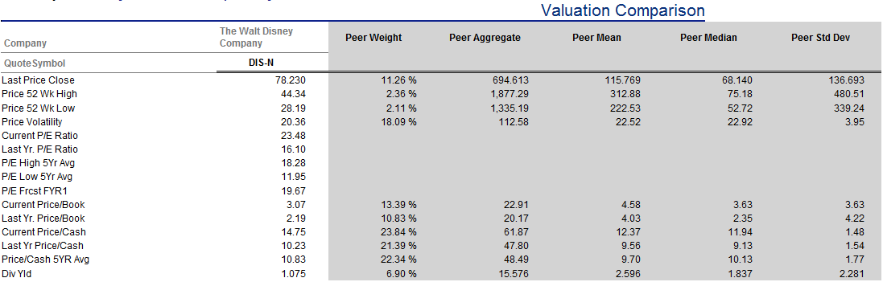

Disney is an organization in the leisure tourism, media, and internet publishing industries. It’s competitors are Bertelsmann AG, British Sky Broadcasting Group PLC, CBS Corp., Fuji Media Holdings Inc., and RTL Group.

Currently, Disney has 7% of its shares held by all insider and 5% owners as shown below. About 64% of shares are held by institutional and mutual fund owners. This number is down from the 2012 numbers which state that Disney’s institutional ownership was 87.33%.
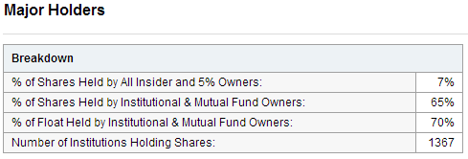
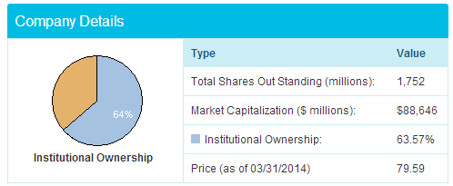
Disney monitors its earnings per share numbers and strives to maintain its high position in comparison with other companies. They seem to gradually increase over time which means Disney is doing a good job of managing its volatility.
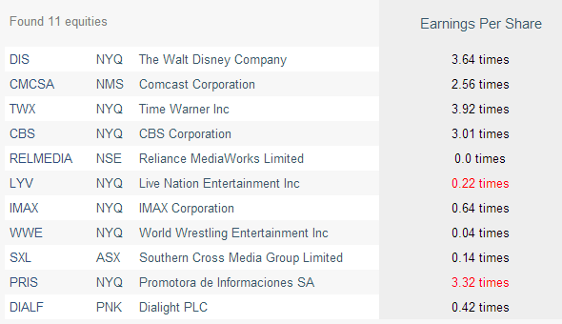
Disney managers and owners generally want success for the company. Owners and managers alike are focused on “generating the best creative content possible, fostering innovation and utilizing the latest technology, while expanding into new markets around the world.” That being said, there are bound to be conflicts between owners and managers being that each party will try to maximize his own welfare. For example, a manager may want to spend more money on launching a new product, while owners may want to focus more on globalization and projects in progress. Since they are in charge of different departments, they will have different priorities. In the end, managers and owners come together to add value to the company as a whole. Main motives are in line with each other.

The operating leverage for Disney is slightly lower than the statistics for other organizations in the entertainment industry suggesting that Disney has “lower fixed costs than its competitors.” We expect operating income to increase in years to come since the organization will incur less costs with the ending of large capital expenditures in the near future.

In terms of the “agency theory” problem, Disney’s situation is debatable. They offer employees stock options which align their interests with company interests. On the other hand, Michael Eisner has been accused of taking advantage of the system since he received 107.2 million in stock options, 5 million in bonuses, and .8 million as a base salary. Disney does its best to provide the best value to the shareholders that it can.

Working Capital Management:
Working Capital is a measure of company efficiency and operating liquidity. The Working Capital is usually calculated by subtracting Current Liabilities from Current Assets. It is important indicator of the firm’s ability to continue its normal operations without additional debt obligations.

Working Capital can be positive or negative, depending on how much current debt the company is carrying on its balance sheet. In general terms, companies that have a lot of working capital will experience more growth in the near future since they can expand and improve their operations using existing resources. On the other hand, companies with a small or negative working capital may lack the funds necessary for growth or future operation.

Working Capital also shows if the company has sufficient liquid resources to satisfy short-term liabilities and operational expenses.

Working Capital Position of the Walt Disney Corporation Last 5 Years
2013 | 2012 | 2011 | 2010 | 2009
$2.405 billion | $896 Million | $1.669 Billion | $1.225 Billion | $2.955 Billion

The Walt Disney Corporation nearly tripled their Working Capital in 2013. It is a sign that the company will experience more growth in the near future since they can expand and improve their operations using existing resources.

Several economic and financial factors have had an impact on the working capital policy, First, is the size of the business, the larger the business the more working capital is needed. Disney has such a large working capital due to its size and numerous different industries it is in. Second, is the nature of the business, but Disney is in the middle here since manufacturing industries and trading organization need more working capital then the service industry.

The Walt Disney Corporation has been working toward its working capital position over the past years, you can tell by looking at the current assets and current liabilities. For the 2013 fiscal year the current assets for the company were $14.109 billion and the current liabilities were $11.704 billion. This is a good indicator that the company does not over keep current assets. Disney has a positive working capital, at the same time that it invests the excess of cash in other, more profitable, investments. The Profitable investments recently include Marvel Comics and Lucasfilms.

Disney classifies as a conservative working capital policy, since it is a company with different and various divisions that can be volatile and seasonal. For example Disney’s parks and resort division is based on tourism and is seasonal. In the conservative working capital policy there is plenty of cash available along with a sufficient amount of inventory on hand. This allows Disney to invest in new projects and investments since they have the assets on hand to do so.

Risk, Return, and liquidity aspects of The Walt Disney Corporations Working Capital:
Risk: Standard & Poor’s Ratings Services’ corporate credit rating on the Walt Disney Corporation assessed the financial risk profile as “modest” based on a fully adjusted debt-to-EBITDA ratio of less than their 2.0x threshold for the ‘A’ rating, good cash-flow generating ability, exceptional liquidity, and a financial policy balancing conservative credit metrics with shareholder-friendly initiatives and acquisitions. The stable rating outlook reflects our view that Disney's business performance will remain strong, particularly at the cable networks, and that management will maintain its current financial policy.

Return: Disney also has the right Return rating. The financial calculation shows that the required rate of return is 11.92%. This number is rational because 11.92% is larger than the 10.75% estimated dividend growth rate. According to the Value Line Publishing’s data it is safe to believe the Walt Disney Company has a stable constant growth. This stability is because the Walt Disney Corporation has seen a stable rate of growth over the past 5 years.

Liquidity: Standard & Poor’s Ratings Service rated Disney’s liquidity as “exceptional”, based on the following assumptions and factors. The sources of liquidity covers uses by more than 2x over the next two to three years. Sources will still excess uses even if EBITDA declines 50%. Disney has an ample cushion of compliance with its credit facility covenant of 3x EBITDA coverage of interest. The firm should be able to absorb, without refinancing, high-impact, low probability events, such as the economic recession in 2008 and 2009. Disney also has well-established and solid relationships with its banks and a high standing in the credit markets and exceptional access to capital.

The Walt Disney Corporation working capital policies is not largely affected by the competitive structure of the industry, mostly due to the size of the firm and the fact that they have a part in several entertainment and tourism industries. Their Working Capital is lower than there competitors such as Comcast, Time Warner, and CBS, but these firms don’t have as many divisions as Disney.

Cash and Marketable Securities Management:
Marketable Securities are very liquid securities that can be converted into cash quickly at a reasonable price. Marketable securities are very liquid as they tend to have maturities of less than one year.

The Walt Disney Corporation hold 5.1% of its total assets in the form of cash and short-term marketable securities.

Disney uses the Cash Conversion Cycle method to speed up the cash inflows which adds days inventory outstanding to days sales outstanding, the subtract days payable outstanding. The lower the score here the better. On a 12 month basis the trend here for The Walt Disney Corporation looks very good.
The biggest contributor to the Cash Conversion Cycle was the DPO which improved compared to the 5 year average.

The Walt Disney Corporation Cash Conversion Cycle:
 | 2013 | 2012 | 2011 | 2010 | 2009
Walt Disney | 21 | 23 | 23 | 21 | 16
Industry | 18 | 19 | 19 | 21 | 23

While the above has to do with quickening cash inflow this section deals with Disney’s slow down of Cash Outflows.

The objective of managing cash outflows is to increase the company’s float by slowing down the distribution process. The tools used are a zero balance account and a payable through drafts.
The average days payable for Disney was 69.92 days. The Company's Strategic Sourcing and Procurement organization works with all Business Units and their Suppliers across the globe to establish the best value for The Walt Disney Company. Disney Sourcing Professionals seek out and contract with companies of all sizes and capabilities, from local and regional Suppliers to those with a global reach — finding Suppliers for a specific Company division or the entire enterprise. By creating a good relationship with their suppliers Disney has been able to expand their days payable, and hold on to their cash for a long amount of time. The company’s unpaid bills can have a big impact on profitability.

As of December 2013 The Walt Disney Corporation had $0 Marketable Securities. They have not had any marketable securities in the past 10 years. Marketable Securities are very liquid securities that can be converted into cash quickly at a reasonable price. Disney does not have any marketable securities because they do not have the need for liquid assets since they have a good cash flow.

Although Disney does not have any Marketable Securities they do have many investments and acquisitions. For example in 2009 Disney acquired Marvel comics for $4 billion and in 2012 acquired Lucasfilm for $4.06 billion. For the Lucusfilm acquisition they paid $2.21 billion in the form of cash payment and just under 37.1 million Disney shares. Soon after the acquisition Disney announced that they would be commissioning a new Star Wars movie to be released in 2015.
Disney makes these multi billion dollar investments in acquisitions but quickly sees an average rate of return on their investments but creating successful projects with their investments such as the Disney Avenger Movies. Of course there is always some risk in the investments, such as if the upcoming Marvel and StarWars movies will be Box-Office successes.

Accounts Receivable Management:
Disney has long-term accounts receivables for the sales of television rights or vacation ownership where accounts can be open for over one year. For these types of accounts the company has allowances for credit losses based on the customers history and financials. At the end of 2013 fourth quarter television sales had an allowance for credit losses totaling $0.9 billion. This has been dictated by the competitiveness of the market and is in the same rates as competitors such as Time Warner Cable.
For the parks and resorts division of the company they had accounted losses for vacation ownership had an allowance for credit losses totaling $0.7 billion or approximately 4%.
These rates are for the firms credit policies since Disney’s parks and resorts division is so big and has such a huge market pull. Other parks and resorts in the industry do not have the same size and policies as Disney.

Bad Debt Experience
Disney maintains an allowance for doubtful accounts to reserve for potentially uncollectible receivables. For the 2013 fiscal year Disney percentage for the allowance of doubtful accounts is 2.18%, and has been constantly lowering since 2009 when the rate was at 6.47%. Indicating that Disney is being cost effective and reducing the amount of bad debt they are receiving.

Financing Activities:
Cash used in financing activities was $4.2 billion in fiscal 2013 compared to $3.0 billion in fiscal 2012. The net use of cash in the current year was due to repurchases of common stock of $4.1 billion and dividends of $1.3 billion, partially offset by cash benefits associated with the exercise and vesting of equity awards of $0.8 billion and contributions from our Shanghai Disney Resort joint venture partner of $0.5 billion. The increase in net cash used in financing activities of $1.2 billion versus the prior fiscal year was primarily due to higher repurchases of common stock of $1.1 billion.

Cash used in financing activities in fiscal 2012 was $3.0 billion compared to $3.2 billion in fiscal 2011. The net use of cash in fiscal 2012 was driven by repurchases of common stock of $3.0 billion and dividend payments of $1.1 billion, partially offset by proceeds from exercises of stock options of $1.0 billion and net borrowings of $0.4 billion. The decrease in cash used
by financing activities of $0.2 billion compared to fiscal 2011 was primarily due to a decrease of $2.0 billion in repurchases of common stock, partially offset by $1.2 billion less net borrowings, an increase of $0.3 billion in dividend payments and $0.1 billion lower proceeds from exercises of stock options. (excerpt taken from 2013 10-k)

Short-Term Financing:
The credit terms The Walt Disney Company has offered over the past five years has changed due to past disruptions in the US and global credit and equity markets make it difficult to obtain financing on acceptable terms. These conditions tended to increase the cost of borrowing and if they recur, or cost of borrowing could increase and it may be more difficult to obtain financing for their operations or investments.
Certain suppliers have had decreased credit ratings in the past few years and has led the Walt Disney Company to increase the cost of borrowing.

Overall Analysis
Based on The Walt Disney Corporation’s performance over that past five years, Disney’s economic success has been positive and is constantly growing. As seen in the tables above, the company did take a hit in 2009, but many if not almost all corporations took a hit due to the recession. Since 2009 Disney has grown and for the 2013 fiscal the company reported record revenue and net income. The Walt Disney Company is a stable and expanding corporation and their continued success is to continue as forecasted.
Reason for their success is because it is a large multi-conglomerate firm with focuses in many areas in the entertainment industry. It has built itself up to one of the most well known companies in the world and is a respected and their international business is continuing to grow more and more each year. A second reason the Walt Disney Corporation is successful is that Disney does not have one main competitor, there different divisions has competitors, but there is no other firm in the industry that is involved in so many different business industries. Making it difficult to directly compare Disney to its competitors that come from the different divisions of the company. The vast size of Disney is an advantage in that if one of the divisions or sub divisions is struggling a little bit in one area, its numbers won’t drop drastically and can make up the loss in another section of the firm.
Looking at the numbers and financials of The Walt Disney Corporation you can clearly see that the company experienced growth last year. Disney’s profit is increasing at a faster rate than the operating margin, and they are increasing the amount of money that they are making by investing in new opportunities such as Marvel comics and Lucasfilms. A second positive outlook on the firm’s financials is that they are not borrowing large amounts of money and shows the financial strength of the company.
The Walt Disney Corporation has both higher stock prices and higher profit margins that its competitors and even has a slightly higher earnings per share numbers meaning that the company is on the right track for growth.
The Walt Disney Corporation is in an excellent financial position and the five-year forecast demonstrates that they are expected to see 5-8% growth in the upcoming years.

References:
"Applied Corporate Finance." Google Books. N.p., n.d. Web. 29 Apr. 2014.
"Can Disney’s Stock STAR STATUS Continue?" Wall St. Cheat Sheet. N.p., n.d. Web. 29 Apr. 2014.

"DIS Balance Sheet | Walt Disney Company (The) Commo Stock - Yahoo! Finance." Yahoo Finance. N.p., n.d. Web. 29 Apr. 2014.

"Disney Closes $4.06 Billion Lucasfilm Acquisition." The Hollywood Reporter. N.p., n.d. Web. 29 Apr. 2014.
"Disney Earnings Per Share DIS NYSE." Macroaxis. N.p., n.d. Web. 29 Apr. 2014.
"Disney Working Capital DIS NYSE." Macroaxis. N.p., n.d. Web. 29 Apr. 2014.

"Disney's Share Buyback Plan for FY14." Yahoo Finance. N.p., n.d. Web. 29 Apr. 2014.

"Industry Browser - Services - Entertainment - Diversified Industry - Company List." Industry Browser - Services - Entertainment - Diversified Industry - Company List. N.p., n.d. Web. 29 Apr. 2014.
"Marketable Securities Definition | Investopedia." Investopedia. N.p., n.d. Web. 29 Apr. 2014.
"SEC Filings." The Walt Disney Company. N.p., n.d. Web. 29 Apr. 2014.

"Suppliers." The Walt Disney Company. N.p., n.d. Web. 29 Apr. 2014.

"TEXT-S&P Summary: The Walt Disney Co." Reuters. Thomson Reuters, 21 Aug. 2012. Web. 29 Apr. 2014.

The Walt Disney Company . "Fiscal Year 2013 Annual Financial Report and Shareholder Letter." The Walt Disney Company. United States Securities and Exchange Commission, 01 Jan 2014.

The Walt Disney Company . "Our Businesses." The Walt Disney Company. Disney, n.d

The Walt Disney Company . "Form 10-K." The Walt Disney Company. United States Securities and Exchange Commission, 01 Jan 2014

"Walt Disney Co. (DIS) | Short-term (Operating) Activity." Stock Analysis on Net. N.p., n.d. Web. 29 Apr. 2014.

"Walt Disney Co. (DIS) | Short-term (Operating) Activity." Stock Analysis on Net. N.p., n.d. Web. 29 Apr. 2014.

"Walt Disney Company (DIS)." Wikiinvest. N.p., n.d. Web. 29 Apr. 2014.

"The Walt Disney Company Names of Competitors." Hoovers. N.p., n.d. Web. 29 Apr. 2014.

"Walt Disney Company (The) (DIS) - Trading Activity by Institutional Holders." NASDAQ.com. N.p., n.d. Web. 29 Apr. 2014.

