Behavior Intervention Plan
ED 674 Professor Muller
Hana Ljubicic

Target Behavior: Looking at and Buckling and Unbuckling Buckle on Wheelchair or classroom OT chair during instruction.
Based on the Functional Behavior Assessment data, this behavior occurs an average of 6 times during a given lesson block, and an average of 13 times during literacy instruction.
Function: Escape/Avoidance
The antecedent to the behavior is always instruction or independent work. The data from the Functional Behavior Assessment shows that the occurrence is often during literacy instruction. Each time I collected data on the behavior, it always manifested during literacy instruction; whereas there in certain math, science and social studies lessons where the behavior did not occur.
Hypothesis: The student looks down and opens and closes her buckle in order to escape during instruction that is not tailored to her specific needs based upon her disability. If proper materials are provided, and instruction is tweaked to accommodate her needs, the behavior will decrease and eventually be eliminated.
Brainstorm of Ideas:
- She should always have her “slant board” (as stated in her IEP)
- Positive reinforcement with “brain breaks”
- Manipulatives and hands-on activities during instruction
Short Term Strategy: The student will be rewarded with a “brain break” when effort is made towards not looking down and/or playing with her buckle during a lesson.
Long Term Strategy: There will be modifications provided for this student for every lesson and corresponding activity.
Short Term Goal: The student will decrease the average amount of occurrences the behavior is exhibited during a lesson by at least 50%. Asking for/taking a quick break will be the replacement behavior.
Long Term Goal: The student will eliminate the behavior. If the student gets used to self-regulating when she needs breaks, and if instruction is more effectively tailored to her needs, then the behavior can plausibly be extinct.
Describe interventions made in an attempt to reduce the occurrence of challenging behavior:

Instead of verbally reprimanding the behavior in the middle of instruction (i.e. “stop doing that”), the student is made aware of a reward system. The student was asked if she was aware of how often she looks down and makes noise by playing with her chair belt during instruction, she said yes. She was asked why she did this, and she said she didn’t know and laughed. The student was then introduced to a reinforcement system that can in turn help her self-regulate her learning/attention needs.
Since this student’s IEP states that she needs information to be presented to her slowly and in pieces, structured breaks would be an effective strategy that could replace her behavior. If the student attended to 25 minutes of a subject block, she could be taken aside from instruction to take a 3-minute “brain break”. She was provided with a choice of getting water, playing a quick game on the iPad, or looking at books. During literacy block (90 minutes), this would equate to 3 breaks. During other subject blocks (45 minutes), this would equate to one break.
In addition, there have been thorough interventions regarding instructional planning and modifications for this student. The data in the Functional Behavioral Assessment shows that the behavior does not occur as much (or even at all on some days) when there are more “hands-on” activities. During literacy, the teacher usually reads a book or article for most of the lesson. Prior to each lesson, I have enlarged the font of the text, and made sure that if the text had pictures that her copy would be printed out in color instead of black and white. The student also uses her “slant board” (as her IEP requires) during all lessons that require a text or worksheet in front of her. During independent practice (in all subjects), I have differentiated the lessons to meet her learning needs. Instead of requiring her to do the same exact work and have a teacher write for her, I have provided cut and paste activities that allow her interact with her tasks with more independence. (Example of differentiation attached)

Intervention Data:
Observation | Date: | Observation Period (based on lesson blocks): | Instances: | Total:
1 | 10/28/14 | 10-11:30am (literacy) |  | 0
2 | 10/28/14 | 12:15-1pm (math) |  | 0
3 | 10/30/14 | 10-11:30am (literacy) | II | 2
4 | 10/30/14 | 12:15-1pm (math) |  | 0
5 | 10/30/14 | 1:45-2:30pm (social studies) |  | 0
6 | 11/6/14 | 10-11:30am (literacy) |  | 0
7 | 11/6/14 | 12:15-1pm (math) | III | 3
8 | 11/18/14 | 10-11:30am (literacy) | I | 1
9 | 11/18/14 | 12:15-1pm (math) |  | 0
10 | 11/18/14 | 1-1:45pm (science) |  | 0
11 | 11/18/14 | 1:45-2:30pm (social studies) |  | 0
12 | 11/25/14 | 1:45-2:30pm (social studies) |  | 0
13 | 11/25/14 | 12:15-1pm (math) |  | 0

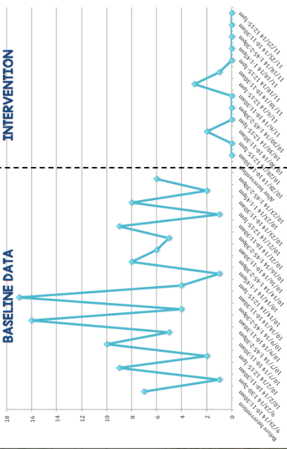

What has been the outcome of those efforts; what has worked and what has not?

The data shows a significant decrease in the behavior. The interventions did seem to be effective, but the intervention and data collection process was chaotic. Although the behavior addressed in this report did significantly decrease, the student developed another undesirable behavior. Towards the end of the day, the student would begin to cry for about 20-35 minutes saying she missed her mother and her brother. This is unusual behavior for this student, who exhibits a cheery attitude at all times. The specialists at the school were concerned about this behavior and pulled the student out for more therapy. This student already gets pulled out for counseling, visual impairment, physical, and occupational therapy.
I collected data during the subject blocks where the student was present and an intervention was attempted. However, the data is not completely reliable because she was sometimes pulled out for parts of the lesson. During the early weeks of my data collection was when this new behavior was surfacing and chaos ensued. If I had more chance to collect complete data, I would be able to get a better understanding of the effectiveness of the intervention.
However, for the last few days of my intervention, I had more time with the student and I was able to fully implement my interventions (especially during literacy instruction- which is the most important). The breaks helped this student monitor her own behavior. I noticed during each lesson she put more effort towards participating simply because of her increased engagement.
I think this specialized setting allows for interventions like individual “brain breaks” to be implemented. In other settings, it might be distracting to peers if one student is allowed to take breaks with iPad, water, books, etc. In this setting, there is a widespread understanding that everyone has different needs and what’s “fair” is not always equal. The other peers were not fazed and didn’t even ask questions about the “breaks” intervention. In a general education classroom, this intervention may be more difficult.
During my FBA data collection and through out my student teaching experience, I noticed that the classwork is not differentiated enough to meet the target student (and other students in the classroom)’s needs. I modified a lot of the work that the classroom teacher planned, and this also helped decrease the student’s behavior. Before, this student would sit through instruction and then listen to a worksheet and recite answers while a teacher or an aide would write them for her. Now, I modified question answer worksheets to include circling, matching, cut and paste. This way, the student can be more engaged and independent and doesn’t need to rely on a teacher in order to complete a task. I have attached an example of a differentiated lesson that I modified for this student to this report.
I hope to further support this student with this intervention. Although the data collection process was interrupted a bit, I truly believe this intervention was beginning to work. Short, structured breaks are a perfect solution for this behavior and it also pertains to her needs as stated in her IEP. Also, this setting requires a lot of differentiation. When I attend as a student teacher in January 5 days a week (as opposed to the 2 days a week I am attending now), I will put effort to aide my mentor teacher in differentiating the work that she finds or creates for the students. I am proud to say that this intervention was effective so far and I will continue to implement it and collect data on it to see if the long and short term strategies are continuously effective.

