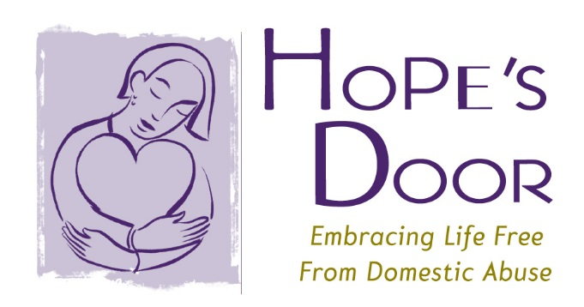

OPINION: TEEN DATING ABUSE – THE FACTS
By: Samantha Clarke
Although self-identifying as a domestic violence victim is becoming slightly more prevalent, the amount of teen dating abuse and the reporting of such incidents needs to be addressed. In 2013, 1,018 family offense petitions were filed by individuals under the age of 21 in New York State Family Courts.. This number has decreased since 2010 and 2011, but remains fairly similar to that of 2012 and 2009. Also, in 2013 26% of primary victim callers were under the age of 25.
According to domesticshelters.org, 161 organizations in New York offer some support for domestic violence victims. Emergency services, resources, and referral and safety planning are among the most popular forms of domestic violence services.
Hope’s Door provides a teen prevention program that allows for different and unique conventions where they have presenters, information, and resources to educate others, as well as workshops for teenage victims of domestic violence. It is important that this type of program be offered nationwide. Although the number of teen domestic violence cases may differ from state to state, having the option to attend a convention, workshop, or seminar nearby would relieve stress, tension, and fear from those abused. After working with teens, the number of victims who would tell no one about their abuse dropped from 25% to 16 %. In addition, the number of victims who would tell either a parent or friend increased 64% and 27%, respectively. After being educated, teens were more comfortable with how to handle situations and knew who to turn to when something they knew wasn’t right happened.
As parents, citizens, and maybe recovering victims ourselves, it is important that we are not only aware of what could happen to our teens, but that we make a stand to help and support them in any way possible. Because we already have the knowledge and tools to keep victims safe and fearless once the tragic incident has encountered their lives, we need to make sure that everyone, everywhere has these resources.
What we need to do to keep our teenagers safe is continue educating them on what could happen if they do not tell someone after being abused, educate them on what the consequences are for committing domestic violence, and keep them aware of all of the resources available to help them through these tough times, as well as what they can do to help others. Other shelters and organizations should have programs like our teen prevention program, safety planning resource, and advocacy groups that are out there helping to educate.
Hopes Door seeks to end domestic violence and to empower victims to achieve safety, independence, and healing from the trauma of abuse. Although this task and goal at hand may not be easy, it will be worth it to see change. If the number of domestic violencfe victims continues to decrease, and the reported incidents continues to increase than we know we are helping.

