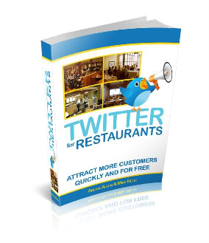
http://www.blogtalkradio.com/analucianovak/2011/02/17/twitter-for-restaurants-by-arlina-allen-social-media-restaurant-marketing
The Podcast I listened to was called "Twitter for Restaurants" by Arlina Allen. Arlina is the owner of Social Media Restaurant Marketing, a Silicon Valley social media marketing company, and author of “Twitter for Restaurants." In this podcast she talks about the importance of restaurants using twitter to maximize their business and build a following. She says how Twitter is where your customers are because there are so many people on there that it is such a great tool to engage people in your business and talk about what is going on. It is free publicity and why not use it. She explains how people are worried that they don't have the time for social media but it is actually very easy to use. Arlina explains how Twitter followers become your local patrons and they love to be updated on new specials at restaurants or exciting events. It is a great way to boost business and it is free and easy.
I'm interested in the restaurant business and have family who own restaurants so I somewhat enjoyed listening to this podcast. It is like listening to talk radio, which I’m not a big fan of. I kind of lost interest after a couple of minutes and it was really hard for me to not be distracted while listening. I already know a lot about twitter so it wasn't any new information for me, it was just a different aspect revolving around the restaurant business. I'm sure there are more interesting and upbeat podcasts out there that might get my attention.

