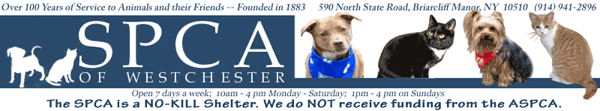

Top Hat and Tails May 2010

Revenue

Petco Sponsor $10,000
Purina Food Sponsor $5,000
Donations $3,575
150 Guests @ $180 ea. $27,000
Silent/Live Auction $4,500

TOTAL $90,575

Expenses

Printing:
Invitations $675
Save the Date Mailing $450
Programs $400
Postage $600

150 Dinner Guests @$65 ea. $9,750
DJ $500
Photographer $450
Decorations $420
Gift Bags $650

TOTAL $13,895

GRAND TOTAL: $76,680

Top Hat and Tails May 2010

January
Draft budget
Update sponsorship/invitation lists
Confirm date with Hotel
Sign contract

February
Solicit sponsorships
Prepare and mail Save the Date-Registration
Design invitations and flyers
Auction Committee Meeting

March
Prepare invitation
Finalize invitation
Continue to solicit sponsors
Investigate order premiums and giveaways

April
Mail invitations
Solicit volunteers
Purchase giveaways
Prepare Speakers and presentations
Prepare Live Auction

May
Confirm all details with Hotel
Confirm photographer
Confirm DJ
Design program for the day
Prepare check list for day of
Confirm # of people attending
Set up all decorations the morning of event

June
Prepare and send thank you/receipt letters
Follow up on outstanding payments

