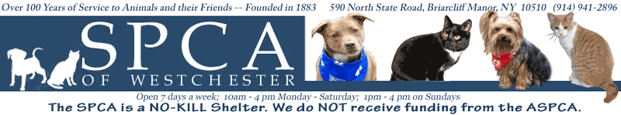

For Immediate Release Media Contacts:
Toniann Urbieta
590 North State Road
Briarcliff Manor, NY 10510
(914)-941-2896
Turbieta@SPCA914.com

FUN FACTS ON THE SPCA OF WESTCHESTER

Listen Here! The SPCA will be holding its annual Top Hat and Tails benefit event Saturday May 22, 2010! This exciting and meaningful event will be held at the Rye Town Hilton with a cocktail reception starting at 6pm and dinner and fun things to follow! Bring your favorite pooch as your date and get ready to dance the night away for a great cause!

SPCA of Westchester:

- Every year over 1,500 lost, abused, or abandoned animals are brought to the SPCA of Westchester.
- Located on several acres, with four separate kennel areas for dogs, a cattery and feline pavilion for cats, there are over 150 dogs and cats residing at the SPCA looking for a new home.
- Founded in 1883 by Ossining resident Mary Dusenberry, today the SPCA is the only humane society in Westchester County empowered to enforce laws relating to animal cruelty.
- The SPCA is immensely proud of its Simpson Spay/Neuter Clinic which provides low-cost surgery and vaccinations for animals.
- The SPCA is a “No Kill” shelter. No animal is ever euthanized except in cases of extreme aggression, terminal illness, or the inability to live a reasonable quality of life in a shelter environment.
- The SPCA has a special fund set up for its Humane Education program where they visit local schools and teach children about animal cruelty and ways to prevent it.
- The SPCA gets no federal, state, or county funds. They rely solely on the financial support from the generous people who care about the wellbeing of animals.

