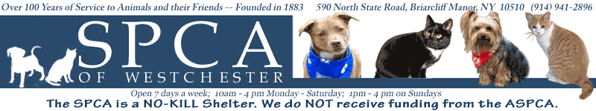

Over 100 years of service to animals and their friends, the Society for the Prevention of Cruelty to Animals (SPCA) of Westchester is dedicated to preserving the health and welfare of large and small animals all over the county. The devoted volunteers spend their days making sure all the animals are well taken care of and in hopes to providing all of them a loving home.

Located on 590 North State Road in Briarcliff Manor, NY, the SPCA of Westchester was founded in 1883 by Ossining resident Mary Dusenberry. Mary was outraged and distraught after witnessing horses being mercilessly whipped and beaten as they trudged up nearby hills to deliver heavy loads of coal. With the help of thoughtful friends, Mary obtained land on which to build the Society’s first home and established a fund to be used to prevent cruelty to animals. The SPCA is still located on the same spot, making it one of the oldest landholders in Briarcliff Manor.

Initially, the SPCA of Westchester was associated with the ASPCA of New York City, but became a self-sufficient organization in the 1920s. Today, it is the only humane society in Westchester County empowered to implement laws relating to animal cruelty. Despite this, the SPCA gets no federal, state, or county funds. So we rely solely on the generous financial support of people who care about the wellbeing of animals.
Services:
Shelter and Rehabilitation for Abused, Abandoned, and Lost Animals: The SPCA of Westchester is located on several acres, with four separate kennel areas for dogs, a cattery and feline pavilion for cats, and the Simpson Spay/Neuter Clinic. At the present time, the Shelter is outfitted to house over 100 dogs and many, many cats. We are particularly proud of the SPCA's Simpson Spay/Neuter Clinic. Since establishing the clinic in 1983, we have spayed/neutered almost 38,000 dogs and cats thus greatly reducing the number of unwanted animals in Westchester County.
Low-Cost Veterinary Services: The SPCA worked diligently to raise funds for over 10 years to finance the construction of the Simpson/Spay Neuter Clinic which provides reduced-cost surgery and vaccinations and has helped to significantly reduce the pet overpopulation issue in Westchester. Besides spay and neuter procedures, the clinic provides additional services including physicals, Frontline treatments, nail trim, micro chipping, and numerous vaccinations.
Cruelty Investigations: The Humane Law Enforcement Division of the SPCA of Westchester is dedicated to protect the animals in the county from cruelty and neglect through the aggressive and proactive enforcement of New York State law and to educate citizens so that ignorance does not result in neglect. The officers are certified NYS Peace Officers and they are empowered to enforce all NYS Laws specifically those relating to animal cruelty. The officers of the SPCA partake in Humane Education classes in schools throughout the county to give children information on animal cruelty.
Adoption Services: Every year over 1,500 lost, abused, or abandoned animals are brought to the SPCA of Westchester. If the animal is lost the SPCA immediately tries to locate the owner but if the owner is not found within eight days the animal is put up for adoption. There are over 150 dogs and cats waiting for new homes and the people at the SPCA put their heart and soul into finding these loving animals a new lease on life.
Happy Tales: There are so many happy stories of animals finding new life and new homes to love thanks to the SPCA’s special care and hard work. One happy tale is the story of Snickers, a beautiful pit mix who was the longest resident at the SPCA of Westchester’s shelter. Snickers grew up at the shelter and lived there for 2,729 days always being taken great care of and never neglected. Volunteer Carol Sena had been working with Snickers for years and when her beloved dog Lucy passed away, she saw the opportunity to finally give Snickers the loving home she deserved. Carol says “For so long it seemed that she might never feel carpet under her paws and have a soft bed or feel warm during the coldest of days. Now she will have all of that-and so much more.”
At the SPCA of Westchester, every animal is welcomed with open arms and always given the opportunity to love and be loved and never neglected.

