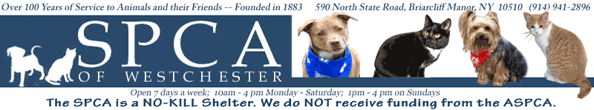

Contact: Toniann Urbieta
(914)-494-4320
Turbieta@SPCA914.com
590 North State Road
Briarcliff Manor, NY 10510

A Spectacular Canine Event You Won’t
Want to Miss!

WHAT:
The SPCA of Westchester, along with its corporate sponsor Petco, will be hosting its annual Top Hat and Tails Gala. Guests will be accompanied by their favorite canine companion as a date. There will be silent and live auctions, a raffle give away, and a special guest appearance.

WHERE:
The Rye Town Hilton, located at 699 Westchester Avenue, Rye Brook, NY.

WHEN:
Saturday, May 22, 2010 from 7:00 p.m. to 10:00 p.m.

PHOTO OP:
Cocktail hour will begin at 7:00 p.m. on the terrace with press availability until 7:30 p.m. Following cocktail hour, press availability will be available in the dining hall from 8:00 p.m. till 10:00 p.m.

WHO:
The SPCA of Westchester was founded in 1883. Today, it is the only humane society in Westchester County empowered to enforce laws relating to animal cruelty. The SPCA's services include shelter and rehabilitation for abused, abandoned, and lost animals; adoption services; low-cost veterinary services; cruelty investigations; community outreach programs; and lost and found services. The SPCA of Westchester is located on several acres, with four separate kennel areas for dogs, a cattery and feline pavilion for cats, and the Simpson Spay/Neuter Clinic.

WHY:
The SPCA gets no federal, state, or county funds thus relying solely on the financial support of people who care about the welfare of animals. Each year this event is held in order to raise money and awareness for homeless animals in Westchester and all over the country.

