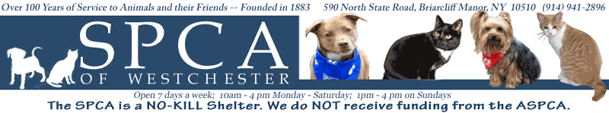

Contact: Toniann Urbieta
(914)-494-4320
Turbeieta@SPCA914.com
590 North State Road
Briarcliff Manor, NY 10510

DOGS MAKE THE BEST DINNER DATES!
Bring Your Canine Companion for an Exciting Night Out at the SPCA’s Annual Top Hat and Tails Gala!

BRIARCLIFF MANOR, New York (May 22, 2010) - Don’t miss the most elegant, zany, and exciting event of the year! The SPCA of Westchester invites you and your favorite dog to our annual Top Hat and Tails benefit to be held Saturday, May 22, 2010 at the Rye Town Hilton. This will be an enjoyable evening with a unique twist-guests are invited to bring along their pups as a date! Tickets start at $180 per person, dogs are of course free. The night will start with a cocktail hour on the terrace with an area designated for your pet to play and interact with their furry friends. Following cocktail hour will be a sit-down 3-course dinner.

Among the festivities there will be a silent and live auction, a raffle give away and we will be honoring our wonderful sponsors of the event. Our main corporate sponsor for the night is the generous and warmhearted Petco company. Sponsoring our raffle and doggie dinners for the night will be Purina Dog Food. We are also very excited to have an extremely special guest attending the event as our spokesperson…the beautiful and talented Jennifer Aniston! Ms. Aniston is a well-known dog lover and an active member of the SPCA community. She will be attending our event in the company of one of her many beloved dogs, and we are honored to have her support for this great cause!

Of course, all of the fun and festivities have a very serious purpose-to assist the SPCA in providing life-saving care for Westchester’s abandoned and abused dogs, cats and horses. Founded in 1883, for over 100 years the SPCA has been dedicated to helping better the lives of hundreds of animals in our community. We depend on the generosity of people like you who share our belief that every animal deserves humane, compassionate treatment.

Come out and help us raise money for a great cause! We truly appreciate each and every one of your support and donations to make give all our animals’ happy and healthy lives!

###

