Using Courseware to Deliver Library Instruction via the Web:
Pace University – Real Education/eCollege.com

Introduction and Objectives

In the Spring 1999 semester Jim Stenerson, an adjunct in the Literature and Communications department, offered an experimental class using the Real Education delivery system. The course was COM 296L - Research Paper Process: Evaluating and Using On-Line Research. Real Education has since changed their name to eCollege.com. This discussion covers the delivery system that was in place in the Spring of 1999. One purpose for offering COM 296L was to test the Real Education system to see if it was a viable option for delivering web-based instruction at Pace. Jim approached me late in 1998 about offering online library instruction to the class.

We had adapted Cornell University's "Hypertext Guide” to Library Research (http://www.library.cornell.edu/okuref/research/tutorial.html) in 1996/97 and I thought that with minimal revision we could use the Guide as a way to deliver the same instruction to distance students as we deliver to students in the library. Our general objectives for any library instruction we offer are to give the students the tools and skills they need to complete their assignments, but also to teach them that the research skills they learn now will be valuable to them in other courses, and after they have finished their formal education. In 1998 we began to change the focus of our sessions from being very specific to a particular course or assignment, to a more conceptual approach, related to the more general components of the research process. Relaying the same message through an online course delivery system was one of the challenges we faced in the Spring of 1999.

After consulting with the faculty member, he and I decided that instead of sending the students to separate library web pages, we would integrate the library instruction into the context of the course delivery system. Our goal here was twofold – first, the students would already be familiar with the course interface and would not need additional instruction on how to use a separate tutorial; and second, we hoped that library instruction integrated into the course itself would be taken as seriously as the other course units, each one-week long.

Putting It Together

I had instructor access to the course; therefore I had the freedom (and the responsibility!) to develop the library units. With the Real Education system, the instructor does have the option of leaving the actual online development and uploading of course materials to the technicians at Real Ed. The current pricing structure for eCollege.com’s services depends on how much support the instructor wants. The professor for COM 296L and I agreed to do the development of the course ourselves.

The Real Education course screen is divided into two frames. The left hand frame serves as a navigation tool, allowing the user to move between sections of the course and the system. The main frame is where content is displayed. Upon login, the user is placed in the Interactive Syllabus, which displays all active course units, and graphic links to Learning Tools within those units. Learning Tools included are: Assignment, Discussion Center, Introduction, Lecture, Quiz and Reading. If a particular Learning Tool was part of a Unit, an icon was present. At the top of the Interactive Syllabus are links to the Professor’s home page, and to the student homepages. A link to my homepage, which provided a picture of me and specific contact information, was provided as well.

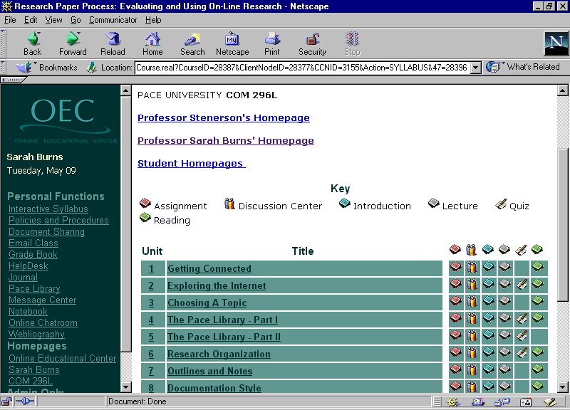

Instructor tools are located in the Course Manager. The learning curve for using the Course Manager is manageable, but only if the instructor is already quite comfortable using some basic computer functions, such as copying and pasting, and uploading files. To make the most of the system, an instructor must have a working familiarity with coding HTML documents. All in all, it took me three straight days in January, 5 or 6 hours a day to create the bulk of the Units and Learning Tools, plus an hour or two each day for the first 2 weeks of the semester doing further development and revision of content and the quizzes. I did have a Course Manager manual, but did not find myself referring to it very often. One of the nice features of Real Ed is that both the instructors and the students get their technical support from Real Ed. I had access to a ProfHelp email account and students had access to an online Help Desk. Turn around time was always incredibly quick, usually under 24 hours.

Once in the Course Manager, I created the two Library Units. A nice feature of the Real Ed system is that I could control when the Units would be accessible by inputting Start and End dates. For COM 296L, units were not available before their start date; all units were left available until the end of the semester once they were open. Once the library Units existed, I started creating the Learning Tools.

For the first library unit – Unit 4 of the course – I used five Learning Tools: Introduction, Lecture, Discussion Center, Assignment, Quiz and Reading. The Introduction provides just that – a space for a brief introduction to the Unit. In the Introduction I outlined the objectives for each Unit. By the end of Unit 4 the students should have been able to:

- get connected to the library databases using the proxy server,
- locate background information on their topic,
- understand why they would use library databases to search for periodical articles,
- choose an appropriate database in which to search,
- and develop a search strategy using Boolean connectors.

In Unit 5, I used only four Learning Tools: Introduction, Lecture, Discussion Center, Assignment, and Quiz. By the end of Unit 5 the students should have been able to:

- recognize the common characteristics most databases share,
- know why and how they should use subject headings when searching,
- limit searches by criteria such as publication date and language,
- know where to get help when searching,
- be able to retrieve articles once they locate a citation,
- and be able to evaluate the information resources they locate.

The Lecture is where the real meat of the Unit is provided. This is where instructions for choosing a database, developing a search strategy, etc. are provided. The Discussion Center is a threaded discussion tool that allows the instructor and the students to post and reply to messages asynchronously. The Assignment area is where the instructor gives specific directions for completing an assignment. The Quiz is self-explanatory, and the Reading area is where the instructor can give specific reading assignments.

One complaint that the faculty member and I both had was that we could not change the order in which the Learning Tools were displayed on the Interactive Syllabus. The default display from left to right was: Assignment, Discussion Center, Introduction, Lecture, Quiz and then Reading. This order did not make sense to us, and when we asked if it could be changed we were told no. We would have preferred to have the order be: Introduction, Lecture, Discussion Center, Assignment, Quiz and then Reading.

Another issue I had was the choice of the term ‘Lecture’ to describe the main portion of each Unit. The term itself has negative connotations for students and really goes against the whole idea of teaching and learning being an interactive, participatory process, which is what online learning must be in order for it to be effective. Looking back, I see now that the choice of what to title each Learning Tool is left up to the instructor. If I used this system again in conjunction with a professor who chose to use the term ‘Lecture,’ I would discuss with her the option of calling the Lectures something else. If I were to use the system on my own, I would call the lecture portion of each unit “Content.”

Creating the content of the Units was not an issue as much of it was taken from our Hypertext Guide to Library Research and revised so that it was applicable to this course. For instance, the students in COM 296L were not to use books, so our piece in the Hypertext Guide on locating and evaluating books was unnecessary.

Creating each Learning Tool is as easy as clicking on a couple of buttons in the Course Manager. Getting the content into the Learning Tool was another story. For the Introduction, Lecture, Assignment and Reading areas the process is pretty much the same: the instructor must input text into a description box. This text is what the students will read onscreen. Content can be added to the box by either typing or by copying and pasting from another application. What’s important to note is that you must use HTML to allow for any formatting of text. If you want text to be bold, or centered, or in a bulleted list, these things must be present in HTML code. I created most of my content using the Netscape Page Composer HTML editor. In Composer I viewed my HTML source code, then copied and pasted it into the description box. From there, the code needed to be manually tweaked if there were links to other files in the course, or if there were graphics on the page.

Graphic files had to be uploaded separately. The File Upload/Download button in the Course Manager allows you to browse to your local drive and select the appropriate files for upload. Once a file is uploaded into the course, it appears in a list of available files that can be referenced in the text of a Learning Tool. For example, in the Lectures I delivered there were a number of times where I used a red checkmark graphic (filename was ‘check3.gif’). I uploaded that file into the COM 296L course. Each time I created a new Learning Tool, a list of files was available to me, including the red checkmark file. The filename had been changed by the system, however, to reflect the local directory structure, and was now listed as ‘oec/com296l-28387/check3.gif’. On each page that I had the ‘check3.gif’ graphic referenced, I had to change the reference to ‘oec/com296l-28387/check3.gif.’ Even though it took extra time in the development stage, I felt it was important to include the graphics to break up the pages in each Unit, and to visually draw students’ attention to particular pieces of information.

ECollege.com now offers “Visual Editing tools,” which work like other HTML editors such as Page Composer. They also provide what they call Microsoft Office 2000 conversion tools, which allow instructors to create new course material or publish existing course materials from Microsoft Word, Excel or PowerPoint onto the Internet directly.

Creating a Discussion Center is one of the easiest things to do in Real Ed. In the Course Manager the instructor clicks on the Add New Learning Tool button, selects Discussion Center, then enters a description. The instructor then returns to the Course, enters the appropriate Discussion Center, and posts a new Topic. Instructors are the only ones who can create new Topics. Within Topics, instructors and students can post and reply to messages.

For both library units the students had items they had to post in the Discussion Center as part of their Assignment. A Discussion Center does demand that the instructor and the librarian check in on the course on a daily basis. The students expect us to be there morning, noon and night, 24/7. They don’t take weekends off, and they don’t think their instructors should either! I checked in every day during the two library units, but only every 2 or 3 days during the surrounding units. Quite a bit of the discussion at the beginning of Unit 4 involved configuring for the library’s proxy server. We had real trouble when students were using AOL to access the Internet from home. Eventually we got most of the bugs worked out. The research questions the students asked in the Discussion Centers were quite insightful. They seemed to be focusing right in on their research topics and doing some very thorough work. This indicated that they had understood and were using the skills taught in the library units.

The Quiz feature was one of the most important tools in the course. We wanted to provide the students with the information seeking skills they needed to succeed, but we also needed to assess what they had learned, and provide them with quick and thorough feedback so they knew if they were on track or not. The Quiz at the end of each Unit allowed us to assess their skills, and gave them substantial feedback, but I am convinced this was not enough interaction. While I was entering the content for each Unit I kept saying to myself that this was too much to give them all at once without stopping and giving them a question or an exercise to test their knowledge. I would have preferred to present a concept, such as creating a search strategy, then give them an exercise, then move on to the next concept. These self-tests would have been for the students’ use only, and would not have been graded. The Quiz at the end of each unit would remain, and would be graded accordingly. Having only 2 units in which to deliver about 10 concepts was a little constricting. What this really means to me is that we could teach an entire online course in library/research skills!

Creating a Quiz is relatively straightforward. Once a Quiz is created, the Exam Manager becomes available. The instructor can create True/False, Fill in the Blank, Essay, Multiple Choice, Many Multiple Choice (more than one answer is correct), Matching, and Short Answer questions. As the instructor creates each question, she can provide explanations as to why each answer is correct or incorrect. When the student retrieves their Quiz grade, they see the explanations. One drawback was you had to put a time limit on each quiz. I did not feel the need to do this with this class, but I had to, so I put a time limit of 2 hours on the quiz, and instructed the students that they could take as long as they needed, as the system would not kick them out if the time limit had passed.

Assessment

At the end of the semester I emailed each student individually to get their feedback on how helpful they thought the library units were. I received a few replies, all generally stating that they thought it was fine. The professor did perform a formal evaluation of the course that included questions about the library units. The evaluation data was split by type of student; students in this course were either traditional undergraduates or adult/returning students. The adult/returning students rated the library units “favorably,” but some did mention they were “a little bored” by them. They noted that technical difficulties and getting booted out of databases interfered with their abilities to use the tools effectively. The traditional undergraduates rated the library units higher in general, but did have more negative comments regarding technical difficulties. As was mentioned previously, we had big problems with AOL users trying to get access to the library databases through our proxy server. We did attempt to get some of the students direct dial-in accounts to the university’s network, but that did not go smoothly either, due to some staffing issues in our own Information Technology unit. Both groups of students rated direct interaction with the instructors as one of the best things about the course.

Conclusion

In using the Real Education course delivery system, we met our objectives as best we could. We provided the students with the information and skills they needed to complete their research, and to approach any information need they may have. I am not confident there was enough interactivity to make the instruction effective, especially given the medium of the Web. This is in part due to having only two units in which to deliver a plethora of information, and not a drawback of the system itself.

I would recommend the Real Education system, now eCollege.com, especially to those who may not have the skills, or who do not want to do much of the technical work of uploading and coding of pages. eCollege.com provides a range of services and if the money is available, having their instructional design and technical support could be invaluable to those just getting started in this arena. The World Trade Institute’s School of International Trade and Commerce, a body owned by Pace University that offers online certificate programs for business professionals, continues to use eCollege.com’s delivery system. For credit-bearing courses at the University, however, the decision was made to use Blackboard’s CourseInfo. The library now partners with a small number of English faculty in delivering online library instruction using web pages and a quiz in the CourseInfo interface.

Whether we are using eCollege.com or CourseInfo, with the onset of more and more distance education programs at Pace, I don’t see how we could serve our constituents without web-based instruction and resources. We will continue to offer, assess, and redevelop our online instruction as the tools and the systems evolve.

