Article:
http://www.adweek.com/news/technology/why-upworthy-was-perfect-match-facebooks-inspirational-branded-content-174351
Summary: Just recently, Facebook teamed up with Upworthy to run a six-week sponsored content campaign demonstrating Facebook’s role in perpetuating unity, openness, and making the world more connected overall. Upworthy’s algorithm for promoting their video content has been brilliant. This campaign initiated 31 million social impressions, 11 million video views, and over 86,000 shares. Upworthy is performing 32 times above the industry’s average. Their statistics are immaculate. Upworthy’s main goal is storytelling, as CEO, as Eli Pari states, "Your heart gets deep into empathy...And your head needs data to better understand the world. Those are what Upworthy combines." Praiser continues explaining the outcome of the partnership. "The presence of Facebook branding on our content didn't impact consumption at all," explained Carrico, "because they were good and authentic stories."
Opinion: Upworthy’s stories are short, and easy to watch. Also, more often than not, users are watching these videos with little to no volume. The text that they use to overlay the video emphasizes the point. It allows you to receive information, and remember that information more accurately because you read the text as you hear it. Their famous text usage has become adapted into Buzzfeed’s videos, and even news outlets. I chose this article because this type of work combines my two passions, filmmaking, and social media. I embrace the digital age and think that these type of videos are not only heartwarming but also informational. Upworthy explores politics, science, societal issues, etc. and provide you with information to make your own consensus. Their content always makes you feel something and this prompts their viewers to like, or share their content. I would love to work with Upworthy and help create videos. Upworthy utilizes creative commons and stock videos which was not seen as often. This helps to produce more content in a faster time. I have already created a few videos utilizing text and stock videos because Upworthy has truly inspired me.
-Elena Roye
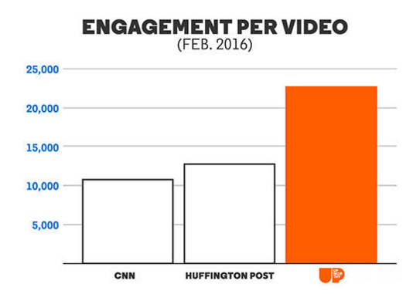
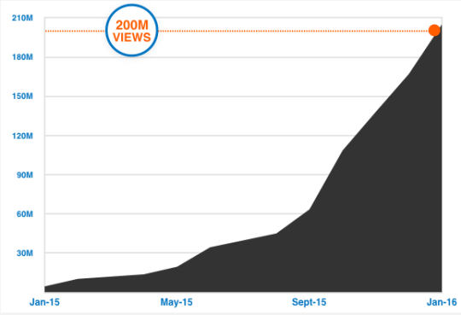
References:
https://www.youtube.com/watch?v=_sZp_eH6BQ0&feature=youtu.be
https://www.upworthy.com/about-paid-content

https://blog.upworthy.com/the-story-behind-the-upworthy-story-35277544ae0b#.v4ity8u5u

