Why do students (ages 18-28) use Twitter for news?
Twitter as a news source

Jared Butowsky, Camilla Klaevold, Francy Rios Germosen & Lanyu Zhang

Pace University

Why do students (ages 18-28) use Twitter for news?
Twitter as a news source
Twitter has made its name as a source of viral news. While this can be harmless, this can also result in the spread of “fake news”, which many sites, including Twitter, have been criticized for enabling. In order to analyze why students use Twitter to get their news in spite of this, we concocted a survey. Among the survey results, a common answer to an open question was that Twitter is quick and easy to use, with a vast range of news sources because many publications use Twitter to post links to their articles.
In this paper, we will look at two days (March 21-22) of tweets from CNN and Fox News, and through comparing these tweets to one another, analyze which ones get how the most interaction. With this information, we will be able to discuss what seems to get people talking on social media. This will help to give us a greater understanding of why people use social media to get their news in the modern age. First we will explain the methodology behind our analysis, before we continue with the data and discussion. Lastly we will summarize and come with a conclusion.
Methodology
We chose to look at tweets from CNN and Fox News since most of our survey respondents (82%) reported that they use Twitter to get news, and again primarily used it for political news (Figure 1 & 2). The reason we chose CNN and Fox News was to see if there were any differences in their content and the way the two channels reported their news. In regards of the fake news aspect we decided to look at tweets linked to President Trump, considering that the President have been liked to fake news multiple times over the last year (Derespina, 2017). Furthermore, we decided to look at the top three tweets from each news organization, to see what content created the most interaction. By “top tweets” we mean the tweets with the most retweets, likes and responses. Gathering our data, we discovered that CNN tweeted a total of 348 during the two-day time span, 33 of these times being of Trump. Fox News tweeted a total of 249 times during two days, with only 12 tweets regarding Trump. We found in to be interesting that that CNN tweeted about Trump nearly twice as much as Fox News, and will therefore go further into this in our analysis.
Data
82% of our respondents reported to use Twitter to get news. 72.45% of our respondents reported to primarily use Twitter to get political news, instead of entertainment, sports, science, or education (Figure 1 & 2). Within exactly two days, Fox had an estimated 249 tweets, and CNN had 348 tweets. We decided to narrow our options down, and examine all the political tweets from both news conglomerates in regards to Donald Trump; being that politically-wise, Trump is the most talked about on Twitter. Out of the 249 tweets, Fox tweeted 14 times about President Trump. Out of 348, CNN tweeted 33 times about President Trump. This leads us to conclude that 5.62% of Fox’s tweets are about President Trump; these tweets are considered to be moderately fair, non-negative, and non-biased. Also, we were able to determine that 9.4% of CNN’s tweets are about President Trump; we find that these tweets are mostly biased in a negative way. We chose three top tweets that best describe Fox’s and CNN’s perspective of President Trump. Fox Tweet #1 had 370 likes, 195 retweets, and 298 replies. Fox Tweet #2 had 1.3 thousand likes, 238 retweets, and 268 replies. Fox Tweet #3 had 1.7 thousand likes, 349 retweets, and 190 replies. CNN Tweet #1 had 2.1 thousand likes, 774 tweets, and 441 replies. CNN Tweet #2 had 756 likes, 432 retweets, and 376 replies. CNN Tweet #3 had 1.4 thousand likes, 1.3 retweets, and 287 replies.
Discussion
Our survey showed that most of our respondents who use Twitter to get news are mainly getting political news on Twitter. Therefore, we would like to discuss the political standpoint of Fox and CNN. The scope of political news is wide, and it has many different kinds of issues, so we decided to narrow the scope. In all political news, President Trump's news is undoubtedly the hottest topic. We chose Fox and CNN published tweets about President Trump in two days for the sample. Even with just two days, the two news platforms have released a large amount of news about President Trump. We selected three top tweets from each, which we will collect the share, retweets, likes, and replies to the tweets.
Within two days, we found that CNN mentioned “Trump” twice as much as Fox News mentioned him. The phenomenon could mean that Fox doesn’t tweet much about Trump because they don’t have much positive things to say or they simply chose to out their focus elsewhere, whereas CNN tweets more about Trump because they have a lot of negative things to say. CNN tweet “The candidate who wore out the phrase 'believe me' is becoming the President fewer and fewer believe” (Figure 3), shows that CNN fronts stories that suggests that Trump is not worthy of trust, and do not agree with the president; this can be because CNN has an opposite political standpoint. As we browse the Tweet comments, the majority of the people think this tweet, along with many others, is fake. People who are Trump supporters are disappointed with CNN and people who are anti-Trump are most likely the ones who gives the Tweets likes. Fox News tweets about Trump can mostly be found to be more objective than CNN, as the content is stating the facts about a certain story, without mentioning Trump in a degrading manner. Trump himself has also tweeted about CNN’s credibility (Figure 4), most likely due to how CNN reference him, Trump’s supporters could therefore more likely to share Trump’s opinions about CNN.
The contradiction between CNN and Trump is not a newly arisen situation. For example, during Trump’s first press conference, and on the day before the press conference, CNN released heavy news that Russia could have information about Trump that could be used to threaten Trump. It is reported that these unconfirmed materials relate to Trump's private life and his finances. These reports caused Trump to anger. At the news conference, Trump broke out in public, directly interrupted CNNs reporter Acosta's question, and refused to let him speak. "Mr. President-elect, since you are attacking our news organization, can you give us a chance," asked Acosta. "Not you," interjected Trump." Your organization is terrible ... I am not going to give you a question ... You are fake news.” After the meeting, CNN responded that it was unfair, bullying behavior (CBSLOCAL, 2017).
The change in the relationship between Fox News and Trump is dramatic. The relationship with Fox News was very tense when Trump began participating in the Republican presidential candidate in 2015 because Fox's hostess raised questions about his negative evaluation of women. After Trump won the election, according to Nielsen data (Stelter, B. 2015) show that Fox News's ratings rose rapidly, while CNN has declined significantly. Some experts say that CNN lost the audience is likely to turn to Fox News. However, due to Fox's political alignment with Trump and its trademarked slogan "Fair & Balanced”, from the Fox released Twitter can be found in the report of Trump, compared to CNN and other mainstream media, it is more moderate (The Huffington Post, 2011).
Based on the fact that CNN seem to be more unbiased than Fox News towards Trump, interaction with the organizations tweets could mimic this image, however we can not know for sure. As many people may put out a different exterior online and on social media, which Goffman also mentions in his front stage/backstage theory (Meyrowitz, 1985), and online trolling has also become somewhat of a phenomenon.
Conclusion
In this paper, we have analyzed several tweets from CNN and Fox News, comparing the levels of interaction these tweets get. Through this method, we were able to determine how people respond to news-based accounts on social media. With this knowledge, we will be one step closer to understanding why people use social media to get their news. However, for future reference we should have coded our material more systematically, and perhaps have looked at more units. The paper looks at the methodology, our data and our discussion in that manner.

Appendix
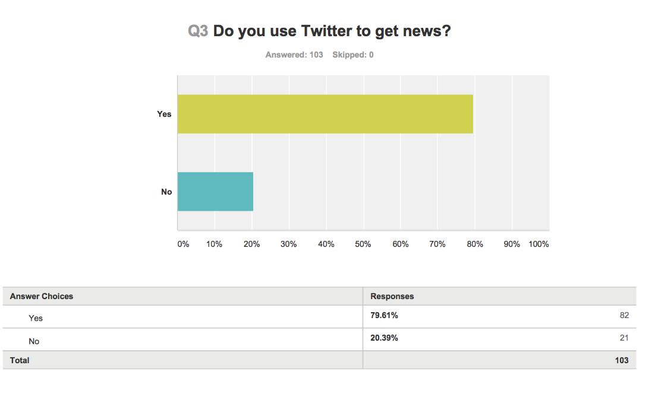
Figure 1.
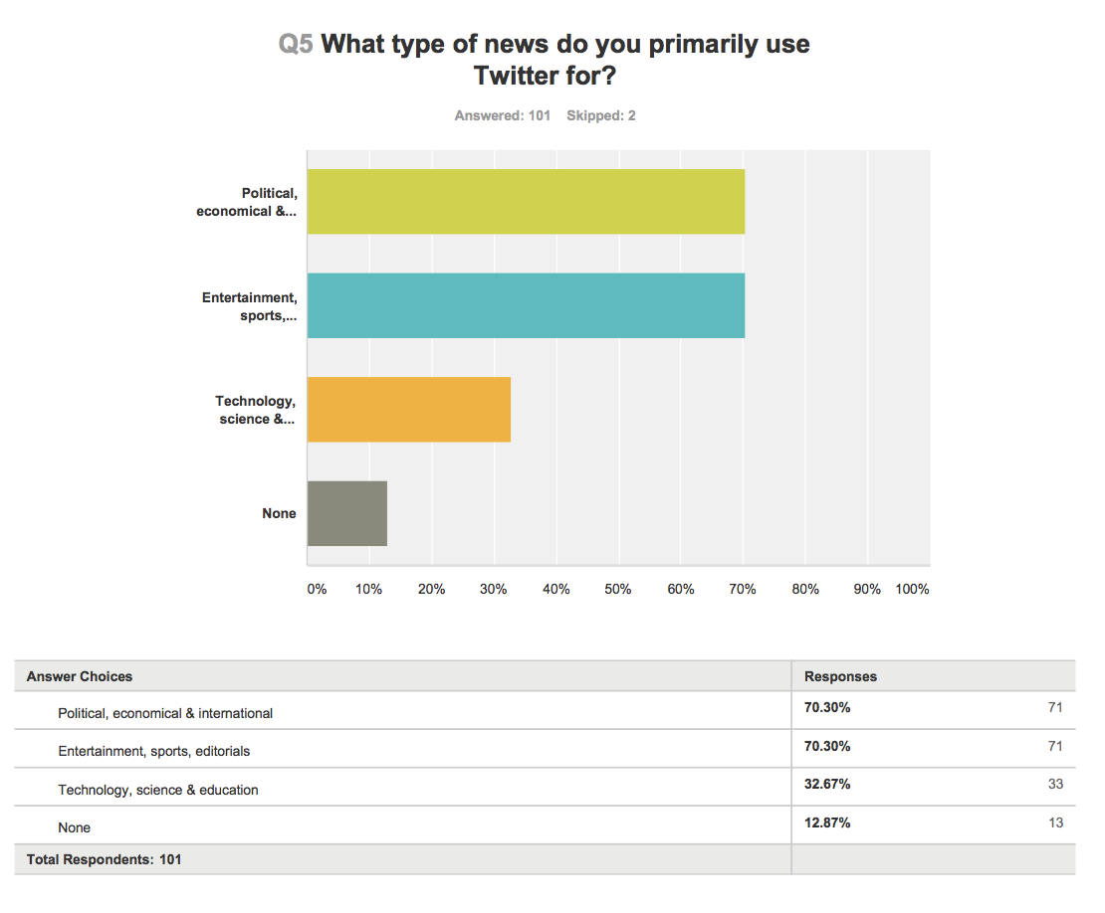
Figure 2.
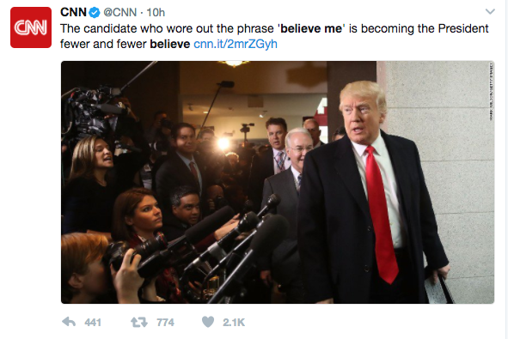
Figure 3.
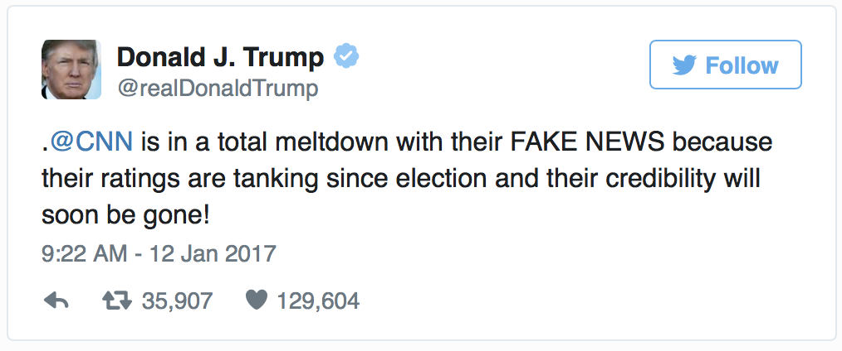
Figure 4.
References
CBSLOCAL (2017, January 11) ”WATCH: Trump Gets Into Heated Exchange With CNN Reporter, calls Them ‘Fake News.” CBSLOCAL. Retrieved from: http://philadelphia.cbslocal.com/2017/01/11/watch-trump-gets-into-heated-exchange-with-cnn-reporter-calls-them-fake-news/?yptr=yahoo
Derespina, C. (2017, March 20) Trump: Russia story is 'FAKE NEWS and everyone knows it!' FoxNews. Retrieved from: http://www.foxnews.com/politics/2017/03/20/trump-russia-story-is-fake-news-and-everyone-knows-it.html
Meyrowitz, J. (1985) No Sense of Place – The impact of electronic media on social behaviour. Oxford: Oxford University Press.
Stelter, B. (2015, August 7) Fox's GOP debate had record 24 million viewers. CNN. Retrieved from: http://money.cnn.com/2015/08/07/media/gop-debate-fox-news-ratings/index.html
The Huffington Post (2011, December) Fox News ‘Fair And Balanced’ Slogan Believed By Plurality In New Poll. The Huffington Post. Retrieved from: http://www.huffingtonpost.com/2011/10/17/fox-news-fair-and-balance_n_1016455.html

