Catherine Weening

Professor Meaghan Brewer

ENG 201

15 December 2014

Children Copy Copy Editors:

How the Publishing Industry Affects Literacy

**Introduction**

I am an adult who reads children’s books and I get paid for it.

That’s what people think I do, anyway. For a little over a year, I have been an intern at Scholastic Inc., the largest children’s publisher in the world. More specifically, I intern for the Production Department in the company’s Book Group. So, yes, I do read children’s books in a way, because my part of the department handles the copy editing of manuscripts, the proofreading of all stages of a title’s mechanicals and proofs, and it oversees the conversion from print to ebook format.

But, no, I do not sit around reading Harry Potter books with Clifford, because children’s book publishing, somewhat ironically, is much more complicated than that. Scholastic promotes literacy in a traditional reading-and-writing sense and, in many ways, is a children’s literacy icon. However, it is also a literacy site in itself because of the company’s and industry’s discourses. What makes this site even more interesting is that these discourses are used to decide the proper grammar, spelling, and other aspects of language children are exposed to. This study will look into how Scholastic uses its work-specific language to influence the “proper” language children consume through Scholastic books. Children’s book publishing both uses and creates one of the many literacies that children acquire.

**Methodology**

I chose this particular literacy site because, as a company, Scholastic dedicates itself to promoting children’s literacy and making the world a more literate place. Through its Book Club and Book Fairs programs, which get inexpensive books directly into the hands of students, the company shows that it wants all children, regardless of background, to be literate. I thought it would be neat to see how this is reflected in the workplace and how specialized literacy is used to complete that goal.

I mainly obtained field notes through observations when I was in the office for about two weeks. I made sure to be conscious of the purposes behind any actions I’ve made at work, which I previously did without too much thought. Looking at my work a little more closely helped me see what would be unfamiliar to those who have never encountered this literacy site and what I was unfamiliar with a year ago before I started at my position.

**Theoretical Frame and Literature Review**

To examine Scholastic as a literary site, I looked at “The Enthography of Literacy” by John F. Szwed, “Literacy, Discourse, and Linguistics” by James Gee, and John Donovan’s “Children’s Book Publishing on the Ascent,” which I found using the Communications and Mass Media Complete database at the Pace University library.

Szwed’s article wants the reader to step back from how literacy is taught, and to look at how it is used in everyday life, as a function and as a social action, because literacy taught in school may not be the literacy used in that student’s future workplace. To look at the differences between the literacy of different literacy sites, Szwed proposes that the five elements of literacy—text, context, function, participants, and motivation—be considered. For instance, the texts used in Scholastic would be the sixteenth edition of the *Chicago Manual of Style*, or CMS 16 for short, the Merriam-Webster Unabridged Collegiate Dictionary, the eleventh online edition, or just Web 11, the Scholastic House Style guide, style sheets for individual titles, the actual titles themselves, the extensive jargon of the publishing industry, and proofreading marks which, in a way, are its own written language:

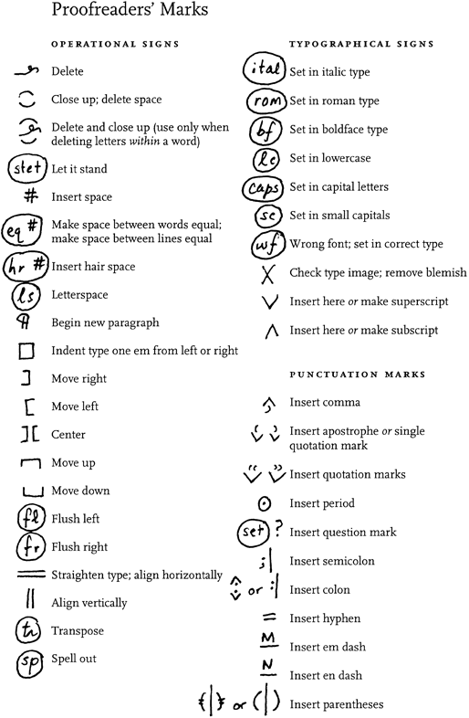

(Numbers, 2.6)

If that language is misused, then the language of the book, or title, is altered, which could lead to a printed title with one or more errors. Employees, therefore, must be fluent in these marks, CMS 16, Web 11, and the site’s jargon, as well as being able to familiarize oneself with a particular title.

Szwed argues that the form, message, and uniformity of these texts, since many of these texts are industry standards, would help define the branches of “literature” that may not be included in a school setting. Odds are students are not familiar with CMS 16 or with proofreading marks. This uniformity of the text’s grammar and spelling, based on these texts, would also dictate how readers, in this case children and young adults, see the published titles. For example, Szwed cites Helvetica as a widely used, but also widely debated, font because it comes across as authoritative and impersonalized. Even seemingly small elements of a finished title can impact how it is read, and these texts help dictate that.

Within his five elements, Swzed makes an interesting, and eye-opening, point over context. Schools may assume children already read at home, and by assuming that they already have and/or practiced the basics of reading, a huge gap is formed. If a published title assumes certain knowledge on the part of the reader and the assumption falls flat, then is that title really promoting literacy?

I also looked at James Gee’s “Literacy, Discourse, and Linguistics,” which looks at how language changes depending on a person’s current literacy site. Gee points out that proper language does not necessarily mean proper grammar if one is at a bar with a friend. “May I have a match please?” would be considered improper, while “Gimme a match wouldya?” would be correct in this context (525). One’s actions are also a language, and Gee calls these “saying (writing)-doing-being-valuing-believing combinations” Discourses. Gee asserts that Discourses are “identity kits.” Someone would have a Discourse for their nationality, gender, occupation, and social events (526). These discourses cannot be taught like grammar, though; they must be acquired through experience. Therefore, children, the audience Scholastic is interested in, start off with an initial Discourse, a “primary Discourse” (527). One way a child becomes literate in a Discourse is to first gain mastery over a secondary one (528), what Gee calls, “filtering.” Filtering is when a child processes elements of a secondary Discourse and “filters” it into their primary Discourse. The example Gee gives is a little girl who, because her mother reads to her every night, starts telling stories in the same fashion as story books. She starts with an introduction of sorts, she sets up a conflict, she uses sympathetic fallacy, and she ends her story with a “the end” (534). Gee explicitly uses children’s books as an example of a secondary Discourse, and one that can be filtered into a primary one. Children’s books help children form their own stories and see the significance in them, but they also do this in a uniform way and structure because they all use uniform guidelines, even if the books are published by different publishing houses.

Donovan’s article, “Children’s Book Publishing on the Ascent” is different from Szwed’s and Gee’s because it’s not quite theoretical; it’s factual. Donovan looks at children’s book publishing from a business point of view and looks at its current trends. One such trend, which Donovan disapproves of, is the rapid pace at which children’s book publishers put books out of print so that new titles can fill their places (13). The reason publishers do this, Donovan says, is to make more money off more titles, but he asserts that mass produced books, such as the famous Golden Books line, are the ones that not only make money, but also become iconic and treasured through multiple generations:

It is a mistake to conclude that if a book is part of a mass-market publishing program, it is not a very good book. Those who have studied the history of American children's book publishing know that some of the best titles in our literature have come from lists such as Golden Books, and that some of our foremost talents…have published comfortably for both traditional and mass-market houses (8).

This contradicts the “distrust of mass society” that Swzed mentions in his essay, a distrust that leads to a snobby, arrogant “book culture” that believes anything given to the masses is cheap and inferior (427). Widespread literacy can be seen as cheapening literacy, but, in fact, it actually promotes it, as seen by the success of mass-produced books.

**Findings and Discussion**

As briefly discussed earlier, Scholastic’s texts help define the context and the function of my department as a literacy site: to produce children’s literature that the company deems worthy of selling. Per my earlier statements, much of this means a certain amount of uniformity that is complied with in the publishing industry. The effects of this are seemingly small, but can impact a child, a filtering machine, in large ways. According to CMS 16, numbers one hundred or less must be spelled out (Numbers, 9.2). So a child may, because of his or her experience with books, spell out fifty-seven and be less inclined to write 57. After, unknowingly, being exposed to Web 11 words, they might write wide-awake instead of wide awake because that is the spelling they know. Furthermore, if a child prefers to write 57 and wide awake, they might see their own language as wrong, because their books tell them differently, and since books are constantly going in and out of print, more and more different books are telling them the same thing and reinforcing the same message. Small elements of books may determine if a child sees themselves as literate or not.

In addition to spelling and grammar, my department also flags anything that might be seen as unclear to that age group. For instance, a history book for very young children may explain the myth about George Washington and the cherry tree, but it would be assumed that older readers already know that, so it may only be referenced in passing. However, if an older reader is not familiar with that tale, especially if that reader is not from America, that would be confusing and form a serious knowledge gap that would, as Szwed pointed out, do the opposite of promoting literacy. Unfortunately, one, uniform way of avoiding this problem is not in place, but Scholastic is trying to avoid that by publishing books by more diverse authors so that many different experiences are put into print. Examples of Scholastic’s efforts included *Love is the Drug* by Alaya Dawn Johnson, which explores the racial and socioeconomic tensions in Washington D.C. and the American government, Trent Reedy’s *Words in the Dust*, which chronicles a young Afghan girl’s experience once the Taliban leaves her country, and Daria Wilke’s *Playing a Part*, due out later this spring, which is a translated, and controversial, young adult book from Russia about a gay Russian teen. Many of these titles are also mass-produced in Scholastic Book Clubs and Book Fairs around the nation in elementary and middle schools, so these books are not only being valued, but are also getting into as many hands as possible because of Scholastic’s wide-spread presence and their affordable school-exclusive prices. Scholastic books, therefore, are not only shaping a child’s language, but also shaping their worldview. Gee would say that both of these aspects of Scholastic books enter greatly into a child’s primary Discourse via filtering. Not only will children gain the basic story structure seen in Gee’s example, but they will also be exposed to characters either very different from them or more similar to them, helping children become more accepting of others and/or more secure in who they are.

The Book Clubs and Book Fairs are particularly interesting aspects of Scholastic to look at because they help ease a significant tension between two important goals in children’s publishing: to help all children become literate for a moral sake *and* an economic one, because publishers also want to make money. Scholastic’s unique because it has programs that promote both. The Book Fair program holds 127,000 fairs a year, selling more than one hundred million books to thirty-five million families, while also generating more than 175 million dollars in both cash and educational resources to the participating schools (“Book Fairs”), while the Book Club ordering forms are distributed in eighty percent of elementary and middle schools in the United States (“Reading Clubs”). This means that Scholastic has direct access to two of the biggest customers of children’s books: schools and parents. It also means that the company is able to promote literacy by helping children buy books who may not be able to at regular retail prices. This wide-spread presence of Scholastic in schools coupled with their affordable prices makes them a credible and verifiable source of reading materials for children, meaning that their mass-produced titles give them a sense of prestige, which, in a way, reinforces Donovan’s point about mass-produced books: They have more prestige than the people in Szwed’s “book culture” think they do. The more power people are given, the more valued people are.

**Implications**

Children’s publishing differs from adult publishing in a significant, way: it sets a precedent for the traditional reading-and-writing literacy children will acquire and how they will see that literacy over the course of their lives. From the books put into the market, children, via filtering, learn how language is “supposed” to be used and how they can use it. By having more diverse book offerings, like what Scholastic has been offering, children are able to pick up different styles, experiences, and even story structures, and bring them into their own Discourse, setting off a chain reaction because then *they* will grow into adults who have the tools to tell their own stories, giving the future’s children even *more* diverse titles. Therefore, it is important that children’s books reach as many children as possible, which can only be done through mass-produced and marketed titles. These titles do not cheapen literacy; they keep it alive because they will reach children of all backgrounds, in a socioeconomic, cultural, and regional sense, which will only add to the richness of literature. Scholastic books do not just grow future readers; they grow the future of reading.

Works Cited

“Book Fairs.” *About Scholastic*. Scholastic Inc. n.d. Web 13 Dec. 2014.

Donovan, John. “Children’s Book Publishing on the Ascent.” *Publishing Research Media*

*Complete*. Web. 13 Dec. 2014.

Gee, James Paul. “Literacy Discourse, and Linguistics: Introduction and What is Literacy.”

Literacy: A Critical Sourcebook. Ed. Ellen Cushman et al. Boston: Bedford/St. Martin’s, 2001. 525-544. Print.

“Numbers, 2.6.” *The Chicago Manual of Style*. 16th ed. Chicago: University of Chicago Press,

2010. Web.

“Reading Clubs.” *About Scholastic*. Scholastic Inc., n.d. Web. 13 Dec. 2014.

Szwed, John. F. “The Ethnography of Literacy.” Literacy: A Critical Sourcebook. Ed. Ellen

Cushman et al. Boston” Bedford/St. Martin’s, 2001. 421-429. Print.

“Wide-awake.” *Merriam-Webster Unabridged Collegiate Dictionary*. 11th ed. 2011. Web