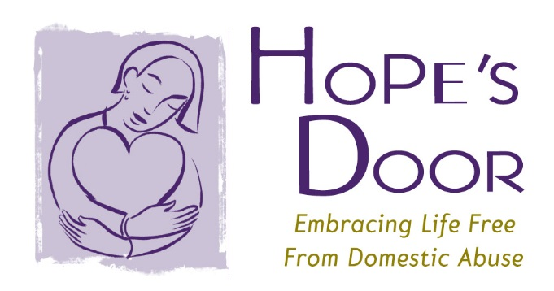

**NEWS RELEASE**

**Contact**:

Samantha Clarke

PR Representative/Community Relations

(845) 775 - 9898

sclarke@hopesdoorny.com

**FOR IMMEDIATE RELEASE:**

**HOPE’S DOOR ANNUAL LUNCHEON AND GUEST SPEAKER ANNOUNCED**

**Westchester County, NY (August 3, 2015) –** Hope’s Door, a Westchester-based foundation who focuses on domestic violence and seeking safety, announced today the details of its annual luncheon. The luncheon will be held at Mt. Kisco Country Club on October 16th, 2015 from 11:00 a.m. until 2:00 p.m.

Through the use of a silent auction, attendees and members of the organization raise money to spread awareness of domestic violence. Dyllan McGee, two-time Emmy-award winning Executive Producer at McGee Media, will be this year’s special guest speaker. McGee will communicate the importance of domestic violence awareness, prevention methods, and offer thanks to all who have made an impact thus far.

McGee is the Founder and Executive Producer of *MAKERS: Women Who Make America*. MAKERS is the largest video collection of women’s stories. The importance it shares to this cause is that MAKERS illustrates how women are strong and powerful individuals who can be independent and resilient.

“It is easy to sit back and believe in change, but not stand up for it,” says McGee “ Standing up takes effort and risk and that can be uncomfortable. This message is extremely relevant and important to everyone who will be in attendance at the luncheon.”

Hope’s Door’s mission is to end domestic violence and empower victims to achieve safety, independence, and healing from the trauma of abuse. Hope’s Door offers services such as a safety hotline, safety planning, counseling, and shelter to those in need. Since advocacy is such an important aspect of what Hope’s Door does, this luncheon is crucial for both the organization and community.

To attend the luncheon or donate go to [www.hopesdoorny.com](http://www.hopesdoorny.com).

XXX

Hope’s Door

Office: (914) 747 - 0828

PO Box 203,

39 Washington Avenue,

Pleasantville, NY 10570

June 12, 2015

Dear Supporters,

It’s that time again! Time to register for our annual *Anti-Domestic Violence* luncheon.

It is with great pleasure that I inform you of the date and guest speaker of our event. The luncheon will take place on **October 16th, 2015** at the Mt. Kisco Country club from 11:00am until 2:00pm. Our special guest is Dyllan McGee, two-time Emmy-award winning Executive Producer at McGee Media

McGee is the Founder and Executive Producer of *MAKERS: Women Who Make America*. MAKERS is the largest video collection of women’s stories. The importance it shares to this cause is that MAKERS illustrates how women are strong and powerful individuals who can be independent and resilient.

I encourage you to register for the luncheon and continue to help us make a difference in the fight against domestic violence. Each year the luncheon, along with our other special events and fundraisers, contributes immensely, last year coming up with $419,497, to what we raise to make the change we have successfully been making.

Because our luncheon continues to be such a huge success, in regards to contributions, donations and support, thanks to all of you, we are so excited and hope you are too! The theme of the luncheon will be announced next month so keep an eye out for that on all of our social media outlets (Facebook, Twitter, and Instagram).

For information on luncheon tickets and sponsorships, contact Jennifer Ryan Safsel at 914.747.0828 x1005 or [JRyanSafsel@HopesDoorNY.org](mailto:JRyanSafsel@HopesDoorNY.org).