*Why do students of ages 18-28 resolve to Twitter for news?*

Jared Butowsky, Camilla Klaevold, Francy Rios Germosen & Lanyu Zhang

Pace University

*Why do students of ages 18-28 resolve to Twitter for news?*

**Introduction**

62% of adults in the US get their news via social media. Of those users, 64% use only one site for their news. 40% of adults on social media are between the ages of 18 and 29. Twitter is one of the most popular platforms for news, with 59% of the service’s users getting their news from there (Gottfried & Shearer, 2016, par. 1).

Twitter began in 2006 as the brainchild of co-founder and current CEO Jack Dorsey. Devised as an SMS platform, it would be used by people to keep up with what their friends were doing. Originally owned by a podcasting company named Odeo, several staff members eventually bought back Twitter for themselves. (MacArthur, 2016).  Today, it has become incredibly popular, especially among the younger generation. What we wish to explore is why students from the ages of 18-28 use Twitter as a news source.

The reason we want to research this topic is that Twitter has made its name as a source of viral news. Viral news is news that spreads by circulating between people very quickly. While this can be harmless, this can also result in the phenomenon known as “fake news”. Many social media websites, such as Facebook, have been criticized for enabling the spread of “fake news” (Isaac, 2016).

What we will do in this paper will be explain the methodology we used in our research, and then we will describe the results. After that, we will discuss them, and then wrap it up with a conclusion.

**Methodology**

The reason for our survey was to examine our research question: “Why students in the ages of 18-28 resolve to Twitter for news?” We used SurveyMonkey to conduct our survey, since this is a site many people are familiar with, and it is anonyms. The survey can be found in the Appendix, figure 1-5. We included two nominal, two ordinal, two interval and two ratio questions in the survey. Our universe consisted of Pace University students both at the New York City and Pleasantville campus, with the population being media and communication students. The reason for this was the convenience of sharing a survey with Pace students, more specifically media and communication students considering it is the class’ major. Collecting the responses, we used the convenience method of sharing the survey online on social media, such as Pace University groups on Facebook and Twitter. To separate the media and communication students from the universe we asked the respondents if they were studying media and communication.

When creating the questions for the survey, we tried to take all factors in to consideration so that we would get all the answers to our research question: “Why do students (18-28) resolve to Twitter for news?” With the ‘why’, we tried to answer our main reason for the research, in regards of why students are using it. We therefore tried to ask questions about the convenience, entertainment and credibility factors on news on Twitter. By ‘students’, like mentioned above we set our universe to Pace University, with a media and communication population. Regarding the age range in our research question, we increased this from our original one being 18-24, due to the fact that a lot of graduate students are older than the age of 24. For the 2015-2016 academic year, most graduate students were over 25 years old (U.S.News, 2017). They can of course be older than 28, but we considered a ten-year span to be sufficient.

The ‘resolving’ part of our question links to Twitter, and was therefore the main focus in the survey. As for ‘news’, we divided it into three categories: 1. Political, Economical, and International, 2. Entertainment, Sports, and Editorials, 3. Technology, Science, and Education. This was to ensure that our respondents would be on the same page as us, when it comes to defining news and different categories.

**Results**

In this survey, a total of 103 people accepted our investigation, 88.3% of people are 18-28 years old. We want to compare the ratio about Media & Communication Arts major and other major resolves to Twitter for news. There are 79.61%of people using Twitter to get news, indicating that most of our respondents use Twitter, and Twitter is an important way to get news.

          45.54% of our respondents started using Twitter for news before enrolled in college, and 39.6% were using it after enrolled in college. “Political, Economical, & International” and “Entertainment, Sports, & Editorials” are most popular type that people primarily use Twitter for. Both of these options had the highest rank at 70%. There were 36.67% of respondents whom chose “Technology, Science, & Education” type, and 12.87% of respondents did not focus on these types.

         We used traditional media as a reference data, the survey showed that 75.73% of our respondents use traditional media to get news. It means besides Twitter, the majority of people use traditional media (TV, radio, print) for news.

          With regard to credibility, about half of our respondents think in their estimation that Twitter's credibility is somewhat. The same outcomes was for traditional media, in which 54.45% people think tradition media has somewhat credibility.

           It was calculated that 30.1% of our respondents use a mobile device for news 4+ per day, 28.16% use 2-4 hours, 38.83% use 1-2 hours, and 2.91% use 0 hours. For traditional media (such as TV, radio, print), 56.31% of our respondents use 1-2 hours, 28.16% use 0 hours, 13.59% use 1-2 hours, and 1.94% use 4+ hours.

           Besides Twitter, our respondents also use other social media platforms for news, the most popular one is Facebook, in which 56.38% use Facebook. 36.17% of our respondents use snapchat, 32.98% use Instagram, and 43.62% use others.

           We want to know the status of Twitter, so we let everyone rank the platforms they use most often. 69.39% of our respondents put Twitter in the first place, indicating that Twitter has a very high status in News sources. On the other hand, we also ranked the traditional media news source. Though the data, we found TV is still an important way to get news, 47.87% put TV in the first.

          We proposed an open question; why do people use Twitter for news? Many of our respondents think Twitter is quick and easy access, and vast range of sources. Someone said its convenience because a lot of publications use their Twitter accounts for easy, and quick news.

**Discussion**

The main purpose of asking the following questions was to gather as much information as possible, to help determine *why* do students of ages 18-28 resolve to Twitter for news. Every question was designed to conclude the many different ways that our main question can be expanded. We began our survey by asking the age of the respondents, this can help us determine what age group is taking our survey, and it can specifically help us determine if the age group we want to focus on has the majority of responses. We asked the major of the respondents because it can help us determine the respondents’ interests; we only asked if they were Media & Communications Arts students or Other (Nursing, Education...), which in part was not as effective because if we had elaborated more on the “other” part we could have had determined a broader list of the interests of our respondents. However, there are so many different degrees, that it would be nearly impossible to mention all of them. Ergo, we ended up with the two different options. The reason to why we chose to separate media students was to see if they had different opinions regarding the topic than other students, and possible linking it to the credibility of the news. However, to compare the results properly we would have needed to get around the same amounts of media students and “others” to reply to the survey.

Being that we are focusing on the social media outlet ‘Twitter,’ it was important to determine if our respondents use the source to receive their news. We proceeded by asking *when* did they begin to use Twitter for news, because it can further help us determine *if* they use it for news and if they began using it before college or after attending college. This question helps us conclude how much of an impact being a college student has on people that use Twitter for their news. Asking the type of news that our respondents prefer to get from Twitter is crucial because it helps us understand the different types of interests that our respondents have. Knowing the credibility of the news they receive is important because it helps us conclude why they continue to choose to receive their news via Twitter. If our respondents believe that the news they receive is credible, then they will continue to resolve to Twitter for their news.

We asked if our respondents use traditional media such as television and newspapers because we wanted to determine if social media is completely taking over traditional media. We proceeded to ask our respondents how credible they believed traditional media is in relation to news opposed to Twitter’s credibility because we wanted to determine which one of the two they believed was more credible. As for limitations to our survey we believe our main problem to be with the population. We forgot to include a question asking our respondents if they were students at Pace University, and considering the power of social media in regards of sharing posts, we cannot be sure if the respondents taking our survey were actually students from Pace University. We have therefore decided, to exclude this part, and rather look at students as a universe in general.

The majority of news outlets have an app on their mobile devices, which resembles to their websites and social media accounts. It was important to determine how much time our respondents spend on their mobile device gathering news opposed to how much time they spend using traditional media for news because it helps us conclude what is more accessible for our respondents.

Twitter is one of the current most popular social media outlets; we wanted to analyze what other social media outlets do our respondents use because many resemble Twitter and its functions, such as Facebook, Instagram and Snapchat. We proceeded to compare all of these social media platforms and asked our respondents to rank which one they use the most to the least. We also asked the respondents to rank which traditional media source they use the most. This helped us analyze which possible news outlet could they be using the most in both social media and traditional media. Lastly, we asked the most important question; *why?* In order to further help us develop our thesis we wanted to know an exact answer for our main question. With this question, our respondents were able to give us an insight to the many different reasons why students of the ages 18-28 might resolve to Twitter for their news.

**Conclusion**

As a source of viral information, Twitter is a useful news source for many. In this study, we have looked at why a sample of students use Twitter, as well as how trustworthy they consider the news found on the service. From the site’s humble beginnings to today, Twitter has become a juggernaut of human interaction, for better or for worse. Time will tell how the way people get their news continues to evolve.

Going forward, we should look more into what effects the way people trust their news. We have only scratched the surface of this topic, and there is a lot of potential for it to be explored further than we already have.

**Appendix**

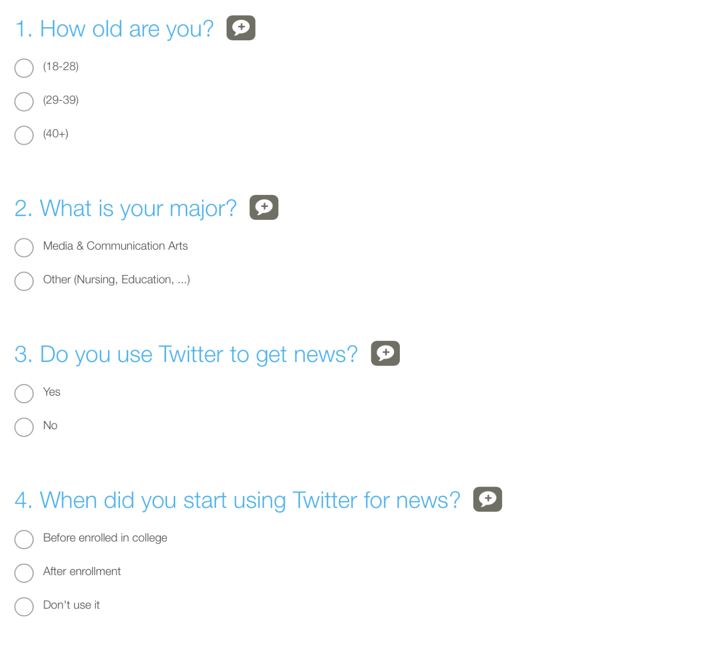

Figure 1.

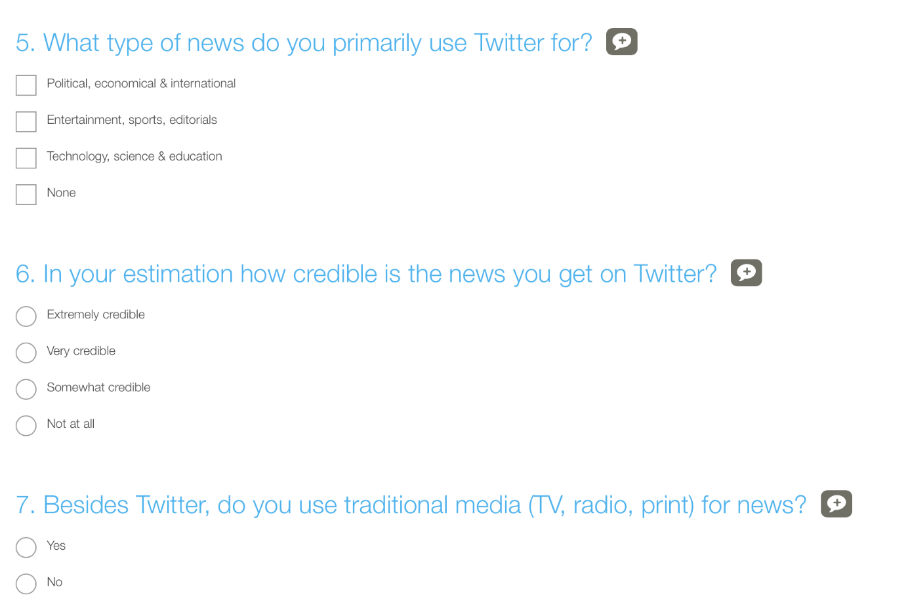

Figure 2.

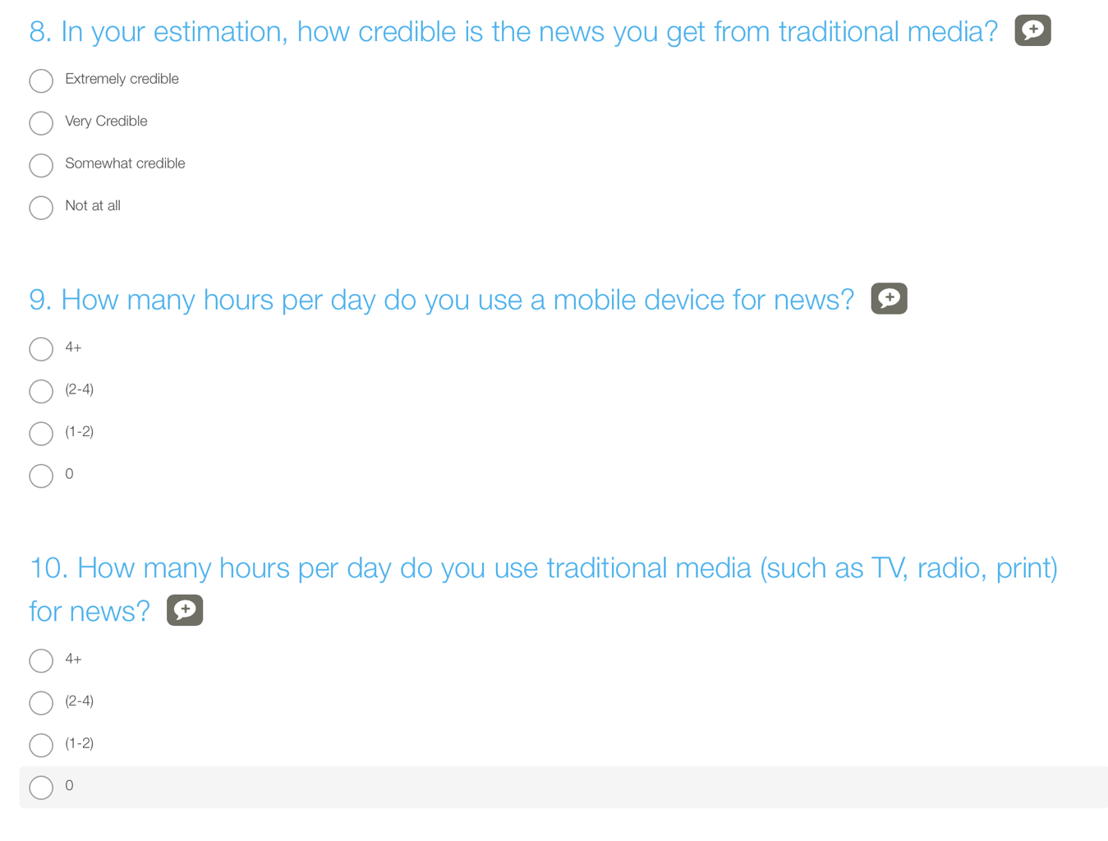 Figure 3.

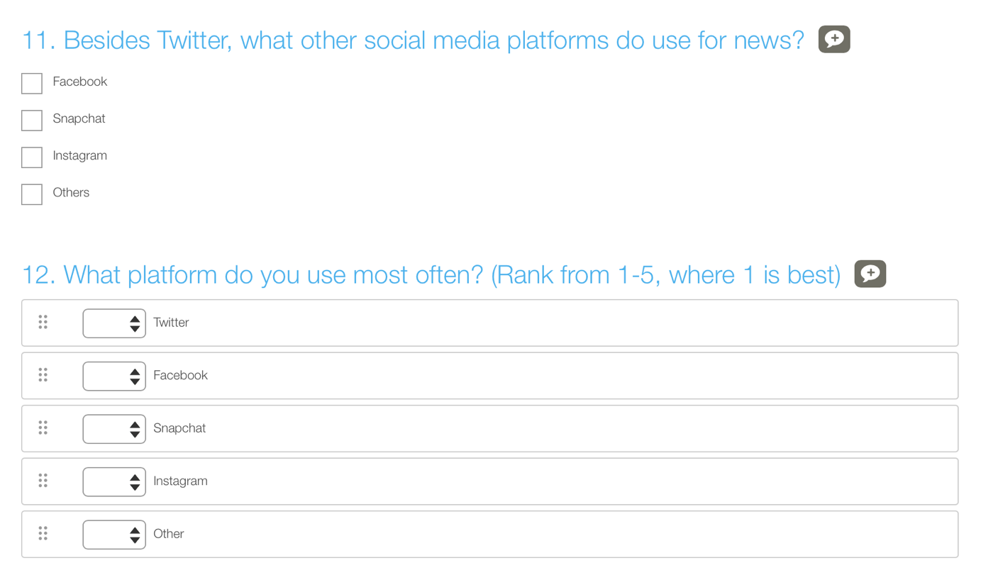

Figure 4.

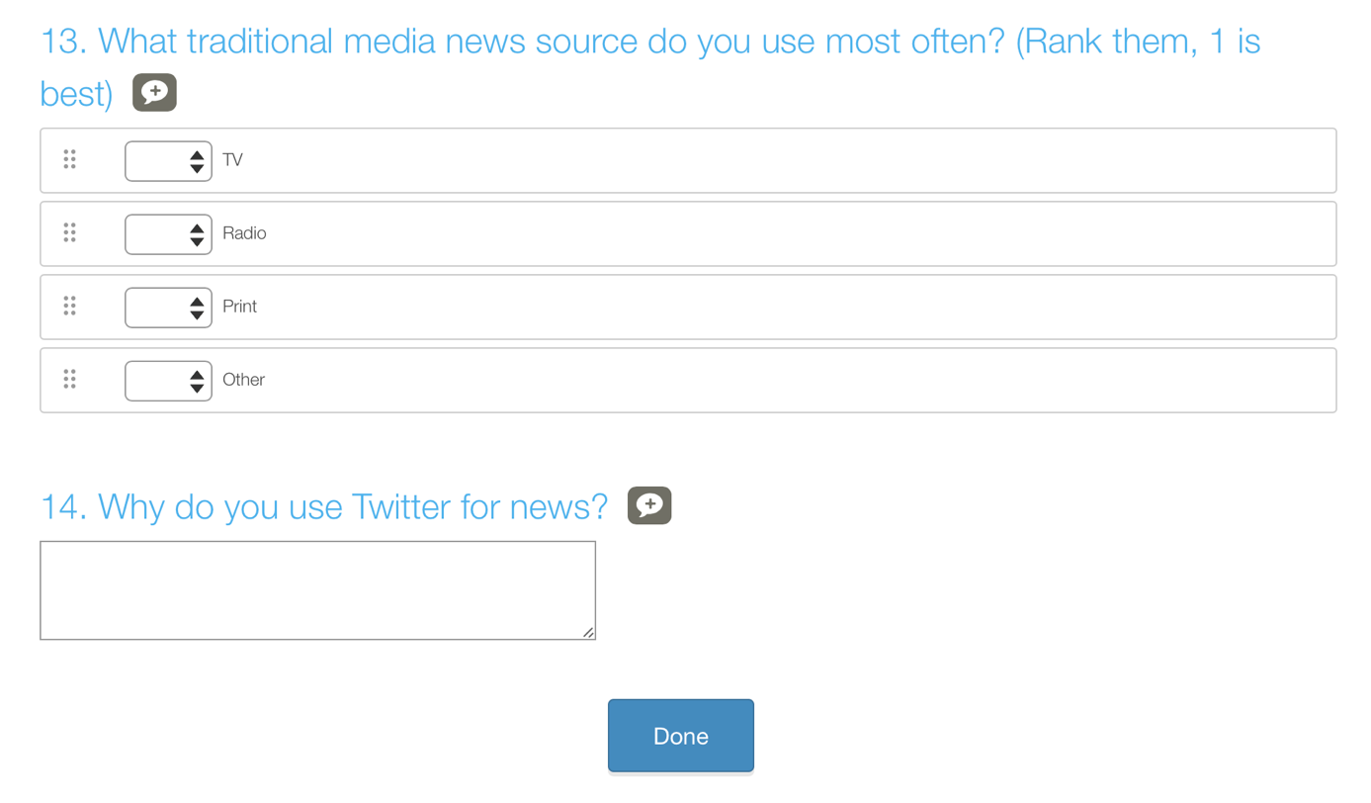

Figure 5.

**References**

Gottfried, J. & Shearer, E. (2016, May 26). News Use Across Social Media Platforms 2016. *PewResearchCenter*. Retrieved from: <http://www.journalism.org/2016/05/26/news-use-across-social-media-platforms-2016/>

Isaac, M. (2016, December 15). Facebook Mounts Effort to Limit Tide of Fake News. *The New York Times*. Retrieved from:<https://www.nytimes.com/2016/12/15/technology/facebook-fake-news.html?_r=0>

MacArthur, A. (2016, October 3). The Real History of Twitter, In Brief. *LifeWire*. Retrieved from:<https://www.lifewire.com/history-of-twitter-3288854>

U.S. News (2017). Most students over age 25. Retrieved from: <https://www.usnews.com/best-colleges/rankings/most-over-25>