**Mini-Training Session: How to Produce a Pop Song in Thirty Minutes or Less**

**By: Lou Guarneri, Christopher Acevedo, Sylvia Auguste, Nicole Freeman, and Iliana Collado**

**MGT363 Professor: Lisa Stamatelos Date: April 14, 2011**

Iliana Collado, Christopher Acevedo, Sylvia Auguste, Nicole Freeman, Lou Guarneri

Professor: Lisa Stamatelos

Assignment: How to Produce a Pop Hit

Date: April 14, 2011

A Music producer doesn’t evolve overnight and neither does a hit song. But any individual with a sincere love of music and a solid grasp of what sells in today’s generation can call him or herself a music producer. A Music producer is responsible for drawing together songs, musical and vocal elements, and sound mixing. The producer combines these factors to fit the current industry trends to construct an organized product for the music market. A music lover should receive a 4-year Bachelor of music degree with a production concentration even though the prime focus should be an honest love of well-crafted recordings. The career definition of a music producer is to oversee technical audio details, leaving musicians to concentrate on making music. Music producers are responsible for the finished work and ensure that musicians’ visions are seen through their art of work. (Education-portal) Life without music would be soundless and monotonous. Life without music producers would emphasize this melancholy.

To become a music producer, the study of music theory is essential when trying to coordinate style, lyrics, and instrumental and vocal arrangements. There are several 4-year bachelor’s degree programs in the United States dedicated to prospective Music Producers. The degree ranges from Bachelor of Music in Music Production and Engineering to Bachelor of Science in Music industry. (Education-portal) There is no specific required educational path to become a music producer, but most producers have an undergraduate degree or college diploma in audio engineering or music management. This educational minimum will give music producers an experience, knowledge of the music industry and a technical background that they will need to succeed in today’s generation.

Music producers are always looking to promote both an artist and their music to stardom; they must possess good judgment and a natural good ear and eye for talent. A music producer must have technical knowledge along with thoughtfulness and good communication skills. Music producers must have the ability to work under pressure and have an extensive understanding of music and new trends. Some of the typical tasks of a music producer are to scout out musical talent for potential recording, find financial backing for the venture, and help musicians throughout the rehearsing and recording stages. Producers also oversee budgets, schedules and plans which help to coordinate day-to-day production in and out of the studio. A music producer’s typical day is sometimes spent of the phone or in meetings with clients and musicians which on most days takes place in a recording studio. The nature of this job can be stressful since hours are irregular and long because recording must be perfect, no matter how many takes it takes. (Schools in the USA) If music producer’s employees were able to produce their own pop song then they could help alleviate some of this stress because they would be cross trained.

In today’s economy competitiveness is the key ingredient to a music producer’s business. The training practices will help a Music producer’s business grow and improve customer service by providing employees with the knowledge and skills they need to be successful. In order to gain this competitive advantage, the music industry must always be a continuous learning environment. (Noe pg.4) Employees must be able to answer the following questions: how does the pop industry produce so many songs in such a small period of time, is it good or bad? How does the altering of songs and sound through auto- tone work? It is essential to have a systematic approach for developing training programs that will enhance a music producer’s work. In this type of industry it is very important to have cross training, so that everyone is able to answer the above questions. (Noe 32) In the next part of this report, a full history and background of the methods that are used in Music Producing will help create a learning organization which will enable all employees to continually acquire and share knowledge. As a business of the music industry we would like everyone to be able to produce their own pop song in thirty minutes or less. In order to produce a hit sensation, it’s extremely in important for us to train ourselves about the pop industry, the programs that are used, and finally relate back to the next person that needs to be trained. This type of training involves continuous learning, because we want our trainees to understand the entire system behind the pop industry in order to work with a music producer or become one. (Noe 5)

HISTORY

Pop culture has evolved greatly because of the advancements in technology and industry capabilities. Over the past forty years, many pop songs have followed a similar structure, mainly in their chord progression, which is an organization of chords into a pattern. In order to understand the functions and chord capabilities of chord progression you must also understand major scales, chord names, chord tones, and chord combinations. A major scale is a scale that has a series of whole steps at the exception of half steps between the third, fourth, seventh, and eighth degrees. (www.dictionary.com) For example, in the C major scale, the key notes are C, so the notes would be as follows C, D, E, F, G, A, B, and C. (Demand Media Studios Contributor for eHow) Next you would move onto chord names; chord names are, “From the notes of the C Major scale, you can extract the tonic (I), subdominant (IV) and dominant (V) chords. These chords are the most common chords used to form progressions in music.” (Demand Media Studios Contributor for eHow) Chord tones focus on the tonic chord (composed of the notes C, E and G) is resulting from the bottom note and every other note up to G. The subdominant chord (composed of the notes F, A and C) is derived from the fourth note in the scale and every other note up to C. The dominant chord (composed of the notes G, B and D) is derived from the fifth note of the scale and every other note up to D (the scale must be repeated).” (Demand Media Studios Contributor for eHow) The last and final step of chord progression is chord combination. Chord combination “can then be realized by creating any combination of the I, IV and V chords. This may include I to V, IV to V, I to IV to V and V to 1.” (Demand Media Studios Contributor for eHow) Perfect examples of chord progression are songs such as, “Don’t Stop Belivin’ ” by Journey, “Under the Bridge” by Red Hot Chili Peppers, “Poker Face” by Lady Gaga, and “Can You Feel the Love Tonight” by Sir Elton John.

WHAT DO THE INDUSTRY PROFESSIONALS USE?

Auto-tuning is a very popular trend in the music industry today, and whether you realize it or not, most artists are somewhat auto-tuned, or pitch corrected. In Melodyne, a vocal line is converted to MIDI, or Musical Instrument Digital Interface, and placed onto a piano roll. There you can simply drag the phrase, or word to the appropriate note value. In Antares Autotune, an entire vocal line is tuned according to the key of the song. In other words, Antares is less specific, and faster, while Melodyne is more in depth. In addition, they might use a program called DAW, or Digital Audio Workstation. Audacity is one of the simplest and user friendly DAWs on the market. (<http://audacity.sourceforge.net/>)

HOW TO CREATE A POP HIT

Now that it’s your turn to create your very own pop hit. To begin the song creating process, download and open Audacity on your computer. Audacity is a forum that is compatible with Windows 98/ ME/ 2000/ XP versions in addition MAC and Linux operating systems. Step 1 will appear like this on your screen.

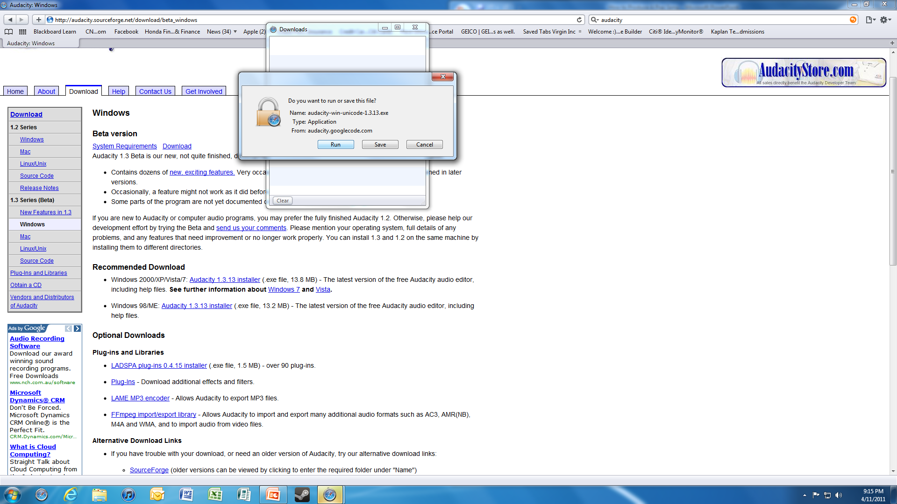

Remember, you must confirm you want Audacity to run on your computer before the download begins.

Step 2, now you can introduce the Melody Track; this song I the beat you have chosen to produce your pop hit too. Step 2 will appear like this on your screen.



Click on *Tracks* on the tool bar and then select *Audio Track*. (more directions needed)

Here is the moment you’ve been waiting for; now it’s time for you to sing on your track. To begin singing you…

Step 3, will appear like this on your screen.



When you’re satisfied with your vocals you can proceed to mix your track using Mix It Up, Step 4.

You’re final Step is to enjoy and share your tune with other. Congratulations you’re on your way to becoming a pop star!

The process of strategic training and development as described previously explains how to become a music producer. Different strategies to gain competitive advantage and edge must help the company reach business goals and objectives. A Music producer doesn’t evolve overnight and neither does a hit song but with continuous learning and training anything is possible.

Works Cited

Contributor, An EHow. "What Is Chord Progression? | EHow.com." *EHow | How to Videos, Articles & More - Trusted Advice for the Curious Life | EHow.com*. Web. 14 Apr. 2011. <http://www.ehow.com/facts_5159356_chord-progression.html#ixzz1JUURoGjB>.

"Music Producers: Job Description and Info for Students Considering a Career in Music Producing." *Degrees, Schools, Online Courses and Careers - Education-Portal.com*. Web. 14 Apr. 2011. <http://education-portal.com/articles/Music_Producers_Job_Description_and_Info_for_Students_Considering_a_Career_in_Music_Producing.html>.

"Music Producer." *Universities and Colleges*. Web. 14 Apr. 2011. <http://www.schoolsintheusa.com/careerprofiles_details.cfm?CarID=1029>.

Noe, Raymond A. *Employee Training and Development*. Boston, Mass. [u.a.: McGraw-Hill, 2010. Print.

*Dictionary.com | Free Online Dictionary for English Definitions*. Web. 14 Apr. 2011. <http://dictionary.reference.com/>.