Griffin Timoney

Politics and Media

I used the issue of the newspaper The New York Times from November 18th. There are seven main headlines on the front page but only a few that have to do with both domestic and foreign issues.

There are two major domestic issues and one foreign issue on the cover of the paper. The domestic issue headlines are “ Lesson Is Seen In Failed Law On Medicare” and “Cheney Sisters In Public Feud Over Marriage” and the foreign issue is “Typhoon Aid Slow to Reach Inland Towns”.

I would have expected more major issues to be on the front page of the NYT. The most important issue was to do with he Philippines but other than that nothing seemed to be as important to me. There were also other stories that I didn’t think fell under either category and were more just informational articles and not major issues.

The only foreign issue that was mentioned was the recent typhoon that affected the Philippines. One of the domestic issues was related to Medicare where the other was related to the Cheney sisters and a family feud that was publicly seen.

I think foreign issues were covered more due to being more relevant right now because of the disaster caused by the typhoon. I feel like that issue is more heartbreaking than something related to Medicare. The typhoon related article does have a picture on the front page where the other main headlines do not. I believe that having the picture this can sway the public’s opinion especially since the article is focused to be sad and is related to a heartbreaking disaster.

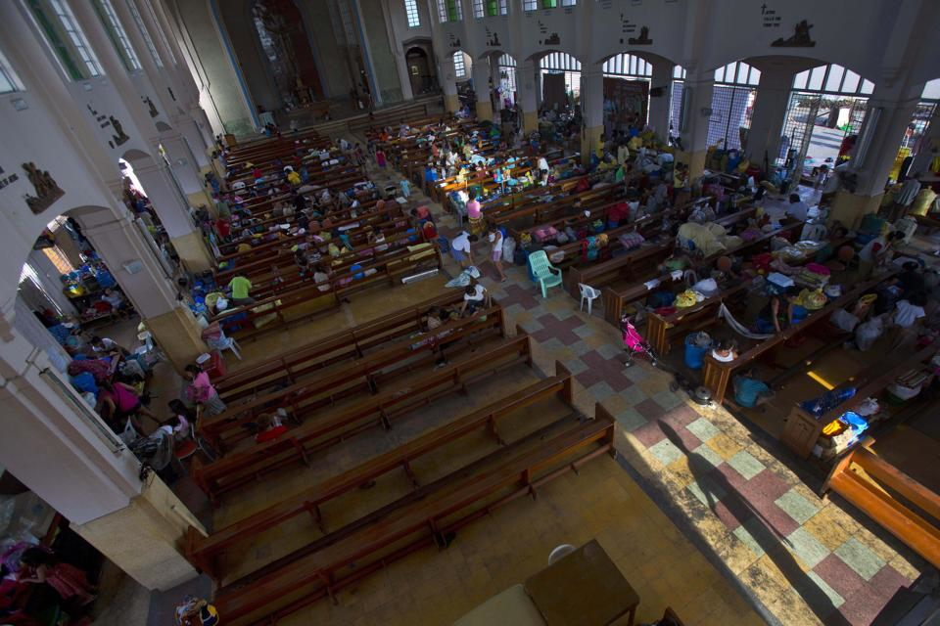

***This is a image of the church that a lot of people have been staying in. It is the same church that is photographed in the NYT.***