**The Utilization of Occupational Therapy in the Armed Forces**

**Alexandra Baker** and Charlene Hoegler

Department of Biology and Health Sciences

Pace University

Pleasantville, New York 10570

**Abstract**

Occupational therapy is a profession that covers a wide range of settings and patients, from children to the elderly, from schools to hospitals or homes. An extremely important area of occupational therapy is with people in the armed forces. Members of the armed forces, whether they are on active duty or not, can benefit from occupational therapy. Therapy can help soldiers who are currently in war zones learn how to deal with stress and traumatic events. Soldiers who were injured in war can benefit from therapy which will teach them how to live their lives as normally as possible. Finally, occupational therapy can help veterans become readjusted to society and can continue to help them with stress management. Treatment for people in the armed forces is the same as treatment for other people, and the therapist is still responsible for finding the best treatment for each person. Treatments can vary from in-office sessions in the field, hospital rehabilitation or in-home exercises. The focus of this paper will be on the different treatment approaches used by therapists for members of the armed forces.

Occupational therapy can be defined as “the therapeutic use of occupations, including everyday life activities…to support participation, performance, and function in roles and situations in home, school, workplace, community and other settings” (Definition, 2014). Many different people may require occupational therapy for a variety of reasons, but one specific group that can utilize this type therapy are soldiers. Furthermore, members of the armed forces can benefit from occupational therapy at different stages in their careers. First, occupational therapists can help soldiers deal with the everyday stress of living in a war zone and dealing with traumatic experiences. Therapists can also help soldiers recover from minor injuries that would not put them out of duty. After a major injury, such as an amputation or traumatic brain injury, therapists can aid soldiers as they relearn how to do everyday tasks that are now much more difficult, such as buttoning a shirt, making dinner, or driving. Lastly, therapists can assist veterans who are assimilating back into civilian life by helping them cope with ongoing stress, or by arming them with skills that can help soldiers live a normal life again. Overall, the goal of therapists for people in the armed forces is the same for other people – to allow individuals to participate in and enjoy their daily lives, and this can be accomplished using an assortment of methods.

The first stage when services members can benefit from occupational therapy services is when they are on active duty. Being in the armed forces can be very stressful, and many service members suffer from combat stress which is “the emotional and physiological stress experienced as a result of exposure to the inherent dangers and demands of serving in a combat environment (Smith-Forbes et al, 2014). Occupational therapists, along with other medical professionals, can help service members deal with combat stress in a variety of ways – though restoration programs, outpatient clinics or prevention programs. Restoration programs are designed to help service members learn basic coping skills to help with the completion of a successful deployment, and usually involve the service member staying at the restoration center for 24 or 72 hours at a time (Fike et al, 2012). Most programs begin daily with physical activity, followed by a multitude of classes on topics like resiliency, anger management, anxiety/post-traumatic stress disorder awareness and positive thinking/problem solving (Smith-Forbes et al, 2014). The classes are all designed to work on those life skills which can help service members in their day to day lives. The program then ends with occupational therapy activity which can include leisure activity, cognitive tasks or physical activity depending on the person (Smith-Forbes et al, 2014). Generally, these inpatient type programs are used to deal with soldiers that have ongoing problems that cannot be fixed with a single visit.

On the other hand, outpatient clinics are useful in cases where service members need to be assessed for minor treatment or go for follow-up visits. Soldiers who sustained trauma not resulting in amputation can be seen in outpatient clinics for “the remediation of their deficits with standard occupational therapy methods” (Doukas and Howard, 2006). While many different medical professionals work with the service members, including physical therapists, psychiatrists, and nurses, the role of the occupational therapist is to “evaluate the service member’s occupational performance and to implement intervention to enhance performance” (Smith-Forbes et al, 2014). Essentially, it is the occupational therapists job to help soldiers reach their optimum performance level, and determine when they can return to active duty. In contrast, prevention programs aim to do just that – prevent combat stress from happening in the first place. Prevention teams often travel to different service units with the hopes of building relationships with service members, and promoting good coping strategies. Building strong relationships can help make the service members feel more comfortable around the therapists in the case of a traumatic or stressful event (Fike et al, 2012).

One of the most significant ways that occupational therapists have helped service members in the restoration programs, outpatient clinics and prevention programs is through the use of animal assisted therapy (AAT). AAT involves using animal assisted activities, usually with dogs, to “provide opportunities for motivational, educational, recreational, and/or therapeutic benefits to enhance quality of life” (Fike et al, 2012). Many studies have found that the use of AAT allowed soldiers to feel more comfortable around the therapists, and that the dogs could also directly help people. For example, Beck et al (2012) found that people “reported feeling more calm and at ease after working with the dogs”. Similarly, Fike et al (2012) observed that people were “more likely to share their concerns, fears, and goals” when the therapy dog was near. Forming good bonds between the therapist and soldiers is important and they dogs play a vital role in that activity. Also, the therapy dogs gave service members a sense of comfort and familiarity that they did not often get overseas. Many soldiers stated that they needed a hug from a therapy dog to make their day better or they just enjoyed playing fetch with them (Fike et al, 2012). This seemingly small acts are very advantageous for soldier’s moral and their sense of well-being, and could not be accomplished without AAT.

The second stage when service members can utilize the skills of an occupational therapist are if they are injured. Soldiers who have served in combat are sometimes injured, with many injuries that lead to amputations or result traumatic brain injuries. In such a case, service members may need an occupational therapist to help them learn how to do everyday activities that once seemed easy or routine. Combat amputations occur frequently in the armed forces and are usually caused by some type of major explosion, such as improvised explosive devices or mines (Melcer et al, 2010). While both upper and lower extremity amputations are common, it has been found that service members with upper extremity amputations are more likely to use occupational therapy while lower extremity amputees are more likely to use physical therapy (Melcer et al, 2010). This is presumably because occupational therapy focuses more on fine motor skills such as those involving the hands while physical therapy focuses on gross motor skills like those used when walking. The main goals of occupational therapists working with amputees include “learning adaptive techniques to complete activities of daily living, establishing equipment needs, and promotion of safety (such as fall prevention)” (Resnik and Borgia, 2013). Therapists also frequently work with amputees to adapt their environment so it is more suitable for their life with a missing limb.

In many cases, occupational therapists also help amputees learn how to live with prosthetic devices. According to Gulick (2011), therapists can provide instructions on how to use prosthetics in basic daily tasks, and can also help integrate the prosthesis into more advanced activities such as driving or sports. One of the most prominent supporters of wounded soldiers is the Brooke Army Medical Center (BAMC) which is using state of the art technology and novel methods to help recovering amputees. Occupational therapists are just one of the many practitioners that work at the center, but their role is fundamental in rehabilitation. One of the unique, and most beneficial, aspects of BAMC is the therapy apartment which has a bedroom, kitchen, living room and washer and dryer. Here, “occupational therapists use everyday chores — like cooking or making a bed — to teach wounded troops to use their prosthetic limbs” (Rawlings, 2011).

In addition to injuries leading to amputations, the second major injury associated with combat is traumatic brain injury. This can also be caused by an explosion, and can be brought on by the impact of the head hitting an object like the ground, or by a projectile actually entering the brain. Traumatic brain injuries can affect service member’s ability to do daily activities by interfering with memory, confusion or poor judgment (Neville and Golisz, 2014). Therefore, an occupational therapist can be utilized to help the service member figure out how to function better and enjoy their lives after their injury. Neville and Golisz (2014) suggest different areas that occupational therapists can assist in which include addressing problems with memory and organization, learning how to control emotions and behavior, being safety conscious, and participating in work or school. Therapists can evaluate problems in each of these areas and make a plan on how an individual can best accomplish each goal, whether it be through therapy sessions, at home exercises or environmental modifications. After an injury, therapists also assist in assessing whether the service member can return to their previous position, if they should be transferred to a different position, or if they should no longer be on active duty (Brown and Hollis, 2013).

The third stage in which service members may need an occupational therapist is when they are leaving the armed forces and assimilating back into civilian life, whether by choice or because of an injury. Not all returning service members have physical or mental disabilities, but they can still face many challenges while transitioning from life in the armed forces back to civilian life (Brown and Hollis, 2013). After being in the armed forces for any amount of time, it can be tough to move back to civilian life where there are no set routines, orders to follow or threat of danger. Because of this, the army developed Warrior Transition Units (WTU) where service members can go when they leave the army to figure how to best deal with this transition. WTU’s incorporate familiar living environments, set daily routines and rehabilitation services for the service members (Erikson, 2008), and an occupational therapist in a crucial member of these units. As stated earlier, occupational therapy is the therapeutic use of everyday life activities to support participation, performance, and function in roles and situations in home, school, workplace or the community. That being said, not all jobs in the armed forces translate well to civilian life (for example a fighter jet pilot), so service members may have a hard time finding meaning in their home or workplace. Therefore, occupational therapists can work with service members to “promote, improve, conserve, and restore the skills, abilities, and aptitudes” that they possess in order to guide them towards their short term or long term goals (Erikson, 2008). In this capacity, therapists can also help service members find activities or jobs that interest them and that can utilize their skills and knowledge.

Occupational therapists in the WTU setting have also been found to be extremely beneficial in early intervention measures. “The stress of combat and returning home can cause maladaptive behaviors” for service members such as alcohol and substance abuse (Brown and Hollis, 2013). Therapists can teach service members how to develop healthy coping strategies, how to maintain good relationships and how to reach out for support. It was also found that early intervention for service members with anger, anxiety, depression or insomnia could also be very advantageous (Brown and Hollis, 2013). Therapists can provide insight into what might trigger these adverse reactions in service members, and teach them how to recognize and cope with them.

Post-traumatic stress disorder (PTSD) is also a big problem for soldiers coming home, and can cause them to have flashbacks, nightmares, and emotional or behavioral changes. Similar to the early intervention methods, occupational therapists can help service members figure out what triggers their PTSD and how to handle it. Yoga is a good example of a coping strategy because it “combines fitness and stress relief for PTSD patients” (Farmer, 2011). PTSD can also play a role in a soldier’s driving abilities because having traumatic flashbacks to war is very dangerous in that situation. The Walter Reed Army Medical Center has developed a program just to help veterans return to driving. According to Hames (2012), “one of the first questions a soldier asks is whether he will be able to drive again”, so it is a big deal for them to regain this independence. Service members with other injuries such as amputations or traumatic brain injuries can also take part in driving rehabilitation (Hames, 2012). Occupational therapists assistance can range from making vehicle modifications to teaching relaxation and coping methods for soldiers behind the wheel.

In conclusion, occupational therapists have been found to be extremely valuable in the armed forces. Occupational therapy can be utilized in many different settings from the battlefield to the home front. Service members on active duty can use therapy to help deal with stress or non-threatening injuries, and one of the most significant ways they do this is though animal assisted therapy. Severely injured service members, such as those with amputations or brain injuries, can use therapy to learn how to regain independence in their everyday lives. And lastly, service members who are no longer in the armed forces can use therapy to help them figure out where they fit in civilian life, and also to help with coping mechanisms for stress or maladaptive behavior. Occupational therapists play an essential role in the rehabilitation of service members throughout their career in the armed forces, and therapists can continue to assist them at home.

**Figures**

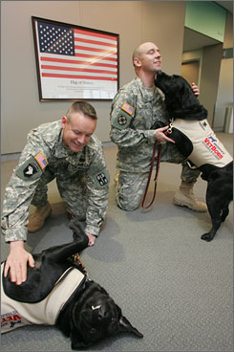

Fig 1: Therapy dogs Boe and Budge playing with their handlers

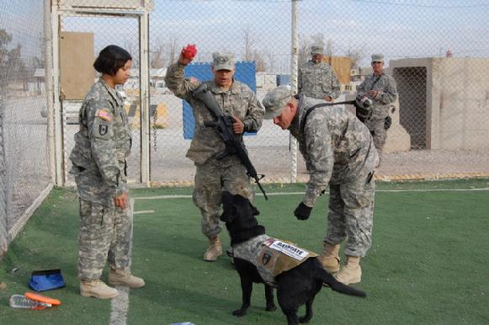

Fig 2: Soldiers playing with a therapy dog

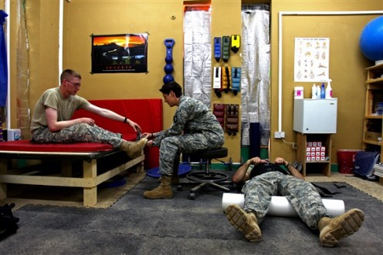

Fig 3: General therapy techniques being utilized by service members

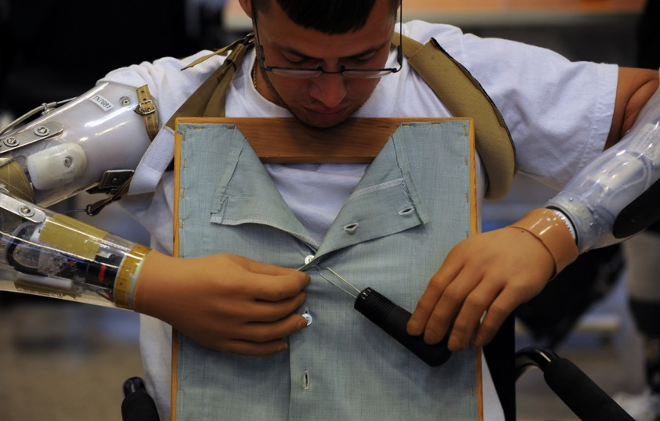

Fig 4: Double amputee relearning how to function in daily life

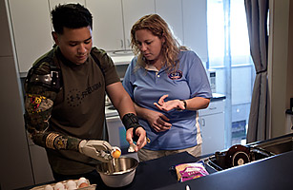

Fig 5: Veteran learning how to crack eggs with his prosthetic

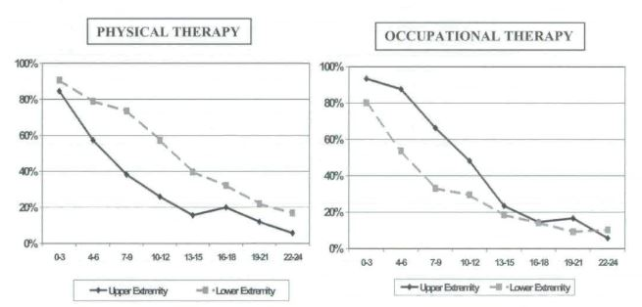

Fig 6: Graphs showing use of PT versus OT after amputation

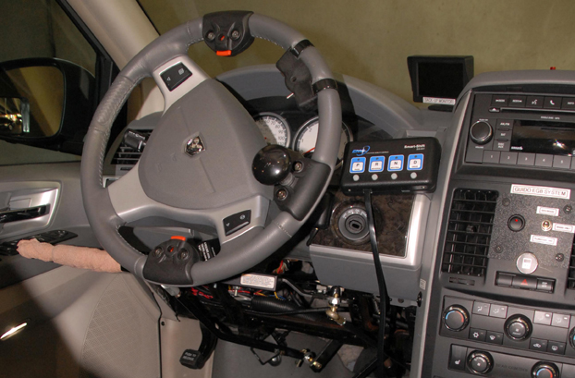

Fig 7: Modified cars allow veterans with injuries to drive

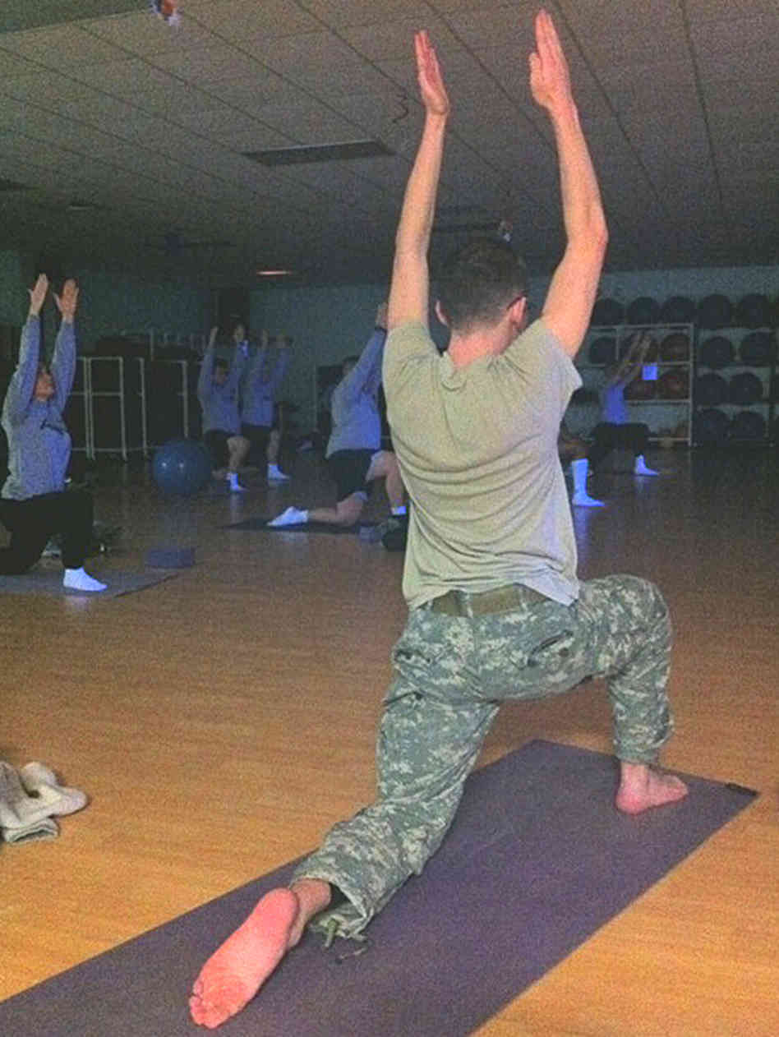

Fig 8: Soldiers learn relaxation techniques such as yoga to cope with stress

**References**

Beck, Christine E, Florie Gonzales Jr, Carol Haertlein Sells, Cynthia Jones, Theresa Reer, Steven Wasilewski, and Yao Yao Zhu. “The Effects of Animal-Assisted Therapy on wounded Warriors in an Occupational Therapy Life Skills Program”. *U.S. Army Medical Department Journal* (2012): 46-50. *Academic Search Premier.* Web.14 April 2014.

Brown, Helen Viola and Vivien Hollis. “The Meaning of Occupation, Occupational Need, and Occupational Therapy in a Military Context”. *Physical Therapy* 93.9 (2013): 1244-1253. *Academic Search Premier.* Web. 24 April 2014.

“Definition of Occupational Therapy Practice for the AOTA Model Practice Act”. *American Occupational Therapy Association*. 16 April 2014. <https://www.aota.org>.

Doukas, William C and William J Howard. “Process of Care for Battle Casualties at Walter Reed Army Medical Center: Part IV. Occupational Therapy Service”. *Military Medicine* 171.3 (2006): 209-210. *Academic Search Premier.* Web. 14 April 2014.

Erikson, Mary W. “The Role of Occupational Therapy in Warrior Transition Units”. *U.S. Army Medical Department Journal* (2008): 20-24. *Academic Search Premier.* Web. 24 April 2014.

Farmer, Blake. “Warrior Pose Part of Rehab for Army Veterans”. *National Press Release.* 20 April 2011. Web. 3 May 2014.

Fike, Lorie, Cecilia Najera and David Dougherty. “Occupational Therapists as Dog Handlers: The Collective Experience with Animal-Assisted Therapy in Iraq”. *U.S. Army Medical Department Journal* (2012): 51-54. *Academic Search Premier.* Web. 14 April 2014.

Gulick, Kristen L. “Rehabilitation for the Person with an Upper-Limb Amputation”. *American Occupational Therapy Association* (2011). 26 April 2014. <https://www.aota.org>.

Hames, Jacqueline M. “On the Road to Recovery”. *Soldiers: The Official US Army Magazine.* 30 November 2011. Web. 3 May 2014.

Melcer, Ted, Jay Walker, Michael Galarneau, Brian Belnap and Paula Konoske. “Midterm Health and Personnel Outcomes of Recent Combat Amputees”. *Military Medicine* 175.3 (2010): 147-153. *Academic Search Premier.* Web. 24 April 2014.

Neville, Marsha and Kathleen Golisz. “Adults with Traumatic Brain Injury”. *American Occupational Therapy Association* (2014). 24 April 2014. <https://www.aota.org>.

Rawlings, Nate. “Rehabilitating Wounded Warriors”. *Time Magazine.* 11 November 2011. Web. 26 April 2014.

Resnik, Linda J and Matthew L Borgia. “Factors Associated with Utilization of Preoperative and Postoperative Rehabilitation Services by Patients with Amputation in the VA System: An Observational Study”. *Physical Therapy* 93.9 (2013): 1197-1202. *Academic Search Premier.* Web. 14 April 2014.

Smith-Forbes, Enrique, Cecilia Najera and Donald Hawkins. “Combat Operational Stress Control in Iraq and Afghanistan: Army Occupational Therapy.” *Military Medicine* 179.3 (2014): 279-284. *Academic Search Premier*. Web. 14 April 2014.