Strategizing Social Media at

Promoting Health in Haiti

Elena Roye

Pace University

November 1, 2015

Introduction: Social media can be utilized to help perpetuate a business or in our case a non-profits’ outreach. We are in constant need of finding potential donors and advocates for our organization. It would be in our best interest to consider new social media techniques to increase our profits and funding. Currently we use face-book as our only and primary social media outlet. While Facebook is a great platform to utilize, we are limiting ourselves of opportunity. Research indicates there are many ways to improve your posts on social media. “It’s important to choose an [image](http://www.socialmediaexaminer.com/how-to-create-social-media-images-that-connect-with-your-audience/) that expresses what you’re trying to say in your post. For example, Red Bull’s Instagram images inspire their followers to enjoy life and seek new adventures.” (Harman 2015) We must utilize images that captivate emotion and make our audience empathize with that emotion. Another great point made in this article is color coordination “Before you start sharing your content on social media, you should choose a color that is synonymous with your brand. Your [color choice](http://www.socialmediaexaminer.com/improve-facebook-ads/) not only represents your business but also impacts your followers on a psychological level.” (Harman 2015)

Situation Description:

Promoting Health in Haiti is doing an analysis of its social media practices. Currently we are utilizing Facebook as our only social media outlet. Our Facebook presents updates of our organization’s accomplishments. We keep our audience up to date with the latest news. We also use Facebook to inform our viewers of current news happening in Haiti. Lastly, it is used to spread the word about our fundraisers, and events that are taking place. The best practices for using social media in our organization is to let people know that we are achieving our goal and that we are changing the health-care system in Haiti. It serves as a constant reminder that our organization exists and we strive to meet all of our goals.

Currently, Facebook is the only social media outlet Promoting Health in Haiti is utilizing. Our founders, social media managers, and nurses contribute to this Facebook page. We also include articles written by people in the organization, and others found online that are relevant to our work. Some examples of successful posts are ones that are hopeful and exhibit the change that is taking place in Haiti.

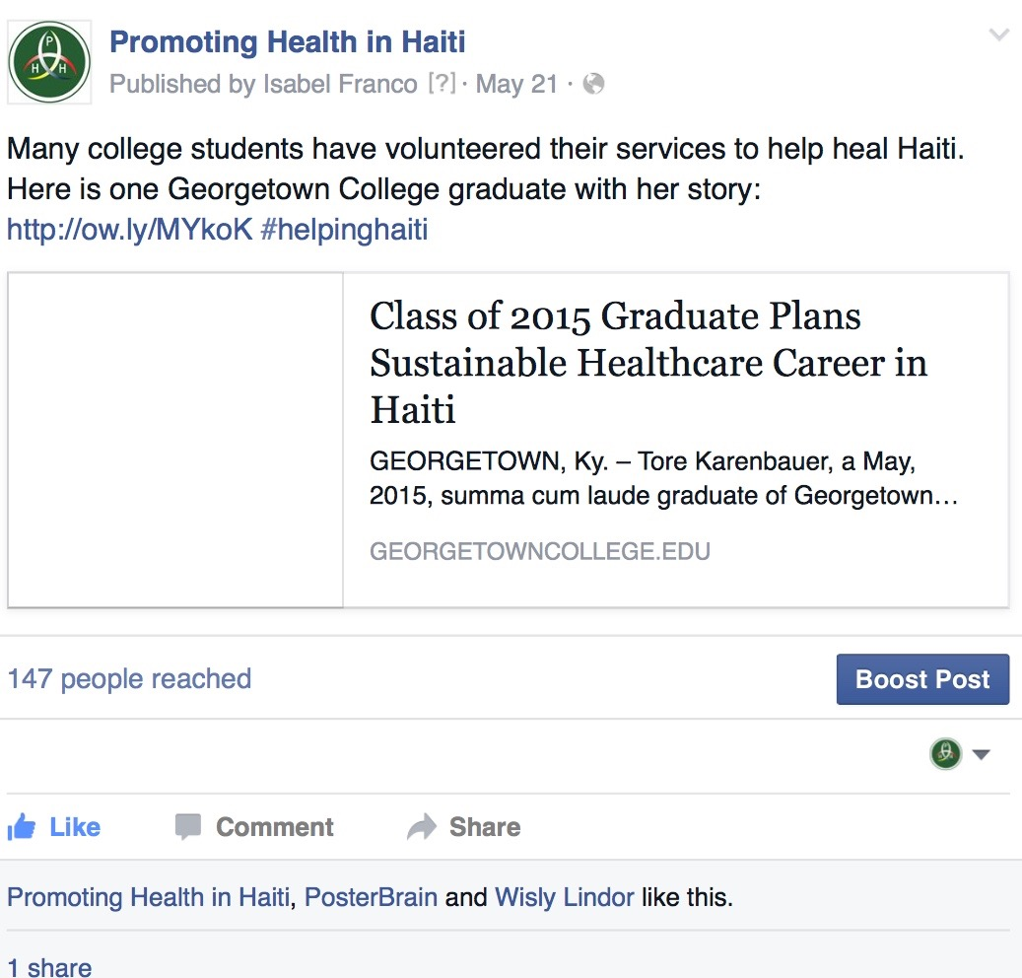

Similarly, to our organization, Hands up for Haiti uses Facebook to inform viewers on what they do and what success they have during their trips to Haiti. They utilize many photos of their trips to inspire their audience even more.

<https://www.facebook.com/HandsUpForHaiti>

Potential courses of action:

PHH’s Facebook page should have more posts written frequently. Facebook should be our primary medium to reach potential donors and advocates for our organization. “Facebook is the biggest social network out there, both in terms of name recognition and total number of users. With over 1.39 billion active users, Facebook is a great medium for connecting people from all over the world with your business.” (Helmrich 2015) The more the audience sees our page in the newsfeed, the more attention we will receive. Different content may add more color and interest to our page, such as photos, videos, news-stories, and inspirational posts. Expanding our platforms will increase our traffic to our website, and may in turn increase our donations. Using numerous platforms will reach more people. In order to accomplish our goals and adhere to these changes, we may need to hire a team of PR and social media managers. This ensures that our media is up to date. The good news about utilizing Facebook as our primary social media outlet is, “Additionally, Facebook is a lot more low maintenance in terms of posting frequency — whether you post several updates a day or only a few a week won't make much of a difference in terms of what your fans think of you.” (Helmrich 2015) They should be finding articles relevant to our organization, and Haiti as a country, as well as health-care. We should be sharing updates and accomplishments that are being made to ensure our donor’s money is being used effectively. Twitter is a great outlet to utilize (which we currently don’t have) because it reaches people around the world as stated, “You can also easily interact with other users by mentioning their usernames in your posts, so Twitter is a great way to quickly connect with people all around the world (the platform has more than 500 million users worldwide)”. (Helmrich 2015) Instagram is also low-maintenance because we can connect our Facebook to our Instagram. There will be an album titled Instagram, and via face-book, we can gain more followers on Instagram. You-tube should be used to share our documentaries that have been made in Haiti. These links should be discussed and shared on all of our social media outlets.

Conclusion:

We should adjust our social media strategy. Facebook should be updated every day. We must add heart-wrenching stories (from our nurses who grew up in Haiti, or found online), as everyone loves a good story. We should use more photos, and videos because we are visual people, especially online. People would much rather see compelling photos, and watch an interesting short film, or interview, than to read a story. We should increase our platform usage. We should add twitter, Instagram, and You-tube. This will put our organization more in the spot-light because we will be reaching more potential donors.

References:

Wade Harman (2015) 5 Psychological Tips to Improve Your social Media Posts (Article) Retrieved November 1st, 2015 from <http://www.socialmediaexaminer.com/5-psychology-tips-to-improve-your-social-media-posts/?utm_source=Facebook&utm_medium=FacebookPage&utm_campaign=Evergreen>

Brittney Helmrich (2015) Social Media for Business: 2015 Marketer’s Guide (Article) Retrieved November 1st from <http://www.businessnewsdaily.com/7832-social-media-for-business.html>