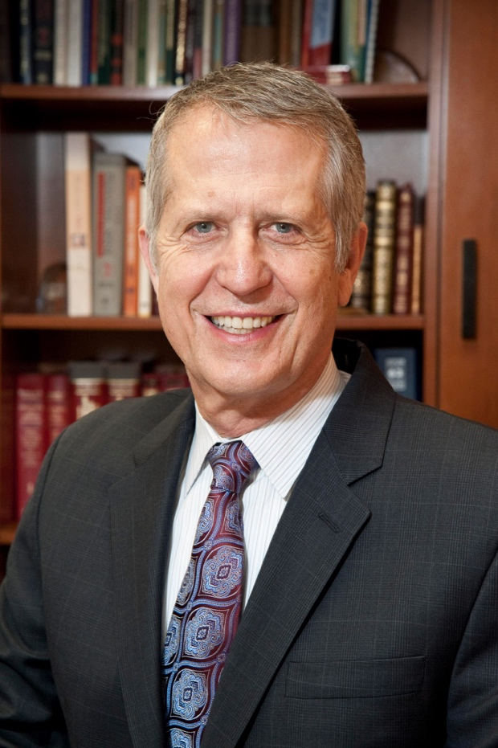

**Proposal:**

**Story Pitch:**

David Roye (my father) is a remarkable human being. He is a pediatric orthopedic surgeon at Children’s Hospital, New York Presbyterian Hospital/Columbia University. His career-choice is brave, and humble. He has gotten awarded Humanitarian four years ago. His patients are very close to his heart. It amazes me to see the impact he has made on people’s lives. There have been countless posts on social media (mostly facebook), thanking him for all he has done for their family. He provides amazing health-care to children, but is also a hero to them. He is charismatic, charming, and brilliant.

Additionally, he is a founder of a non-profit organization called Children of China Pediatric Foundation. He and his team go to China and better the health-care system. They perform “free” surgeries on needy children, some whom are orphans.

My documentary would be about him. It will start off with his childhood and how he became who he is today. It will then progress into his work-life, and all he has done. This will be echoed by his patients whom I will interview. The film will then talk about his non-profit which is important to him.

An example of a post on **social media** follows:

“When I dragged open my eyes in the ICU, pain fuzzing every muscle and thought like smoke and fire, he was sitting at my bedside in a white jacket and tie, looked at me lovingly, frowned, and said, "Do you hate me?"

God. No. I could not love him more.

He saved my life and ensured ALL of you more years of Shea than you otherwise would be given. Dr. [David Roye](https://www.facebook.com/david.roye), you are the feature this week. In this extra life you have granted me, I promise I'll make you proud.

I love you, and thank you for straightening me out.”

I want this documentary to showcase all he has done for people of New York and China. He is making global change and remaining humble through it all. I have no doubt he will reveal himself, and express himself fully and confidently to the camera.

In terms **of B-rolll** (if this is doable)

I would get shots of David talking to patients and examining them.

If not:

I will shoot him communicating with his fellow doctors (to show how personable he is)

Him walking into the building, and to his office

I will take establishing shot of the building (outside, and inside)

**List of Questions:**

1. Where did you grow up? What was it like growing up?
2. What was it like being drafted into the army? Did it influence your decision to go into the medical field?
3. When did you realize you had a calling/passion for this career-choice?
4. What was your biggest obstacle to becoming a doctor/surgeon?
5. What relationship do you have with your patients? Have they impacted your life?
6. What gave you the idea to create this non-profit
7. What were some obstacles you had to over-come to produce such a successful non-profit
8. What is it like giving talks around the world?
9. How has CCPF changed your life?
10. What do you hope your work in NYC, and China will do? Do you think you and your team are making global changes?

**Questions for Patients:**

1. What was it like being told you had to get surgery? What feelings did you have?
2. Did Dr. Roye facilitate this process? If so, how?
3. Do you feel that Dr. Roye has impacted your life?
4. How has Dr. Roye changed your life, physically
5. What would you say to Dr. Roye, right now, if you could?

**Production Pitch:**

* I will be working alone, as it will make this process easier (the times are very strict, for example, a 5 am shoot/and a 10pm shoot)
* Lavalier microphone
* Boom Mic (as back up)
* Canon 6D
* Tripod
* XLR cable
* (I have my own light set) Two key lights and one fill
* I will be shooting Wednesday October 20th, Monday October 26th, and Friday October 30th