Griffin Timoney

Blog HW Assignment

This week there is an issue where headlines are now reading “ the government is shutting down.” This is due to the current issue of ObamaCare and the fact that the political parties have not made an agreement on a budget. This is a large issue right now for the country because if the government does in fact shutdown, the people of this country will experience several issues that I do not think they will expect. Some jobs that would be affected would be the postal service, the military, and border patrol. These jobs will not be terminated but the workers will not be paid. As well as the national parks and monuments will closed. The House has made it clear that they will stop all funding for ObamaCare unless something is done to realize that it is costing too much money.

**"We're going to continue to do everything we can to repeal the president's failed health care law," said House Speaker John Boehner, R-Ohio. "The law is a train wreck."**

In my opinion, I believe that the media is doing a good job with keeping the public up to date with information about this issue. The people need to know what is going on because if the government does shut down then the people will be affected by it in multiple ways

[How Will The People Be Effected](http://www.cnn.com/2013/09/23/politics/government-shutdown-daily-life/)

[Trying To Avoid The Shutdown](http://www.cnn.com/video/data/2.0/video/bestoftv/2013/09/23/government-shutdown-acosta-newday.cnn.html)

***Image from the Shutdown in 1995***

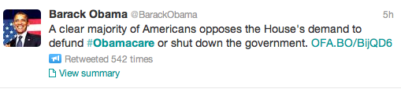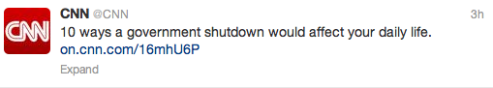Yes, this is what Obama “promised” when he was elected to office and unfortunately for him it isn’t working out the way it was planned. The law is costing America a lot of money and not having the benefits it should. I think the media needs to cover this issue even more because of the fact of the short amount of time until the government would in fact close down. So far I personally have been using CNN to see if there are any updates. This topic is being spoken about on twitter, mostly sharing articles and tweets from The White House and the President’s account.

One republican that is a strong voice about defunding Obama is Senator Cruz. He has been on twitter trying to express his view on the situation. This is a awkward situation because of the fact that the majority of democrats are obviously for obamacare and then even some republicans are now more for obamacare funding rather than the government shutting down as of October 1st. These are both two extremes and the fact that there is no middle option makes me nervous because the government should be able to reach an agreement instead of such drastic options.

In addition, I feel that even though the news is covering the issue, that the American people aren’t as aware of the issue. I think that the people need to be kept up to date about the possibility of this actually happening.