Megan Morse

February 18, 2013

Media Invasion of Privacy

Coco Austin sex tape being shopped for $100K

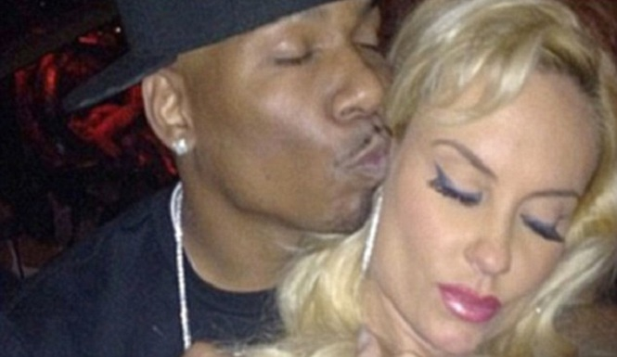

<http://www.inquisitr.com/516304/coco-austin-sex-tape-ap9-says-possibly-pregnant/>

Representatives of Rapper AP.9 whose real name is Kenneth Huddleston contacted Publicist Kali Bowyer asking for “help to promote and sell pictures and video of Coco Austin above the 100k offer.” The Publicist told RumorFix the rapper claims he “has various pics, audio and footage of him placing his hand into her private parts, acts of oral sex, doggy style positions with miscellaneous graphic exploits and sexual conduct.” Bowyer declined to take the job saying, “I will NOT engage in something so crude and disgusting, I have no hesitation in blowing the lid off his intentions.”

Ap.9 is persistent on ruining Coco’s marriage to rapper Ice- T. Not only is he claiming to have naked pictures of her, he is also claiming they had unprotected sex and is pregnant with his child. Ap.9 is a relatively unknown rapper, this could all be, and most likely is a ploy to get more credibility by going after one of the most influential and respected rappers of all time.

This is an invasion of privacy because sex tapes were not made for the public to see or know about. The fact that nobody has seen the tape and the owner of the tape is shopping around for who will pay the most amount of money makes this story hard to believe.