**Summary:**

Donald Trump produced an [apology video](https://twitter.com/realDonaldTrump/status/784609194234306560) after the release of an increasingly disturbing [sound-bite](https://www.facebook.com/attn/videos/1154713107897480/). As he was on a bus with Billy Bush to do a cameo on a soap opera, his words were captured on mic, recounting his experience with a woman, “I moved on her like a bitch….and she was married.” He proceeds, “When you are a star you can do whatever you want including, “grab them by the p***y.” People are (rightfully so) offended, and repulsed by his actions. Trump’s video apologizing to the citizens of the United States was released shortly after. His specific goal in producing this video was to seek the forgiveness and acceptance of the U.S.

It appears however, that the latitude of rejection is a huge obstacle for him to overcome. The anchor of most people prior to the apology speech, was that Trump was wrong, and that there wasn’t much to be said or done to fix this. Trump’s apology contained statements that were both indirect and unspecific. He stated that he never said that he was a perfect person, he pledged to be a better man tomorrow, and swore that anyone who knew him knew that those words do not reflect him.

He then resorted to cause-effect pattern in which he makes accusations about Hillary and Bill Clinton. He tries to persuade people into thinking that voting for Clinton is far more dangerous that what he has said or done. He says, “Hillary Clinton and her kind have run her country into the ground.” Later, he claims that Bill has abused women at the hands of Hillary’s threats, (that the women must remain silent). The outcome of this apology video was unsuccessful. According to CNN, “…Top Republicans in marquee Senate races, including New Hampshire Sen. Kelly Ayotte and Rep. Joe Heck of Nevada, said they could no longer support Trump.”

Furthermore, [Mike Pence cancelled a political event](http://www.nbcnews.com/politics/2016-election/mike-pence-stands-after-trump-disinvited-n662436) in which he would speak on this issue and represent Trump. Pence announced, “As a husband and father, I was offended by the words and actions described by Donald Trump in the 11-year-old video released yesterday." Paul Ryan even disinvited Trump to his campaign event, stating, “…He is bragging about sexually harassing women…” Ryan proceeded to say that he wishes Trump would stand down.

CNN also reports, “House and Senate members [rescinded their endorsement](http://www.cnn.com/2016/10/08/politics/donald-trump-video-women-remarks-republicans/index.html) of Trump in increasing numbers -- and others were sure to follow.” John McCain withdrew his support for Trump. Jeb Bush tweeted, "As the grandfather of two precious girls, I find that no apology can excuse away Donald Trump's reprehensible comments [degrading women](http://www.cnn.com/2016/10/07/politics/donald-trump-respect-women/index.html). Lastly, Kelly Ayotte also explained that she cannot support someone who “brags about degrading and assaulting women.”

**Opinion:**

People are still outraged by this event, and the apology video may have fueled more hate rather than remorse for Trump. In my opinion, it was not a success. I believe that this speech was a manuscript speech. It sounded and read like a script, and was by no means sincerely apologetic. I feel that Trump did not take into account his demographic audience, which consists of many women. Also, people watching this are mothers, fathers, and daughters. He should take into account that this is an insult to everyone’s daughter, mother, etc. I don’t believe he did this, when addressing his audience. Trump’s general purpose with the video was to sustain his position in the election, as well as to keep his supporters. Based on the evidence stated in the summary, his purpose was unfulfilled. I believe the main reason for this is that Trump remains blind and ignorant towards listener’s attitudes. Had he been more sympathetic and understanding rather than defensive, perhaps he would have succeeded more. Similarly, he was either uninformed or didn’t care about citizens’ anchor. Page 253 summarizes my opinion, “If listeners feel hostile or indifferent, your approach won’t be the same as the one taken if they are excited to hear from you.” (Pg. 253) He did not take this into consideration and alter his approach when addressing so many offended citizens.

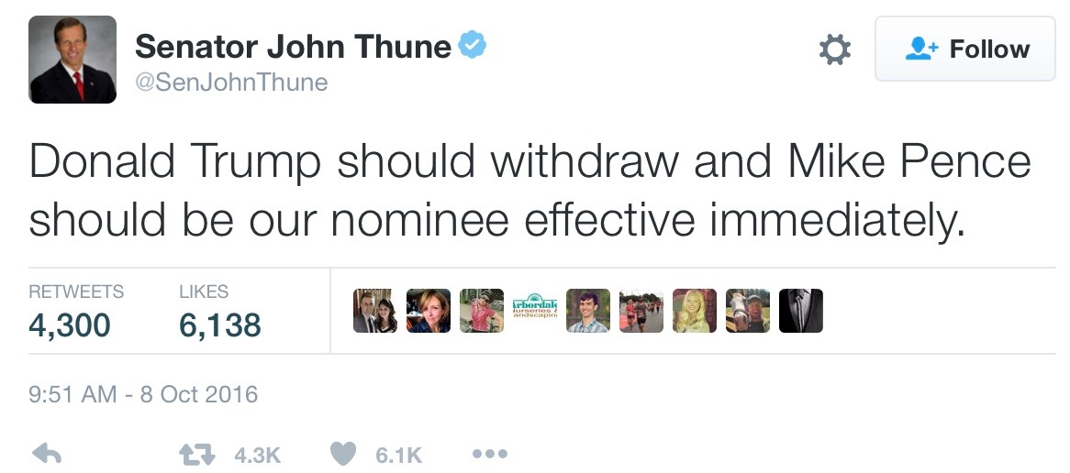

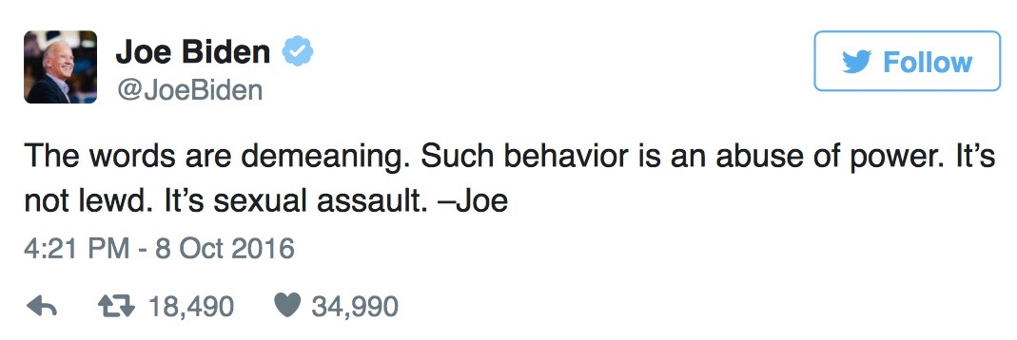 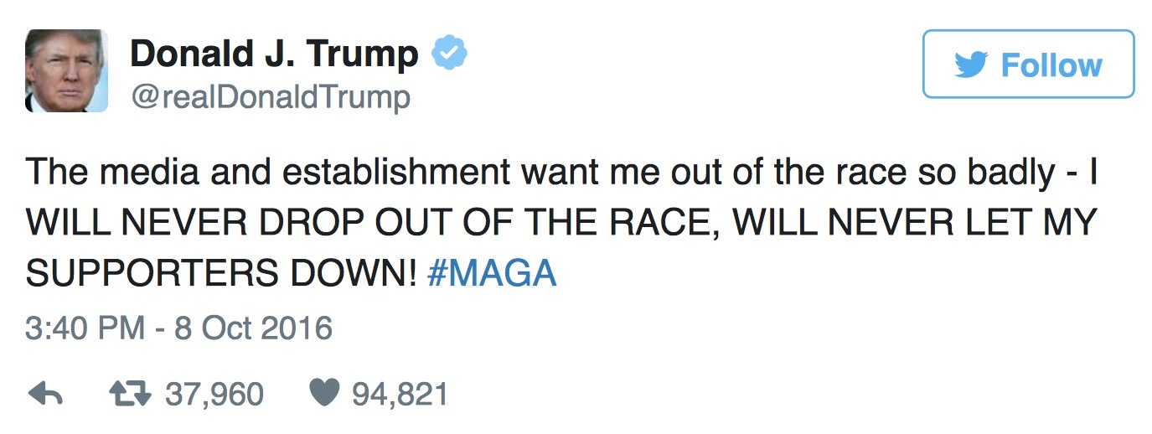

-Elena Roye

**References:**

<http://www.cnn.com/2016/10/08/politics/sean-spicer-donald-trump-women-remarks/index.html>

<http://www.nbcnews.com/politics/2016-election/mike-pence-stands-after-trump-disinvited-n662436>

<http://www.cnn.com/2016/10/08/politics/donald-trump-withdraw-republicans-race/index.html>

<http://www.cnn.com/2016/10/07/politics/donald-trump-campaign-crisis/index.html>

<https://twitter.com/realDonaldTrump/status/784609194234306560>

<http://www.cnn.com/2016/10/07/politics/donald-trump-respect-women/index.html>

<http://www.cnn.com/2016/10/07/politics/donald-trump-republicans-endorsement/index.html>

<http://www.cnn.com/2016/10/07/politics/donald-trump-republicans-endorsement/index.html>

<https://www.facebook.com/attn/videos/1154713107897480/>