Determining the Genotype of Zebrafish with a Laminin

Gene Mutation

Alex Baker

Genetics

Dr. Horne

ab11129n@pace.edu

Biology Department

Pace University

**Abstract**

When one organism differs from the normal “wild type” organism, it can be inferred that the different organism has a different genetic makeup. In this experiment we used two groups of zebrafish embryos, normal and mutant, in order to determine the genotype of the normal fish and to determine whether the mutant gene was dominant or recessive. Before we started the experiment we knew that the parents, named Lary, carried a genetic mutation that caused a mutant phenotype in some of their offspring. The gene we looked at was Laminin, which is known to function in making structural proteins. To determine the genotype we first made an observation of the number of normal versus mutant embryos and using a statistical chi-squared test, we determined what the genotype must be. Secondly, we directly determined the genotype by using the polymerase chain reaction (PCR). We then analyzed our PCR products by running agarose gel electrophoresis. Our results show that the normal fish had heterozygous genotypes and that the gene that causes the mutation is recessive. When we analyzed our PCR products, it showed that all of the mutant embryos had the mutant gene while only some of the normal embryos had the gene, which is what we hypothesized would happen. Overall, these experiments show that the mutant laminin gene causes a structural abnormality in a small number of zebrafish progeny.

**Introduction**

A gene is a segment of DNA that codes for a specific trait and for every gene, there can be two versions: a dominant version which shows up phenotypically and a recessive version which is hidden and does not show up phenotypically. An organism can have two dominant alleles, two recessive alleles (both homozygous) or one dominant and one recessive allele (heterozygous). For this experiment, we were studying zebrafish (Danio Rerio). Zebrafish are a good organism to use because they mate and grow fairly quickly and they can be easily viewed when they are in the embryonic stage.5 The rational for this experiment was that we needed to isolate the DNA of the zebrafish in order to determine the genotype to discover more about the mutation on the Laminin gene.

We were presented with embryos from a cross of two phenotypically normal zebrafish, which were named Lary, but their genotype was unknown.3 To directly determine the genotype we first did a polymerase chain reaction. PCR is an important technique used to extract DNA from an organism. Along with the extracted DNA, we added a viral primer that would attach to the mutant gene so we would be able to see which embryo had the mutant gene and which ones did not. Next, we used agarose gel electrophoresis to test our PCR results. In gel electrophoresis, charges are passed through the gel which separates the negatively charged DNA molecules from the other molecules in the sample. In a process called molecular sieving, the smaller molecules pass faster and farther through the gel then larger ones and this creates bands of DNA; the sizes of the bands can then be compared to a standard sample. From these tests, we concluded the genotype of the zebrafish.

At the beginning of the experiment we knew that the mutant fish had a mutation in a gene called Laminin.4 One form of the laminin gene is laminin-111 which is a basement membrane protein and is required for early muscle development.1 It was also found that laminin plays a distinct role in different aspects muscle development and muscle differentiation is slightly abnormal in embryos deficient for the laminin gene.1 In a previous study, a non-sense mutation in the zebrafish lama5 gene (one form of the laminin gene), prevents laminin alpha5 from interacting with its cell surface receptors. Analysis showed severe morphological abnormalities and defects of the developing fin fold at 36 hours post fertilization.2 This reveals that a loss of function mutation in laminin genes cause mutant phenotypes to form.

**Materials and Methods**

The protocols for all lab procedures were provided on handouts by Dr. Horne.3, 4

For the first part of the experiment, view the progeny of a mating of two Lary zebrafish that was set up by the professor. View the embryos when they are approximately 96 hours old. First, determine the phenotypes by looking through a dissecting microscope. Then put a drug in the petri dish to stop the fish from swimming and take a digital picture of them. Pipette the mutant fish into one petri dish while counting them and pipette the normal fish into another petri dish while counting. Then make a hypothetical punnett square to find the expected ratio of normal to mutant fish. Next, do a chi-square analysis of the data to see if the expected and observed values are close. Make a hypothesis for what the genotype of the Lary fish could be and determine a cross that could be used to test the hypothesis. Make a punnett square for this cross and have the professor set up the mating. After the mating of the hypothetical cross, view the progeny when they are approximately 96 hours old. Look at the embryos through a dissecting microscope. Count all of the normal embryos and determine whether the hypothesis is true or false.

For the second part of the experiment, do a PCR genotyping of the embryos. First, get two petri dishes with the drug to stop the embryos from swimming and put four normal embryos in one and two mutant embryos in the other dish. Then put the dishes on ice to euthanize the fish. Next, put the dead embryos in separate 1.5 mL microcentrifuge tubes, remove the excess drug with a micropipette and add 50 µL of extraction buffer to each tube. Then put the tubes in a 55°C water bath for fifteen minutes then vortex each tube. Return the tubes to the water bath for another fifteen and vortex again. Put the tubes in a 95°C water bath for ten minutes. Next, measure materials for the six 0.5 mL PCR tubes (19 µL water, 2µL laminin primer, and 2µL viral primer). Remove the other tubes from the heating block; add 150 µL water to each and vortex. Then add 2 µL of the prepared DNA solution to each PCR tube and also add 25 µL of PCR mastermix to each tube. Put the PCR tubes into the PCR machine and run the program: 1 cycle at 94 °C for 2 minutes, 33 cycles at 94°C for 15 seconds, 60°C for 30 seconds and 72°C for 1 minute and 1 cycle at 72°C for one minute.

Next, run a gel electrophoresis to test the PCR results. First, calculate the amount of agarose needed for a 1% solution (1% = x/50 mL, x = .5 grams). Then weigh out 0.5 grams of agarose and mix it with 50 mL of TAE buffer. Next, microwave the solution until the agarose is completely melted (about 75 seconds), let it cool and then pour it in a gel box. Prepare the samples for the electrophoresis: label four tubes “normal” and two tubes “mutant”, add 15 µL DNA sample to each tube and add 3 µL loading dye to each tube. After the gel hardens, pour buffer over it then load 15µL samples into the wells (6 samples and 1 standard). Let the gel run for 45 minutes and then take a picture of the completed gel. Next repeat the same PCR procedure from above with one mutant embryo, three normal embryos and one control (control is a known sample of DNA).

Lastly, repeat the gel electrophoresis on the second set of PCR samples. Again weigh out 0.5 grams of agarose and mix it with 50 mL of TAE buffer. Then microwave the solution until the agarose is completely melted, about 65 seconds, let the solution cool and then pour it in a gel box. Prepare the samples for electrophoresis: label three tubes “normal”, one tube “mutant” and one tube “control”, add 15 µL DNA sample to each tube and add 3 µL loading dye to each tube. After the gel hardens, pour buffer over it then load 15µL samples into the wells (5 samples and 1 standard). Let the gel run for an hour and then take a picture of the completed gel.

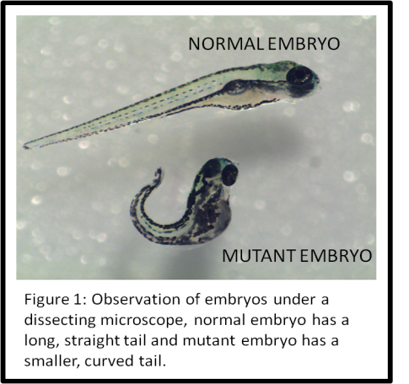**Results**

When we observed the embryos at 96 hours post fertilization, we saw two clearly defined phenotypes (Figure 1). One phenotype was that of a normal embryo which had a long, straight tail. The other phenotype was that of a mutant fish which had a shorter, curved tail. When we counted the number of each phenotype in our petri dish, we got 22 normal embryos and 10 mutant embryos. It was important to carefully count each phenotype so we could get accurate numbers in order to make a hypothesis of the genotype.

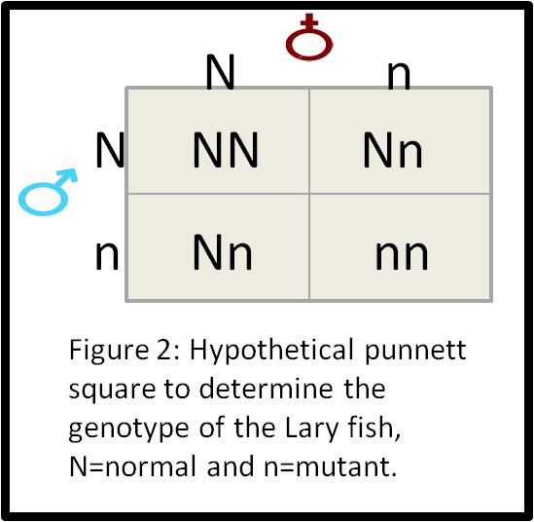We then made a punnett square to hypothesize what the genotype of the Lary fish were (Figure 2). If the Lary fish was heterozygous (Nn when “N” is normal and “n” is mutant), than that would give the offspring a ratio of 3 normal fish to 1 mutant fish; we compared that ratio to the embryos that we counted and deduced that that genotype was the most probable. If the Lary fish were either NN or nn, the offspring would be all normal or all mutant, respectively, which was not the case.

Next we did a statistical chi-square analysis test on our data to see if it fit the expected numbers (Figure 3.1). We had a total of 32 fish so there should have been 24 normal fish and 8 mutant fish. The calculations show that this data had a chi-square value of 0.667 which is in the 20% - 50% range which is good which means that the number of fish we observed was close to the number of fish we should have expected if we hypothesized the genotype correctly.

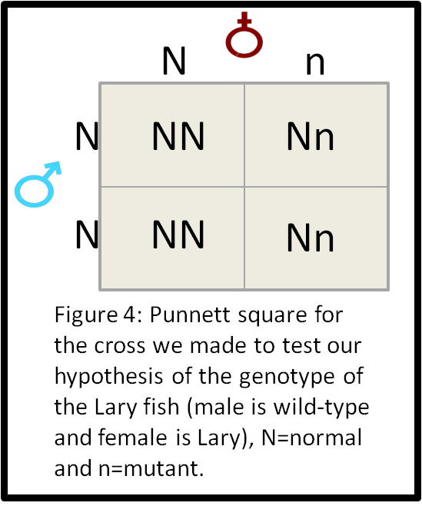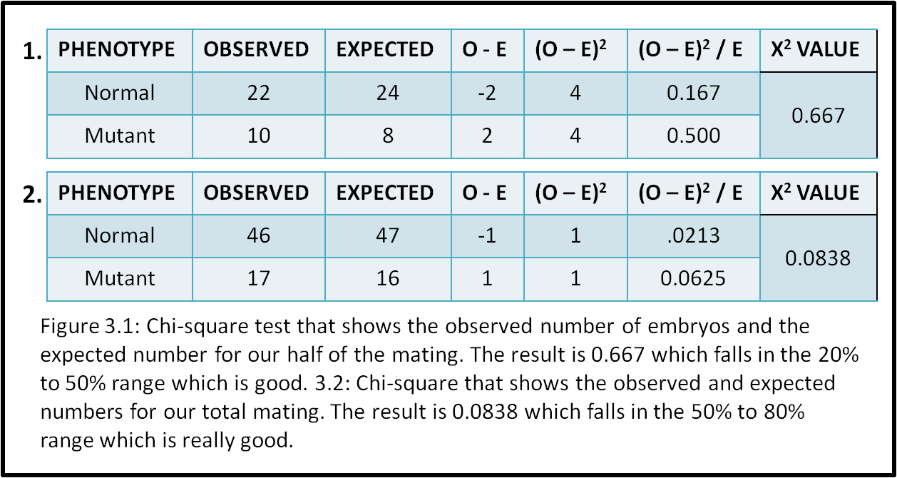Next we had to add the other half of the data from our mating pair because it was counted by another group. The other group counted 24 normal embryos and 7 mutant embryos so for the total of our mating pair we had 46 normal and 17 mutants. We then did another chi-square analysis on the total data (Figure 3.2). The total was 63 so we should have expected 47 normal embryos and 16 mutant embryos. The calculations show that the total data had a chi-square value of 0.0838 which is in the 50% to 80% range which is really good because the observed numbers were really close to the expected numbers.

Then we had to make a second punnett square that showed the hypothetical cross we chose to test if the Lary fish were really heterozygous, Nn (Figure 4). We chose to do a cross between a Lary fish, Nn, and a wild-type fish, NN. That way if all of the offspring were phenotypically normal, we would know the hypothesis was correct and when we observed the embryos from that cross they were all normal (about 53 embryos) so that means the genotype of the Lary fish is definitely Nn and it also shows that the mutant allele is recessive since it is masked by the dominant, normal allele.

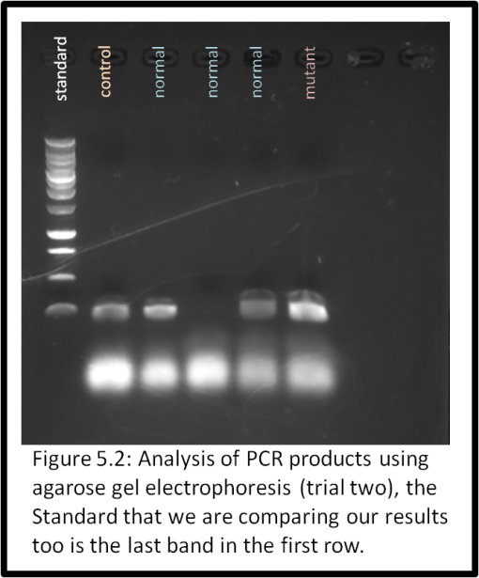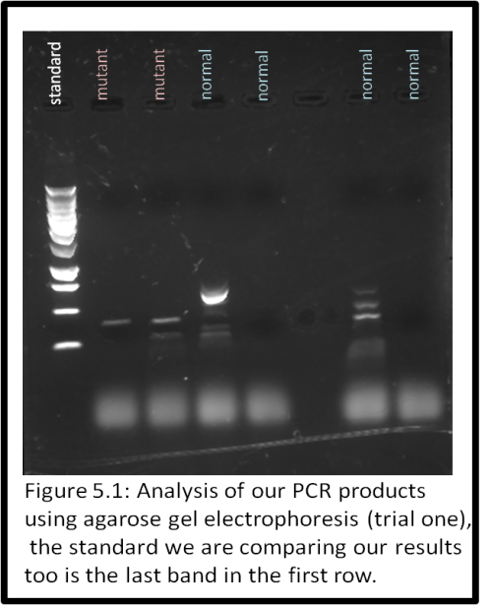Next we extracted DNA from the zebrafish embryos to use in the PCR reaction which we then tested using agarose gel electrophoresis. We did two separate PCR and electrophoresis trials. In the first trial we used the DNA from 4 normal embryos and from 3 mutant embryos. Hypothetically, all of the mutant DNA should have a PCR product of the appropriate length (≈ 250 base pairs long) and approximately two thirds of the normal DNA should have a PCR product of the appropriate length (Figure 5.1). This picture is a little hard to see but both mutants have an appropriate PCR product and the first and third normals also have an appropriate product. For the second electrophoresis trial we used DNA from 1 mutant embryo, 3 normal embryos and 1 control sample which was a known sample of DNA (Figure 5.2). This picture has more defined bands so it is easier to see. Again, the mutant has an appropriate PCR product and the first and third normals also have an appropriate product. The control has a product too which is expected. These techniques are important in helping to directly determine the genotype of the zebrafish. If the extracted DNA has a PCR product then we know that it has an “n” allele so then we can conclude the genotypes for all of the DNA samples we tested.

To the right is a table that shows that genotypes of each sample of DNA based on its PCR product in the electrophoresis (Figure 6). The first table is for the first trial and it shows that the mutants have a genotype of nn, which is expected since that is the recessive allele. One half of the normal embryos have the mutant allele but it is masked by the dominant allele. The second table is from the second trial and again, the mutant has a genotype of nn and two thirds of the normals have the mutant allele. The control had a PCR product but we cannot determine the genotype because it was not a DNA sample from a zebrafish.

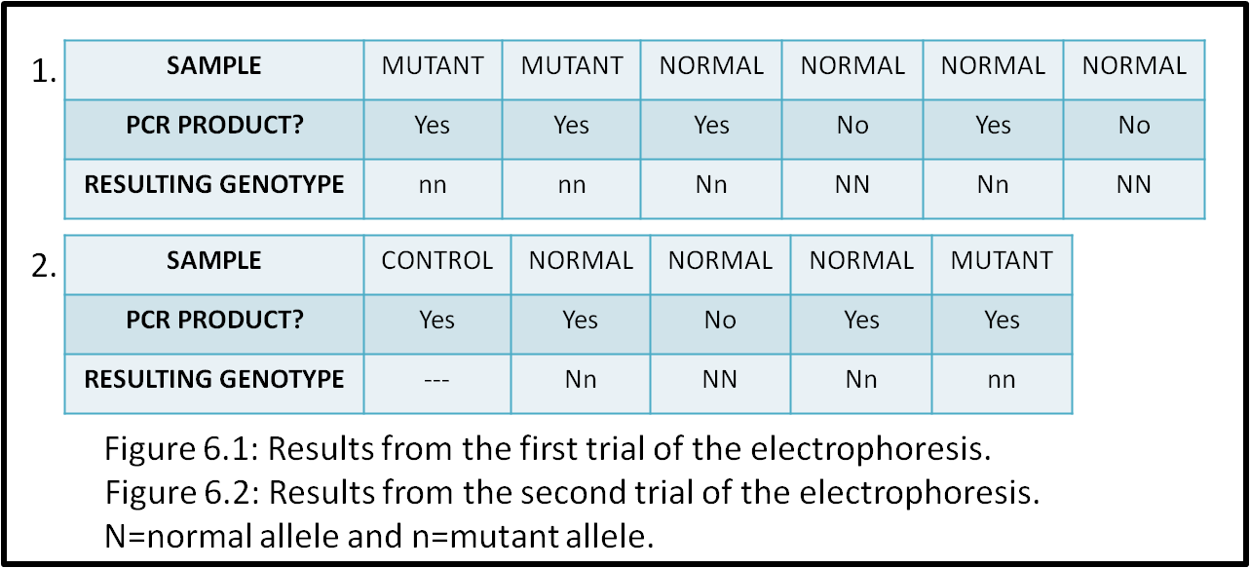

**Discussion**

For this experiment, we concluded that the genotype of the Lary zebrafish is heterozygous which supports our hypothesis. In the first cross, the ratio of normal embryos to mutant embryos followed that of a normal, heterozygous Mendelian cross (3 normal to 1 mutant). It can be concluded that the mutant zebrafish would not survive for very long because the curvature of their tails caused them to swim in circles which is not advantageous in any environment.

The results of the chi-square tests showed that the total data of our mating pair, which was a larger sample than only half the data, had observed numbers that were closer to the expected numbers. When we did the chi-square for our mating pair, the number was 0.667 and when we did the chi-square for the total mating, the number was 0.0838. The lower number shows that there is less variation between the observed and expected numbers.

At the beginning of this experiment we knew that the laminin gene was the gene that had the mutation. It can be concluded that mutation in this gene leads to a structural deformity in the body of the zebrafish, which supports the data I found. We can also conclude that the mutation is recessive since it only shows up in a small number of progeny of a heterozygous cross.

There are no other possible genotypes for the Lary fish. If the fish were homozygous dominant, NN, then all of the progeny we first observed would have been normal and if the Lary were homozygous recessive, nn, then all of the progeny we first observed would have been mutant and neither of these cases was true. Also, if all the progeny were mutant they would die and not live to reproduce.

I think for this experiment it would be better to test more normal embryos in the electrophoresis part so that we could get a better idea of how many normal embryos had the mutant gene and how many did not. As for experimental error, I don’t think this experiment really had any except for the fact that we could have let our first gel run a little longer which would produce a better, clearer picture.

To further test our hypothesis, we could cross a Lary fish with a mutant fish but that would only be possible if the mutant fish lived long enough to reproduce. If the progeny from this cross were half normal and half mutant, we would know the Lary fish are Nn, which would prove our hypothesis is correct. Another experiment I think would be interesting to do, even though it wouldn’t test our hypothesis, would be to set up a tank with only mutant fish and see how long they survive together. They can’t survive very long with normal fish because the normal ones get all the food first because they can swim better but the mutants might be able to survive longer on their own.

**References**

1. Peterson, Matthew T and Clarissa A Henry. “Hedgehog Signaling and Laminin Play Unique and Synergistic Roles in Muscle Development”. March 2010. Pubmed. 10 Nov 2011. <http://www.ncbi.nlm.nih.gov/pmc/articles/PMC2954646/?tool=pubmed>.

# 2. Webb, AE, J Sanderford, D Frank, WS Talbot, W Driever, and D Kimelman. “Laminin alpha5 is essential for the formation of the zebrafish fins”. 28 August 2007. Pubmed. 10 Nov 2011. <http://www.ncbi.nlm.nih.gov/pubmed/17919534>.

# 3. Horne, Jack. “BIO 231: Mutant Zebrafish Experiment”. September 2011.

4. Horne, Jack. “BIO 231: PCR Genotyping Lab”. September 2011.

5. “Why are zebrafish used for scientific research?” The University of Sheffield. 3 Dec 2011. <http://www.fishforscience.com/model-organisms/why-zebrafish>.