**METHICILLIN RESISTANT *STAPHYLOCOCCUS AUREUS* IN ATHELITIC FACILITIES: IDENTIFYING *MecA* GENES FROM BETA HEMOLYTIC ISOLATES**

Casey Gelderman

Dr. Andrew Wier

Biology

Department of Biology, Dyson College of Arts and Sciences

May 2018

631-626-2724

caseygelderman@gmail.com

***Abstract***

*Staphylococcus aureus,* is a typically commensal bacterium that is present on the skin, hair, and mucosal membranes of most of healthy humans. Although humans regularly associate with many different bacteria on a daily basis, some members of the genus *Staphylococcus*, *S. aureus* in particular, can invade host tissues when the cutaneous tissue is compromised. This can lead to a multitude of superficial or deep infections that can cause serious health complications. The ability of *S. aureus* to become resistant to antibiotics in a short amount of time is of great concern to the medical community. Antibiotic resistance of *S. aureus* has become a significant problem in countries around the world and few reserve antibiotic remain for humans. Penicillin was the first antibiotic to be used to treat resistant *S. aureus*, but within thirty years, penicillin-resistant strains were considered a pandemic. Overuse and unnecessary applications of antibiotics in general has led to the overall evolution of resistance in *S. aureus*. Methicillin has become one of the last antibiotics used to treat penicillin-resistant strains of *S. aureus*. Methicillin-resistant *S. aureus,* or MRSA is now considered an epidemic as hospitalizations for this infection has tripled over the last decade. *Staphylococcus aureus* becomes resistant to antibiotics by acquisition of the *MecA* gene via horizontal gene transfer. The *MecA* gene allows for overproduction of penicillin binding proteins, which reduces the effect of β-lactam antibiotics on cell wall synthesis.

College students, especially college athletes, are more prone to MRSA infections due to tight living spaces and poor hygiene habits. This study was conducted to determine if the student-athletes at Pace University are exposed to these strains of bacteria through contact with communal use facilities, specifically gym equipment and surfaces used in athletic competition. Samples were taken from locations around campus where athletes work out and compete. Surface isolates were diluted in distilled water and isolates were grown on blood agar plates. Blood agar plates were chosen as a selective medium for isolation of *S. aureus* strains. Most strains of *S. aureus* are β-hemolytic bacteria, meaning they completely lyse red blood cells. Bacteria that showed the β-hemolytic characteristic by having zones of clearing were chosen for colony PCR, where the *MecA* gene was amplified. Samples that were positive for the *MecA* gene were identified if a band at 310 base pairs were visualized via gel electrophoresis. Key isolates of *S. aureus* that contained the *MecA* gene as well as ones showing beta-hemolysis were identified by sequencing the 16srRNA gene.

***Table of Contents……………………………………………………………..……………Page Number***

Abstract ……………………………………………………………………………………………………2

Introduction………………………………………………………………….…………………………..5

Materials and Methods…………………………………………………………………………..…13

Data…………………………………………………………………………………………………………18

Discussion………………………………………………………………………………………………..23

Acknowledgements………………….……………………………………………………………….26

References……………………………………………………………………………………………….28

***Figures and Tables***

**Table 1:** Locations of swabbing

**Table 2:** Trial one summary

**Figure 1:**Methods for swabbing and plating

**Figure 2:** Examples of blood agar plates

**Figure 3:** Examples of plates with grids

**Figure 4:** Gel electrophoresis trial one results

**Figure 5:** Catalase test results

**Figure 6:** Gram-staining results from first four positive samples

**Figure 7:** Gel electrophoresis trial two results

**Figure 8:** Sequencing results

***Introduction***

The frequency of hospitalizations due to *Staphylococcus aureus* infections is increasing at an alarming rate, not only in the United States, but also in many countries around the world. *Staphylococcus aureus* is one of the pathogenic species in the *Staphylococcus* genus of bacteria. Staphylococci bacteria are coccoid shaped, found clumped together, and a single bacterium usually measures one micrometer in diameter. All staphylococci are gram-positive, which means the bacteria have a thick cell wall made up of peptidoglycan and other polymers. *S. aureus* is different from other staphylococcal species because they have the ability to clot plasma, produce catalase, and lyse red blood cells. There are different tests and laboratory methods that can be used to determine if a staphylococci microorganism is *S. aureus*. First, *S. aureus* and *S. intermedius* are the only two species that are coagulase positive, which means they have the ability to clot blood plasma. *S. intermedius* is not a common human pathogen, so a positive coagulase test is usually a good indicator for presence of *S. aureus* (Foster, 1996). The second way to distinguish *S. aureus* from other strains of staphylococci is by performing a catalase test. Hydrogen peroxide is a byproduct of aerobic respiration that can be toxic to organisms unless they can produce the enzyme catalase. *S. aureus* is capable of producing catalase, which breaks down hydrogen peroxide into water and free oxygen (Cappuccino and Welsh, 2016). Finally, many strains of *S. aureus* are β-hemolytic, which means they cause complete lysis of red blood cells. When grown on blood agar media, a zone of clearing can be seen to indicate the *S. aureus* has grown(Vitko and Richardson, 2013).

Naturally, *S. aureus* is found in the mucosal membranes of nasal and oral passages as well as the axillae of humans. When found in these places, *S. aureus* is not harmful to humans, and the bacteria exhibit a symbiotic relationship with their human host. However, *S. aureus* becomes pathogenic to hosts when the bacteria enter and invade the host tissue. This can happen when there are cuts or trauma to the cutaneous tissue of the host, or from unsterilized needles and medical devices (Mustapha et al., 2014). A variety of different infections with a varying degree of severity can be caused by *S. aureus.* First, *S. aureus* can cause superficial skin wounds like impetigo and localized abscesses. However, *S. aureus* can also cause much more serious skin infections as well as deep infections like endocarditis, pneumonia and osteomyelitis. Endocarditis is the infection of the inner walls and valves of the heart, pneumonia is the infection of the alveoli in the lungs, and osteomyelitis is the infection and inflammation of bones. In addition, *S. aureus* can cause food poisoning by releasing toxins into food, and can also cause toxic shock syndrome by releasing antigens into the blood stream. Finally, *S. aureus* in combination with *S. epidermidis* is a major cause of surgical wound infections in hospitals (Foster, 1996).

A combination of factors expressed by *S.* aureus is used to contribute to the overall virulence of the bacteria. The first factor is the expression of extracellular proteins that promote the infection of host tissue. *S. aureus* expresses many extracellular proteins and polysaccharides that help them attach to host proteins. For example, most strains of *S. aureus* express fibrinogen-binding proteins on their cell wall to promote the attachment to the host’s fibronectin proteins. Fibronectin is found on epithelial cells, endothelial cells, and is a component in blood clots. *S. aureus* also has factors that can inhibit phagocytosis, which is the major mechanism used to fight off staphylococci infections. Two examples are polysaccharide capsules and immunoglobulin protein A, which interfere with phagocytosis by disrupting opsonization. Finally, *S. aureus* can release toxins that are harmful to host tissue and cause symptoms during infections. There are many different types of protein toxins that *S. aureus* can express. For example, α-toxins cause septic shock, enterotoxins in combination with TSST-1 cause toxic shock, and leukocidins in combination with γ-toxins cause damage to membranes of leukocytes. Hosts can combat these toxins by producing antibodies to neutralize the toxins, and then target the bacteria for phagocytosis (Foster, 1996).

*Staphylococcus aureus* poses such a threat to the medical community because of its ability to adapt to become resistant to new drugs and in only a short amount of time to. Antibiotics put *S. aureus* under selective pressure, which prompts the bacteria to use horizontal gene transfer in order to become resistant. Resistance begins with the transfer of the mobile genetic element called staphylococcal cassette chromosome, or *SCCmec* (Ubukata et al., 1989). This genetic sequence contains the *MecA* gene, which will causes methicillin resistance by coding for low affinity penicillin binding protein, or PBP2a (Chambers and DeLeo, 2009). Normally, penicillin-binding proteins catalyze bacterial cell wall synthesis and can be inhibited by β-lactam antibiotics because they have similar chemical structures. However, bacteria develop resistance to antibiotics because PBPs are overproduced and can develop and low affinity for penicillin. This results in the development of PBP2a, which will allow bacterial cell wall synthesis to proceed therefore making the β-lactam antibiotics ineffective (Ubukata et al., 1989). Generally, resistant strains develop in a hospital setting, but after a series of modifications and adjustments, the strains make their way into the community (Chambers and DeLeo, 2009).

Untreated or rare strains of *S. aureus* can lead to serious health complications such as pneumonia, infective endocarditis, and necrosis of tissues. Less than five percent of *S. aureus* strains produce a cytotoxin called Panton-Valentine leukocidin, or PVL. Although rare, this toxin is very serious because it destroys the membranes of white blood cells and can cause tissue necrosis. Strains of *S. aureus* can be screened for the PVL gene by amplifying DNA using polymerase chain reaction. A clinical study in France was done to try to detect the PVL genes in *S. aureus* strains. Samples were collected from 172 hospitalized patients from the years 1985 to 1998. The study determined there was a definite association between having the PVL gene and community-acquired pneumonia or furunculosis.. Furunculosis is a deep *S. aureus* infection in a hair follicle that leads to the formation of an abscess of pus and necrotic tissue. Eighty-five percent of community-aquired pneumonia infections and ninety-three percent of furunculosis infections were PVL positive. On the other hand, zero percent of *S. aureus* strains responsible for hospital-aquired pneumonia, infective endocarditis, urinary tract infections, and toxic shock syndrome expressed the PVL genes (Lina et al., 1999). Overall, this showed PVL genes were most common in strains that caused disease by direction invasion and destruction of tissue rather than secondary infections, indicating PVL is mostly associated with necrotic injuries in the skin or mucosa.

Different antibiotics target different parts of a bacterium’s cell. Antibiotics used to treat *S. aureus* like penicillin and vancomycin disrupt the cell wall synthesis of the bacteria in order to stop their growth and multiplication (Tortora et al., 2016). Alexander Fleming first discovered penicillin in 1929, and within a year of being used to treat *S. aureus* the first wave of bacteria resistance began. *S. aureus* became resistant to penicillin by producing an enzyme to break down penicillin’s components that were necessary for antimicrobial activity. “These [penicillin-resistant] strains produced a plasmid encoded penicillinase that hydrolyses the beta-lactam ring of penicillin essential for its antimicrobial activity” (Chambers and DeLeo, 2009). By the 1960’s, penicillin-resistant strains of *S. aureus* were considered a pandemic. As a result of penicillin resistance, in 1959 methicillin was introduced to treat *S. aureus.* Unfortunately, by 1961 *S. aureus* had started to develop resistance to methicillin as well (Green et al. 2012). The methicillin-resistant strains spread worldwide, and are now considered an endemic as MRSA continues to evolve to become resistant to more antibiotics. Today, vancomycin is one of the few remaining antibiotics used to effectively treat MRSA infections

Methicillin-resistant *Staphylococcus aureus,* or MRSA, has become an increasing problem worldwide because it can be fatal and can occur in epidemics. Strains of *S. aureus* that are resistant to common antibiotics are called MRSA, even though they may be resistant to antibiotics other than methicillin. Over the last ten years, the hospitalizations due to MRSA skin and soft tissue infections have tripled. MRSA is also the leading cause of skin and soft tissue infection in patients that need to be treated in an emergency room. The main mode of transmission for *S. aureus* is through skin-to-skin contact. However, touching contaminated surfaces or sharing personal items such as sheets, razors, and towels can also spread the infection (Chambers and DeLeo, 2009). The Center for Disease Control describes a MRSA infection as a red, swollen, painful area or bump that can be warm to the touch, and can be filled with pus. The most common areas for MRSA infections are legs, groin, buttocks, and the back of the neck (Methicillin-resistant, 2016). Two classifications of MRSA that effect public health are HA-MRSA and CA-MRSA. The most common cause of HA-MRSA, or hospital acquired MRSA, is infection. People who have compromised immune systems, such as the chronically ill or drug users have and increased risk for HA-MRSA. CA-MRSA, or community acquired MRSA, occurs in individuals who are in close contact with each other, and those infected usually develop skin and soft tissue infections. CA-MRSA usually affects younger and healthier, and is most common in competitive athletes, college students, military personnel, and prison inmates (Green et al. 2012). It is not shocking that these groups of people would be more susceptible to skin infections because of the tight living spaces and the poor hygiene practices. When these factors are combined with exposure to trauma and various environmental factors it is easy to contract skin infections. One study done between 1922 and 2005 states more than half the outbreaks of infectious diseases in competitive sports are skin infections. Skin infections like MRSA are reported to be extremely common in athletes, especially at the collegiate level (Zinder et al., 2010).

Clinical cases of vancomycin-resistant *Staphylococcus aureus,* or VRSA, infections have been confirmed by the Centers for Disease Control and prevention as early as 2002. The development of vancomycin-resistant strains is thought to have started with *enterococcus* bacteria. These bacteria are normally present in human intestines, but have the opportunity to become pathogens, as they are one of the common causes of hospital infections. The bacteria have the ability to develop resistance to antibiotics, and are called Vancomycin-resistant *enterococci*, or VRE. VRE were first reported in the United States in a hospital in 1989, and soon became an increasing health concern. A study done on hairless mice by Noble et al. describes how VRE can create VRSA strains. They determined it is possible for VRE to conjugal transfer the *van*A gene to MRSA to create VRSA. The *van*A gene is said to be responsible for mediating vancomycin resistance. The gene was likely donated from VRE to *S. aureus* strains enclosed in a polymicrobial biofilm, for example, in a wound or gastrointestinal tract. In June 2002, the first case in the world of *Van*A mediated VRSA was reported by the Michigan Department of Community Health. At the time this article was published, there were already seven documented cases of VRSA in the United States (Sievert et al., 2008). VRSA infections are a huge concern because vancomycin is one of the few antibiotics that have the ability to treat MRSA infections, so a new antibiotic will have to be developed to treat these infections.

This experiment was conducted at Pace University to test if student-athletes were exposed to any strains of infectious staphylococcus bacteria when using workout facilities. Isolates were classified as *S. aureus* if they expressed β-hemolysis, catalase production, gram-positive cocci shape characteristics, and the *MecA* gene, a common indicator used to identify MRSA strains worldwide. The Isolates that were positive for all of these tests were chosen for colony polymerase chain reaction to determine if they harbored the *MecA* gene. The PCR procedure was replicated from a study done by Mogahid M. Elhassan et al. in 2015. “A PCR program was conducted with initial denaturation at 94∘C for 5 min followed by 30 cycles of 94∘C for 60 sec, 62∘C for 30 sec, and 72∘C for 35 sec ended with a final extension at 72∘ C for 10 min. The following primers were used: Forward: 5’ -GTAGAAATGACTGAACGTCCGATGA-3’ and Reverse: 5’-CCAATTCCACATTGTTTCGGTCTAA-3’. These primers produced a DNA amplification of 310 base pairs, which was visualized on 2% agarose gel (Elhassan et al., 2015).Samples that showed a band at 310 base pairs were identified as positive for the *MecA* gene and considered MRSA.

Since MRSA strains were identified at Pace University, it is important to know what we can do as a community to prevent the spread of these infectious bacteria. It is also crucial that everyone including athletes, coaches, athletic department staff, and even custodial staff work together to follow these guidelines. The first action that should be taken is maintaining a clean environment in all athletic facilities by disinfecting regularly touched surfaces and keeping a detailed cleaning schedule. Second, athletes must follow good hygiene practices. Examples of this include showering after every workout, laundering gear and clothing on a daily basis, disinfecting equipment and braces, and refraining from sharing gear or towels. Perhaps the most important precaution an athlete can take is taking proper care of any open wounds. Athletes with open wounds should never use communal whirlpools or tubs, and should always consult an athletic trainer to ensure the wound is clean and covered. Exposing open wounds to dirty athletic facilities is an easy way for pathogenic *S. aureus* to invade host tissue. The final precaution is making sure everyone is educated about the seriousness of these infection control guidelines (Zinder et al., 2010).

***Materials and Methods***

**Sample collection from weight rooms:**

First, I selected three communal athletic facilities that I thought would be sources of bacterial growth. Twenty samples were taken from Ianniello weight room, Goldstein weight room, and the turf field to total 60 samples. Using sterile cotton swabs, I swabbed the chosen areas and then placed each cotton swab into its own-labeled plastic bag. The samples were put in the refrigerator and kept there until they were plated. After each sample was analyzed, I repeated sampling in the same locations for an additional 60 samples. The second sampling took place two months after the first, and the same procedure was followed.

Ianniello Weight room:

Collection on Wednesday January 31st, 2018, Time 1:00pm

Teams that worked out previous to sample collection: softball, football, and women’s lacrosse.

Plated on February 7th, 2018

Goldstein weight room:

Collection on Wednesday January 31st, 2018 Time 1:25pm

People/teams that worked out previous to sample collection: women’s soccer, Pace students, general public

Plated on February 7th, 2018

Pace Stadium turf field

Collection on Thursday March 29th, 2018 Time 1:30pm

Teams that played on field that week: men’s and women’s lacrosse

20 samples were collected from different areas around the field.

Plated on March 29th, 2018

**Ianniello Weight Room**  **Goldstein Weight Room**

|  |  |  |  |
| --- | --- | --- | --- |
| **Bag Number** | **Location the sample came from** | **Bag Number** | **Location the sample came from** |
| 1 | Head of bench in rack #2 | 21 | Small red exercise ball |
| 2 | Handle of water fountain | 22 | Large yellow exercise ball |
| 3 | Weight clip | 23 | Spinning bike |
| 4 | Safety bar where it goes around shoulders | 24 | Door handle on way out of gym |
| 5 | Barbell in rack #1 | 25 | Treadmill |
| 6 | Barbell in rack #2 | 26 | Elliptical |
| 7 | Head of bench in rack #8 | 27 | Barbell |
| 8 | Door handle on way out of gym | 28 | Head of bench at bench press |
| 9 | GHR machine #4 | 29 | Weight clip |
| 10 | GHR machine #3 | 30 | Leg pad of pull down machine |
| 11 | Bench by dumbbells | 31 | Bar of pull down machine |
| 12 | Handle of 20lb dumbbell | 32 | Pull-up assister handles |
| 13 | Handle of 40lb dumbbell | 33 | Handle of 20lb dumbbell |
| 14 | Leg pad of pull down machine | 34 | Handle of 40lb dumbbell |
| 15 | Bar of pull down machine | 35 | Handle of water fountain |
| 16 | Foam roller | 36 | Medicine ball |
| 17 | Turf in back of room | 37 | Yoga mat from top of pile |
| 18 | Turf in front of room | 38 | Yoga mat from middle of pile |
| 19 | Blue pad in rack #7 | 39 | Leg press pad |
| 20 | Pull up bar in rack #1 | 40 | Arm press pad |

**Table 1.** This table lists the gym equipment that was swabbed in both gyms.

Repeated sampling using the same procedure was done at the same locations on Wednesday April 11th at 12pm. Second samples were plated on April 17h, 2018.

**Plating of samples on TSA 5% Sheep’s Blood Agar media:**

I autoclaved test tubes each containing one-milliliter of water. For each sample that I collected, I immersed the cotton swab in the water of the sterile test tube. I made sure the cotton swab was damp, but not dripping wet before I streaked each sample across the entire TSA 5% Sheep’s Blood agar petri plate. The plates were incubated at 37 degrees Celsius for forty-eight hours, and then moved to the refrigerator. The procedure up to this point is represented in figure 1.

**Picking isolates with zones of clearing**

I identified and assigned numbers to individual colonies that showed zones of clearing on the TSA Sheep’s Blood agar plates. The colonies were chosen from any of the samples, and several plates had more than one colony that was picked. For the first round of sampling, I identified 28 colonies from the Ianniello samples, 28 colonies from Goldstein samples, and 23 colonies from the turf samples. For the second round of sampling, I identified 21 colonies from the Ianniello sample, 18 colonies from the Goldstein sample, and ­­­­11 colonies from the turf. The colonies were picked and regrown on new TSA Sheep’s Blood agar plates that had a numbered grid corresponding to the colony number as shown below. I picked the colonies from the original plate by gently touching them with a sterile toothpick, and then gently touching the toothpick in the corresponding space on the new plate. Plates were incubated at 37 degrees for 24 hours. An example of what the gird plates look like is shown in figure 3.

**Colony PCR*:***

Microtubes were labeled corresponding to the numbers on the grid plates, and 100μl of DNA free water was pipetted into each one. I gently used touched a sterile toothpick to each of the samples and then swirled the toothpick in the water of the microtube. This was done to dilute the amount of DNA from each sample. The samples were vortexed for five seconds each. In a 1.5ml tube I created enough colony PCR Master Mix for all the samples. The PCR mix for one sample consisted of 25.0μl of GoTaq Green Master Mix, 1.0μl of Primer F, 1.0μl of Primer R, 21.0μl of nucleolus free water, and 2.0μl of DNA from the diluted sample. I multiplied each component of the PCR mix by the number of colonies that I selected from each sample. PCR was ran for about 5 hours and after all cycles were finished the samples were stored in the freezer.

**Gel Electrophoresis:**

I made a gel with 0.6 grams of agarose, 50ml of TAE buffer (1x diluted), and 1 μl of SABR safe stain. 25μl of each DNA sample from colony PCR was loaded into the wells, and a 1kb DNA ladder combined with loading dye was loaded into lane one. The gel was ran under 100 volts for 30 minutes.

**PCR cleanup to be sent out for sequencing:**

Ten samples were chosen based off gel electrophoresis results to be cleaned up and sent out for sequencing. First, I pipetted the remaining volume of the PCR amplifications into new PCR test tubes, and then added an equal volume of Membrane Binding Solution to each sample. This mixture was transferred to SV minicolumns that were inserted into collection tubes. The sample was centrifuged at 16,000x g for one minute. Then, 700μl of Membrane Wash Solution was added, and the tubes were centrifuged for one minute. The flow through in the collection tube was discarded and 500μl of Membrane Wash Solution was added. The tubes were centrifuged for five minutes and the flow through in the collection tube was discarded again. The SV minicolumn was transferred to a clean1.5ml microcentrifuge tube and 50μl of nuclease free water was added. The tubes were centrifuged for a final minute and the SV minicolumn was discarded. The microcentrifuge tubes with the DNA product were closed, labeled, and stored at 4 degrees Celsius until they were sent out for sequencing.

**Catalase Test:**

Using aseptic technique, organisms were transferred from the grid plates to a clean microscope slide by a sterile loop. One drop of 3% hydrogen peroxide was placed on the sample and observed for the immediate presence of bubbles. Free oxygen bubbles indicated a positive test and no bubbles indicated a negative test.

**Bacterial smears and staining:**

The four samples positive for the *MecA* gene after colony PCR were stained to be observed under a microscope. First, a bacterial smear was prepared on a microscope slide by placing a drop of water in the center of the slide and transferring a small amount of bacteria to the water. Then. I quickly passed the slide through the flame of a Bunsen burner in order to heat fix the bacteria to the slide. Then, the slide was placed on a staining tray and flooded with crystal violet and left to sit for one minute. The slide was gently rinsed and then flooded with Gram’s iodine for one minute. The slide was rinsed again and then decolorized using three drops of 95% ethyl alcohol. Again, the slide was rinsed and flooded with safranin for 45 seconds to counterstain. The slide was rinsed for a final time and blotted dry using bibulous paper. This procedure was repeated for all four samples, and then observed under a light microscope.

***Data:***

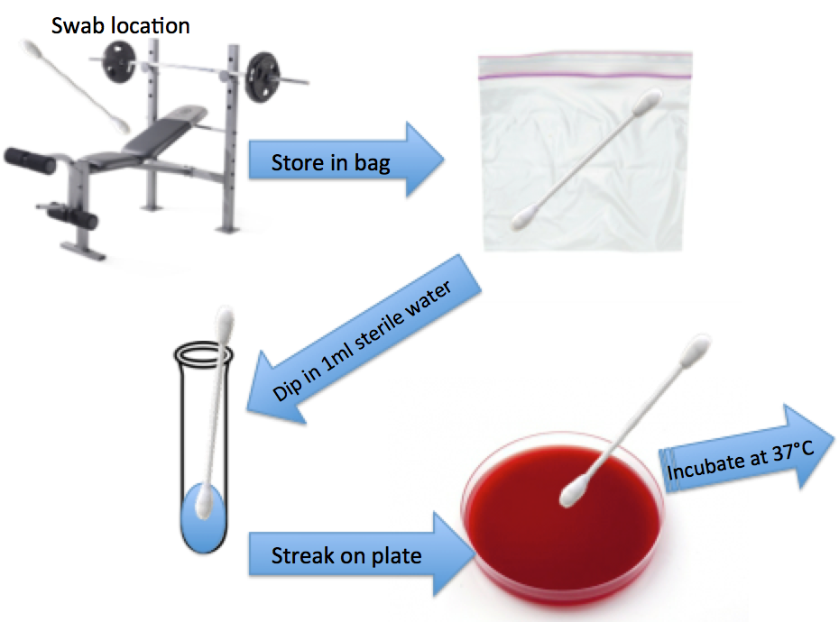**Figure 1.** This figure represents the method that was used to collect samples in a simple and sterile way. The chosen locations from table 1 were swabbed with a cotton swab, and then the cotton swab was sealed in a plastic bag. Test tubes with 1ml of water were autoclaved to make sure they were sterile. The cotton swab was dipped in the water and streaked on the plate, which was incubated for two days.

|  |  |  |  |  |
| --- | --- | --- | --- | --- |
| IMG_1798.JPG | IMG_1789.JPG | IMG_2019.jpg | Macintosh HD:Users:caseygelderman:Pictures:iPhoto Library.photolibrary:Masters:2018:02:13:20180213-224823:IMG_1775.JPG | Macintosh HD:Users:caseygelderman:Pictures:iPhoto Library.photolibrary:Previews:2018:04:24:20180424-225448:8n1a+G%7TCymeU3ts4MQtQ:IMG_2017.jpg |
| Ianniello plate 19 | Ianniello plate 17 | Turf plate 7 | Ianniello plate 11 | Turf plate 11 |

**Figure 2.** This figure shows some examples of plates after being streaked with samples and incubated for two days. Distinct zones of clearing can be seen in each of the samples above, indicating a β-hemolytic bacterium has grown.

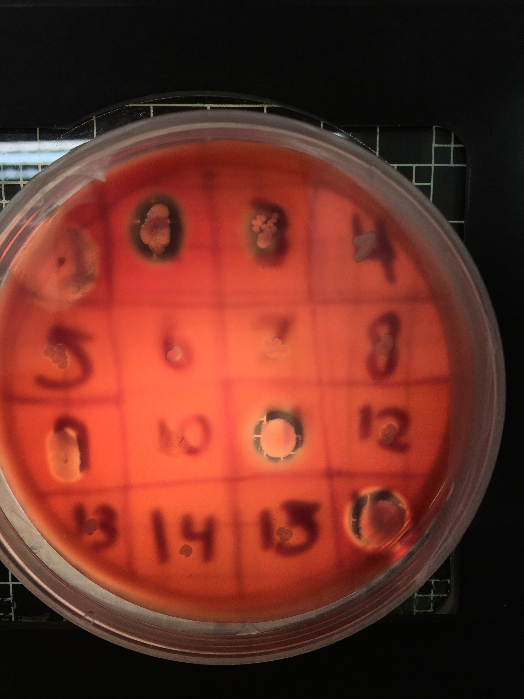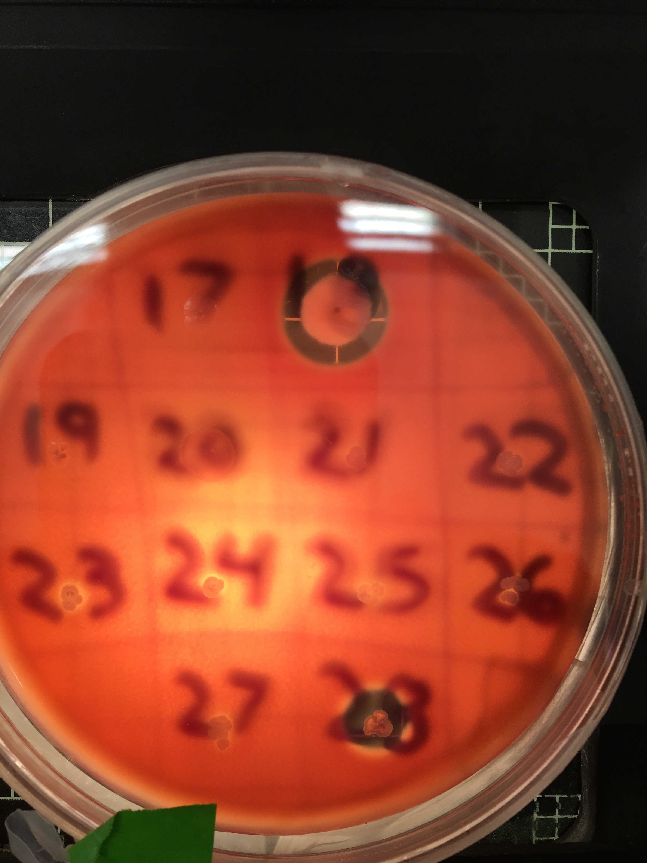

**Figure 3.** This is a photograph of the grid plates. Isolates that showed zones of clearing on the original plates were picked and re-plated in grids like this. Samples were re-plated 2-3 times throughout the semester to make sure samples stayed viable.

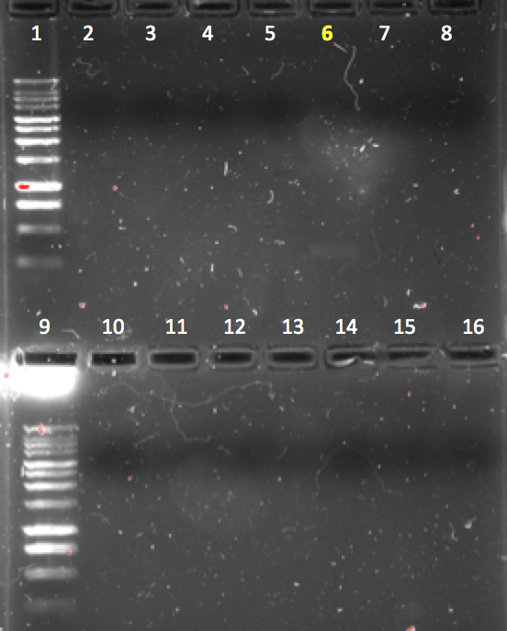 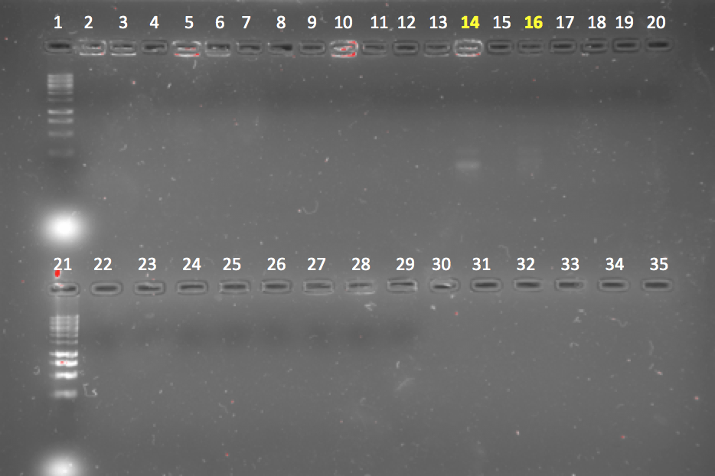

B

A

x 100% = 5.06%

D

C

**Figure 4.** Gel electrophoresis results for the first set of samples. Lanes numbered in white had a negative result for the *MecA* gene and lanes numbered in yellow had a positive result. 1kb DNA ladder is shown in the left lanes in each image. A, Ianniello samples. B, Goldstein samples. C, Turf samples. D, The percentage of samples that was positive for the *MecA* gene out of the total number of samples.

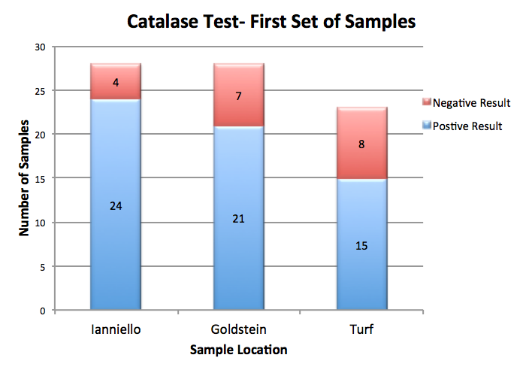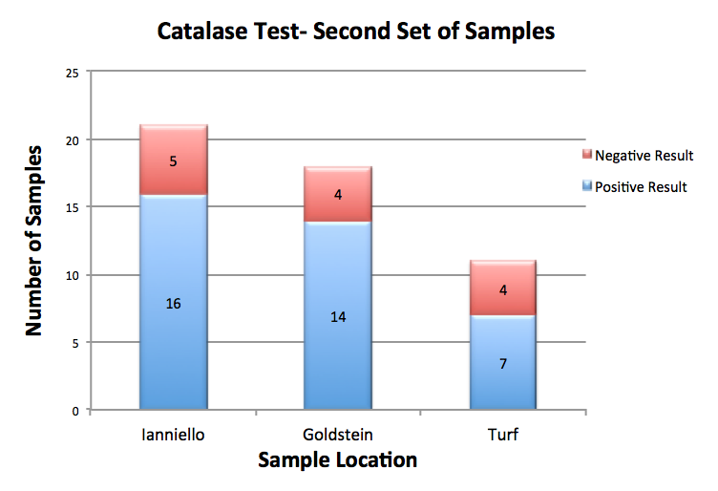

A B

**Figure 5.** Figure 5A graphically represents the results of catalase test for the first set of samples while 5B represents the second set of samples. The red bar represents a negative catalase test (did not produce free oxygen bubbles) and the blue bar represents a positive catalase test (produced free oxygen bubbles). Each sample location has a different number of samples due to the number of β-hemolytic isolates that were identified.

|  |  |  |  |
| --- | --- | --- | --- |
| Macintosh HD:private:var:folders:72:8hz3fs_x77d26xnc6gg8l8ch0000gn:T:com.apple.iChat:Messages:Transfers:IMG_2207.PNG | Macintosh HD:private:var:folders:72:8hz3fs_x77d26xnc6gg8l8ch0000gn:T:com.apple.iChat:Messages:Transfers:IMG_2210.PNG | Macintosh HD:private:var:folders:72:8hz3fs_x77d26xnc6gg8l8ch0000gn:T:com.apple.iChat:Messages:Transfers:IMG_2208.PNG | Macintosh HD:private:var:folders:72:8hz3fs_x77d26xnc6gg8l8ch0000gn:T:com.apple.iChat:Messages:Transfers:IMG_2209.PNG |
| (A)Ianniello 5 | (B)Goldstein 13 | (C)Goldstein 15 | (D)Turf 13 |

**Figure 6.** This figure shows microscope images under 40x magnification of gram-stained isolates. The four isolates are the samples that had a positive result for the *MecA* gene from the first set of sampling. A, C, and D are coccoid shaped while B is rod shaped. All samples are stained purple, indicating they are gram-positive bacteria.

**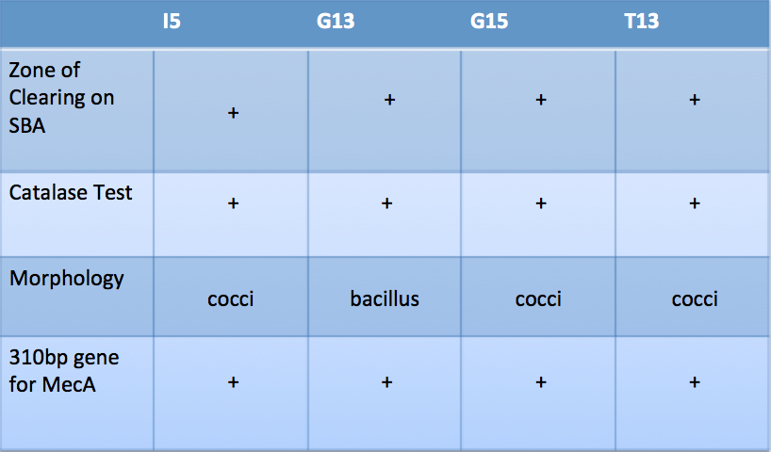**

**Table 2.** The left column of this shows characteristics that could help identify a bacteria is MRSA. The top row is the four isolates from the first set of sampling that had positive results for the *MecA* gene. A positive result for one of the tests is indicated by a “+”.

B

***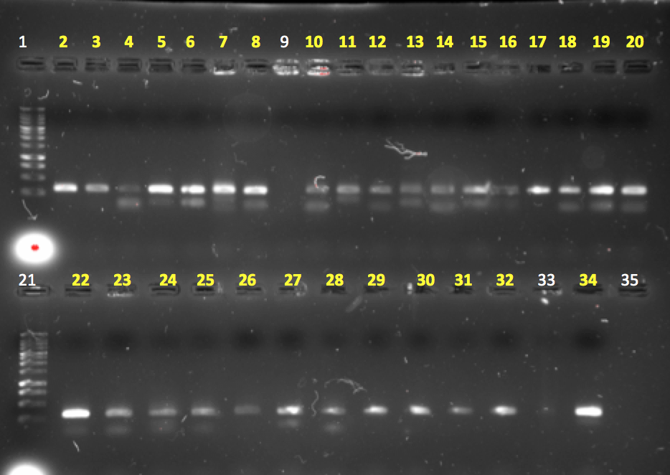 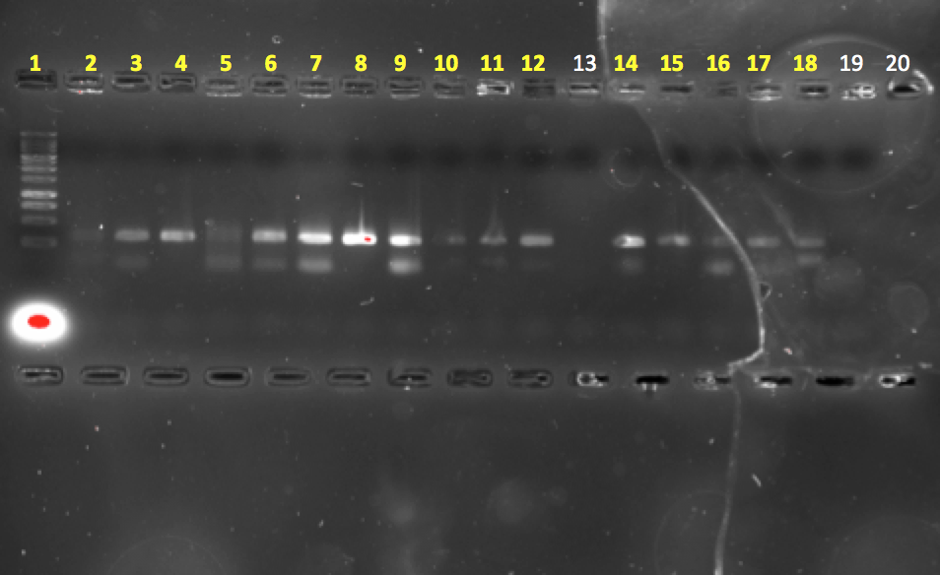***

A

C

**Figure 7.** Gel electrophoresis results for the second set of samples. Lanes numbered in white had a negative result for the *MecA* gene and lanes numbered in yellow had a positive result. 1kb DNA ladder is shown in the left lanes in each image. A, Lanes 2-23 are Ianniello samples while 22-35 are turf samples. B All lanes are Goldstein samples. C, Shows the percentage of samples that was positive for the *MecA* gene out of the total number of samples.

**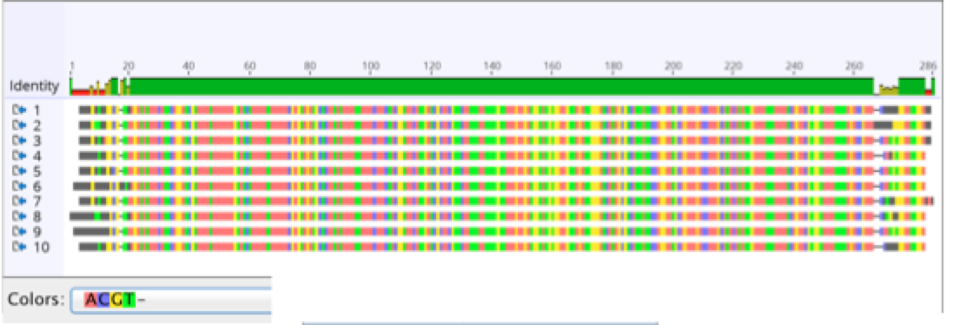**

A

****

B

**Figure 8.**This figure is a nucleotide alignment generated by Geneious. A, The identity bar at the top shows the identity over all pairs in the column, Green is 100% identity, brown is over 30% but under 100% identity, and red is under 30% identity. Below the identity bar is a representation of the nucleotides by color from the 10 sequences that were compared. B, This image shows the statistics of the nucleotide alignment, which was also generated by Geneious.

***Discussion:***

Athletic facilities can be the home to several different types of bacteria, but many of these bacteria are harmless until they are able to invade host tissue. *S. aureus*  is a perfect example of a bacteria that can be easily found on athletic equipment, but can also become extremely dangerous. Through a series of lab tests, I was able to identify over 50 isolates that displayed all characteristics of *S. aureus* and also harbored the *MecA* gene for antibiotic resistance. The process started with identifying isolates that were β-hemolytic. There was no shortage of β-hemolytic isolates, as there were 129 total isolates that were identified and chosen for further testing, Figure 2 is an example of five of the plates where I was able to identify zones of clearing. The Quebec colony counter or another light source was used to easily visualize the zones of clearing. Isolates that had zones of clearing on the original streaked plates were chosen to be re-plated on the grid plates in order to keep the cells viable. Some isolates did not appear β-hemolytic when they were re-plated, but that was most likely due to the fact that they were removed from the incubator before they had time to fully grow. Even if isolates did not appear β-hemolytic on the second plate, they were still amplified using colony PCR since they were originally identified as β-hemolytic (Fig. 3).

Colony PCR was first performed on the Ianniello first set of samples, however due to schedule constraints, I was not able to run gel electrophoresis until one week later. After running all the samples through gel electrophoresis, I was able to identify one very faint band in lane 6. This was the weakest band out of all the positive samples from the entire experiment (Fig. 4a). Colony PCR was performed on the first set of Goldstein and turf samples on the same day. Two days later I ran the samples through gel electrophoresis and found two bands in lanes 14 and 16 for the Goldstein samples, and one band in lane 14 for the turf samples. The bands found in these samples were also faint, but slightly stronger than the band from the Ianniello sample. In total, 5.06% of the first sets of samples were positive for the *MecA* gene (Fig 4B and 4C). For the second set of samples, I performed colony PCR on all three locations on the same day, and then ran them through gel electrophoresis the following day. The bands from the second set of samples were much more distinct than the first set of samples. For each of the locations, all but one sample were positive for the *MecA* gene, meaning 96.0% of samples showed bands around 300 base pairs (Fig. 7). Improved PCR technique and a shorter timeline are two possible reasons why the second set of samples had more positive results than the first set. *S. aureus* has the ability to produce the enzyme deoxyribonuclease, which is an enzyme that catalyzes the cleavage of the phosphodiester bonds of DNA, therefore degrading DNA. The presence of this enzyme could be have degraded the DNA from the first set of samples during the week that I waited to run gel electrophoresis. This is most likely the reason that I had better results when I ran gel electrophoresis only one day after running PCR. In order to make sure I didn’t get false positive results, I chose 10 of the 47 positive samples to be sent for sequencing.

All ten samples that were sent for sequencing were identified as *S. aureus* and had a high percentage of identity with the *MecA* sequence. The nucleotide alignment results showed 93.7% of the nucleotide sequence were identical between the ten strains. The areas that were not identical were in the first 20 base pairs and about 10 base pairs near the ends of the sequences. These results support my conclusion that the strains were MRSA because it showed the gene that I was trying to amplify was consistent in all the samples (Fig. 8). Another result that supports the identity of the isolates as *S. aureus* is the catalase test results. Majority of the isolates were positive for catalase production because they produced free oxygen bubbles (Fig. 5).

Since the first set of samples was not sent for sequencing because I considered the samples degraded by deoxyribonuclease, I gram-stained the four positive results to identify their morphology. Three of the four samples were coccus shaped, but one of the samples was bacillus. I concluded that the three that were coccus were MRSA because they were positive for all the characteristics of MRSA that I tested for (fig. 6A, 6C, 6D, Table 2). However, the Goldstein13 (G13) isolate was not MRSA, because it was not a *S. aureus* strain. It is possible that the bacteria could have acquired the *MecA* gene through horizontal gene transfer; similar to the way *S. aureus* strains acquire the gene (Fig. 6B). All together, I concluded that I accurately identified 51 isolates that were positive for the *MecA* gene, and 50 of them were MRSA.

Although my results can be concerning, there is plenty of precautions we can take as a community to prevent serious infection. These results were reported to the staff members in charge of maintaining the athletic facilities at the university. I suggested that facilities be cleaned thoroughly since I found so many positive strains. Throughout my experiment I noticed more cleaning wipes being placed in the gyms for athletes to wipe down gym surfaces and their hands. I also have suggested to many athletes that they be extremely careful when they have open wounds. I have already noticed members of my team being more aware and diligent of covering any small cuts they may have. I hope that I can work with the athletic department at Pace to continue to spread an awareness of how real the risk of MRSA is to all athletes around campus. Another very important thing I advise all athletes to do is to regularly wash their equipment and anything used when competing.

***Acknowledgements:***

I’d like to thank Emily Ankabrandt, Stephanie Chadnick, and Amanda Perez for helping me collect samples in the weight rooms. I would also like to thank the Pace University Athletic Department for allowing me to incorporate my interest of athletics into my research project. I think MRSA infections are a concern that is very real for student-athletes, and I am thankful that they allowed me to use their facilities to address my research questions. Finally, I would like to thank Dr. Wier for taking on my project with me, and supporting me throughout the semester. Thank you for taking my idea and helping me turn it into a real experiment with meaningful results.

***References:***

Cappuccino, J. G., & Welsh, C. (2017). *Microbiology: a laboratory manual* (Eleventh edition). Upper Saddle River, NJ? Pearson.

Chambers, H. F., & DeLeo, F. R. (2009). Waves of Resistance: Staphylococcus aureus in the Antibiotic Era. *Nature Reviews. Microbiology*, *7*(9), 629–641. https://doi.org/10.1038/nrmicro2200

Elhassan, M. M., Ozbak, H. A., Hemeg, H. A., Elmekki, M. A., & Ahmed, L. M. (2015). Absence of the mecA Gene in Methicillin Resistant Staphylococcus aureus Isolated from Different Clinical Specimens in Shendi City, Sudan. *BioMed Research International*. Retrieved from https://www.hindawi.com/journals/bmri/2015/895860/

Foster, T. (1996). Staphylococcus. In S. Baron (Ed.), *Medical Microbiology* (4th ed.). Galveston (TX): University of Texas Medical Branch at Galveston. Retrieved from http://www.ncbi.nlm.nih.gov/books/NBK8448/

Green, B. N., Johnson, C. D., Egan, J. T., Rosenthal, M., Griffith, E. A., & Evans, M. W. (2012). Methicillin-resistant Staphylococcus aureus: an overview for manual therapists. *Journal of Chiropractic Medicine*, *11*(1), 64–76. https://doi.org/10.1016/j.jcm.2011.12.001

Lina, G., Piémont, Y., Godail-Gamot, F., Bes, M., Peter, M.-O., Gauduchon, V., … Etienne, J. (1999). Involvement of Panton-Valentine Leukocidin—Producing Staphylococcus aureus in Primary Skin Infections and Pneumonia. *Clinical Infectious Diseases*, *29*(5), 1128–1132. https://doi.org/10.1086/313461

Methicillin-resistant Staphylococcus aureus (MRSA). (2016, March 16). Retrieved January 7, 2018, from https://www.cdc.gov/mrsa/index.html

Mustapha, M., Bukar-Kolo, Y. M., Geidam, Y. A., Gulani, I. A., & Department and Faculty of Veterinary Medicine. (2014). Review on Methicillin-resistant  Staphylococcus aureus  (MRSA) in Dogs and Cats. *Maxwell Scientific Organization*, 13.

Sievert, D. M., Rudrik, J. T., Patel, J. B., McDonald, L. C., Wilkins, M. J., & Hageman, J. C. (2008). Vancomycin-Resistant Staphylococcus aureus in the United States, 2002–2006. *Clinical Infectious Diseases*, *46*(5), 668–674. https://doi.org/10.1086/527392

Tortora, G. J., Funke, B. R., & Case, C. L. (2016). *Microbiology: an introduction* (Twelfth edition). Boston: Pearson.

Ubukata, K., Nonoguchi, R., Matsuhashi, M., & Konno, M. (1989). Expression and inducibility in Staphylococcus aureus of the mecA gene, which encodes a methicillin-resistant S. aureus-specific penicillin-binding protein. *Journal of Bacteriology*, *171*(5), 2882–2885.

Vitko, N. P., & Richardson, A. R. (2013). Laboratory Maintenance of Methicillin-Resistant Staphylococcus aureus (MRSA). *Current Protocols in Microbiology*, *0 9*, Unit – 9C.2. https://doi.org/10.1002/9780471729259.mc09c02s28

Zinder, S. M., Basler, R. S. W., Foley, J., Scarlata, C., & Vasily, D. B. (2010). National Athletic Trainers’ Association Position Statement: Skin Diseases. *Journal of Athletic Training*, *45*(4), 411–428. https://doi.org/10.4085/1062-6050-45.4.411