Erika Tremblay

Dr. Weigold

Research Paper

Seminar on Historiography

In France, most notably in the Loire Valley, lie some of the most beautiful homes of all time; chateaux, built by Kings, to fulfill their need for grandeur and to emphasize their power with giant, magnificently structured buildings that exude supremacy. Louis XIV is the best known example of this with his glorious Versailles. But there are other Kings of France who wanted to exude the same greatness as Louis, and they too built colossal chateaux to illustrate their superiority. One of the most intriguing chateaux is Chambord. Built by Francois I and located in the Loire Valley, Chambord is mystical on the outside, something only to be seen in dreams, but quiet and obscure on the inside. From its construction in the 16th century to the 19th century when it was kindly restored, the Chateau of Chambord and its massive structure have played an important role in each of the lives of its residents. For some it brought power, and the feeling of greatness. For others it simply brought socializing and pleasure. But for some, there was a realistic fear that such an enormous structure would throw a shadow over them, would make them feel somber in its vast, dark, stone walls. To embrace and overcome this fear would be for most the true impact of Chambord on their lives. (Sitwell 1961) (Buckley 1977)

In the early 16th century, the King of France, King Francois I, was very interested in the arts, especially those of Italy. He was taken aback by how beautiful Italian art and culture was. He wanted to bring Italian art to France and in this he started a large Renaissance collection, which is still in France and hangs in the Louvre. He also invited many Italian artists to France to decorate his palaces. He even invited the famed Leonardo da Vinci to live in France. These Italian influences had Francois I dressing his court in Italian influenced clothing and also bringing women to court for the first time ever to make his court more of a social place than a place simply of government. (Brown 2007) (Hackett 1937)

This change in the court of King Francois I was probably the reason Chambord appealed to him so much. Chambord was originally a small structure that had set out from Jean d’Arc during the Siege of Orleans in the 15th century. But for King Francois I, who loved to hunt, he saw the perfect place for a new and spectacular hunting lodge; one to make other King’s truly envious. (Sitwell 1961) (Hackett 1937)

Four years before the building of Chambord began, King Francois I had captured Milan, Italy and took the title, Duke of Milan. His interest in Italian Renaissance grew quickly after that. He saw these Italian masterpieces through French eyes and he could picture the French versions of architecture, paintings, clothing, and more, assimilated quickly into his country. Assimilate he did, and in his excitement and love for Italy, he invited Leonardo da Vinci back to France and gave him a home in Amboise. He also acquired the Mona Lisa at this time, probably unaware of how important it would be to historians, artists and laymen alike, for the next 500 years. (Hackett 1937) (Brown 2007)

In 1519, the building of Chambord began. Francois I wanted Italian men who could build the same Renaissance as Italy, but in a French form. He used Italian designers and builders to build models and give advice while he searched for French contractors who would be able to keep up with the Renaissance demands. Though it isn’t entirely sure who made the plans for Chambord, the most obvious answer to those who know a bit about French Kings, would say Francois I himself was the main designer. Although Francois I had Dominique de Cortone build small wooden designs that are most likely of Chambord, the palace architecture changed as the building progressed. Though Leonardo da Vinci died months before Chambord’s building had begun, there is no question that Francois I would have went to Leonardo for advice on plans and used some his grand ideas in the making of the chateau. But in the end, Francois I probably headed the endeavor and directed the building to his liking, taking advice from others and hiring many different people to show him new ideas. (Hackett 1937) (Gebelin 1964) (Guerlin 1929)

The King, like those before and after him, felt that he needed to build his own superior palace to show his grandeur and to be a place to call his own. Francois I knew that other Kings had built other palaces and they did not truly feel like home to him. Building of the castle moved quickly because of the King’s enthusiasm and an almost finished castle was shown to Emperor Charles V, who said it was, “the epitome of all that human industry can achieve.” The fact that the castle was only to be a hunting lodge helped make it extraordinary; such a huge palace only used for hunting trips! (Auzas 1957) (Hackett 1937)

To truly understand how the Chateau could show such power for Francois I, and have such an effect on its residents, there has to be an understanding of the structure of the Chateau. There is no way to think a building could be of influence to a person until they have walked up the drive to meet Chambord. The chateau is embraced in over 13,500 acres of forest, perfect for a hunt, or peaceful walk. Walking towards it, only the roof is visible, the forest hiding the rest of the chateau. The top of the Chateau literally looks like a crown, with many little chimneys and turrets and towers jutting out all over the roof, hence the forest looks like its wearing a crown. As the full chateau moves into view, the vastness of it is literally unimaginable. To stand right next to the building, to touch it, feels absurd; to not look at it from afar makes it real, instead of seeing the whole chateau with the forest and sky laid out in the mind, which most certainly must be a dream, for nothing looks so regal, and yet so sincere. (Auzas 1957) (Dutton 1957) (Gebelin 1964) (Sitwell 1961) (Gascar 1962)

The outside structure is a giant square keep, 3 stories high then the roof, with four cylindrical towers on each corner. Wings surround the keep, creating a space for a courtyard that can be reached from three sides of the keep. The back of the chateau or the south façade is only one story, letting the keep and its amazing roof be seen from all angles, to be the center and most incredible part of the castle. In the center of the main keep, the most extraordinary and famous part of the chateau is the spiral staircase that is centered in the keep going from the ground floor to the roof terrace. The staircase is special because it is really two staircases in one; they are two spiral staircases that wind around one center. The center is hollow and includes windows, so it is possible to see people on the other staircase, if passing at the same moment. (Guerlin 1929) (Gascar 1962) (Gebelin 1964) 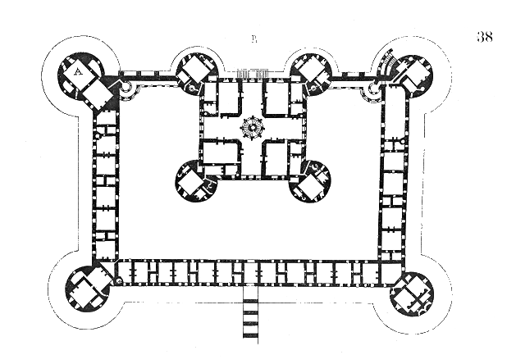

Another part of the chateau that is quite interesting is that many of its arches and hallways are open, a beautiful Italian gesture, but not quite as ingenious as one may suppose. In the French summers a cool breeze flows through the open hallways, a glorious relief to be sure. But in the cold French winters, the palace is freezing, impossible to heat the entire home. Even if a room was warm, when the door opened, the cold hallways would freeze it once more. This point of the castle is quite important. It shows in the extreme that the house was not practical for long term residents, but better for short stays, like hunting trips, and summer vacations. (Hackett 1937) (Guerlin 1929)

The stone that the castle is built with is a beautiful bright off-white color making it very dreamy while standing outside of it. Inside, however is much darker, and much less bright than the outer shell. Part of the structure of the castle is the feeling of being inside. It relays what the structure means to those who enter. Upon entering the grand keep, the stone turns to gray and the sunlight is only peering into the dark, enormous vault. Already the feeling of greatness is overwhelming. Splitting up and heading in two groups upstairs in opposite spirals, the vastness is toned down by the silence and the thick walls. Once entering a room and moving down open hallways, it’s easy to see that getting lost is perfectly possible. Looking out of an open hallway into the courtyard is like looking out of a jail window with bars on it; smelling, seeing, feeling the outside world, but not being able to escape or find a way out; it’s exciting but chilling, trapping, but liberating. Without a court full of people, or a hunting party, Chambord would be very quiet, and lonely; the idea of it being a residence for one family begins to seem absurd. (Gascar 1962) (Sitwell 1961)

These things are so important to note for King Francois I. He made a castle that was so grand it literally gave men insecurities, but yet, it was only a hunting lodge to Francois I. It made him seem that he could live in a more extraordinary place as his home. The fact that the castle is also too overbearing for a regular family to live in, makes it seem like it could only be home to a King. Francois I literally built a palace that he knew only he could be comfortable in. Francois I said of Chambord, “Let us go home.” (Auzas 1957) (Guerlin 1929)

From the first drawings of Chambord, it was not to be so flamboyant, but over time Francois I’s influence made it into a very different structure than what his architects had originally drawn out. The change from average to fantastical shows a blatant feature in Francois I’s personality; his seriousness can easily be turned into fun and interest, and is consistent with his love of the arts. The interior’s ominous structure shows his seriousness, but also his quiet strength. The magnificence of Chambord and the power it portrayed for Francois I made him truly a King, in name and at heart. (Hackett 1937) (Brown 2007) (Buckley 1977)

For about 80 years after Francois I’s death in 1547, the Chateau was mostly quiet. Henri II built the Chapel, but mostly the Medicis used the castle for hunting until Louis XIII gave it to his brother Gaston d’Orleans in 1626. Gaston and his family were quite fond of Chambord. Gaston and his daughter played games on the great staircase, and felt greatly at home in the giant castle. Being the brother of a King, and a rebel against the crown, Gaston came with much confidence probably making him more comfortable in Chambord than many others would be. He also felt protected in such a large estate and the restorations he undertook most likely kept him busy in between rebellions. Gaston always felt safe in Chambord, and his did family, too. His daughter declared her love to Lauzun on a fogged looking glass, so that he may know her affections. The house was truly a home to this family, most probably the only family to feel this way of Chambord. (Gascar 1962) (Moote 1989) (Auzas 1957)

Though King Louis XIV did not live at Chambord, he visited several times, and Francois I’s ambition in building Chambord, was most likely a great inspiration for Louis XIV’s grand Versailles. Louis XIV did many restorations at Chambord, including changing one of the floors in the keep to make his own personal rooms at the palace. Louis XIV had many festivities arranged whenever he stayed at Chambord and the palace had the famous Moliere put on two plays with music by Lulli. By the time Louis XIV had moved the court to Versailles, he would only visit Chambord once more, but there is no doubt that Chambord played a huge role in Louis XIV’s building of Versailles, and motivated him to push beyond the greatness of Francois I’s castle. (Auzas 1957) (Gascar 1962) (Guerlin 1929) (Sitwell 1961)

Louis XV was a timid man who didn’t really have the strength and power to reform France, and in this Chambord was not really the place for him. Though, it can be deduced that he spent time there as a child, since his great – uncle, Phillipe Duke d’Orleans was his Regent when the boy was too young to rule, and the Duke D’Orleans was still in ownership of Chambord. Knowing the chateau and not wanting to be there, showed a lack of confidence in Louis XV that not many would be surprised about. (Sitwell 1961) (Gebelin 1964)

Since Louis XV had no use for the Chateau, he gave it to his father-in-law, Stanislas Leczinski, King of Poland who had to take refuge in France. Leczinski and his Queen lived in Chambord from 1725 to 1733, where he was quite content. He changed the gardens and drained the moats, and he stood as godfather for many of the children in town. Stanislas plays only a small part at Chambord, but being the place of his refuge made Chambord a big part of Stanislas life, and brought him safety in his time of need. What better place to feel safe than in the thick walls of Chambord. (Auzas 1957) (Guerlin 1929) (Sitwell 1961)

The next resident was yet another Polish man, Marshal Maurice de Saxe, who received the Chateau from Louis XV because of the marshal’s great bravery during a battle. The marshal did much work to the castle, as he had always wanted to live regally, and this was his chance to live out his dream. He took over the rooms that were once Louis XIV and made sure there were always guards standing outside his bed chambers. He had also installed six canons onto the chateau, maybe trying to relive a more medieval period, as if he lived in fortress. There were many men in the chateau with him and he kept very good records, and also kept a very strict household. People were occasionally hung during the marshal’s stay at Chambord. He put on many comedies in the castle keep and had a luxurious playhouse set up on the second floor of the keep so that he may have a good place to seat his guests. As most of the men living at Chambord, secret love always played a role. Chambord was a place of easy secrecy, and the marshal loved women. Mademoiselle de Pompadour even lectured him on his shameful life style. Though the Marshal lived his dreams here, it didn’t take long to realize that the chateau had become aged, that the musty, diseased walls were maybe less of a problem than the hardship of keeping the castle warm. Marshal writes in October in 1749, “Chambord is a hospital. I have more than 300 sick, many dead, and the rest have faces of those risen from the dead.” (Gascar 1962) (Auzas 1957) The restoration done to the Chateau was not enough; it was doomed and literally impossible to live in. Marshal de Saxe died of a chill in 1750. Marshal was a bastard child, so his regal life at Chambord was most appreciated, even though the atmosphere killed off him and many of his men. (Auzas 1957) (Gascar 1962) (Guerlin 1929) (Sitwell 1961)

After Marshal de Saxe’s heir died in 1756, the Chateau was given back to crown and was taken care of by the Marquis de Polignac, who, ironically for poor Marshal de Saxe, turned it into an infirmary before the revolution. When the revolution started, the timid Marquis abandoned the castle, while M. Marie, its architect, stayed with the chateau to protect it. M. Marie had been the architect for 60 years at Chambord before the revolution, and though there is not much information on him, it’s hard to believe that Chambord didn’t change his life. Who, living there for the pure pleasure of its architecture could not be taken aback every day by its magnificence? Whether M. Marie was affected by Chambord or not, Chambord was definitely affected by M. Marie. He closed the doors and gates, and with only a game keeper’s assistance, stopped the first rush of rebels in their tracks. Unfortunately, after the crown had fallen, there really was no way to keep the rebels out, and they took and sold all the furniture and paintings. When they tried to remove the fleur-de-lis’ and all the royal emblems, M. Marie stepped forward and explained that it would cost over 100,000 francs to take them down, which was too much for the rebels to afford, so they let the palace be. M. Marie stood beside the chateau and saved it from ruin, keeping it alive so that history can live within it. M. Marie may truly be the hero in the story of Chambord. (Auzas 1957) (Guerlin 1929) (Sitwell 1961)

In 1796, Napoleon wanted to restore the Chateau, but when the price had estimated over nine million dollars, he quickly handed it off to the Marshal Berthier along with 500,000 francs for restoration. The marshal used the money to worsen the problem at Chambord and died having spent only two days in its walls. His wife got the rights to sell it and the Chateau ended up in the tiny hands of the Duke of Bordeaux who was only an infant at the time. His mother started the restoration of the building but soon the young Duke of Bordeaux, and now Comte of Chambord, and the family had to leave in 1830, right after the ten year old boy had ascended the throne as Henri V, exiled to England because the Duke of Orleans took his throne. The chateau was the only property that Henri V was allowed to hold while in exile, which kept him a part of France. When the Empire collapsed in 1870, Comte of Chambord returned as King is 1871. He would not however accept the throne with the tri-color flag; it had to be changed back to the white fleur-de-lis flag of the royalty. On this silly point, no one would yield and Henri V left France again forever. He had left Chambord to his nephews, the Duke of Parma and the Count of Bardi, who, along with their decedents, did extreme restorations on the home through the 20th century. The Chateau held the monarchy high while others tried to ruin it. Henri V held true to Chambord and to the monarchy and his descendents proudly restored a piece of France’s history. Their interest in Chambord brought it back from its horrid state, and their ability to do this shows a great deal of personal strength, and their pride in restoration pushed away the melancholy aura that had since befallen the great Chambord. (Auzas 1957) (Gascar 1962) (Guerlin 1929) (Dutton 1957) (Sitwell 1961)

Although Chambord has lasted the pasted 478 years, it has only been occupied for 20 of those years all together. All of the chateau’s residents didn’t stay very long, or died in the giant castle, leaving it empty and desolate for much of the castle’s history. But the desolation and empty times are not those that have made marks on history; it is the feelings that Chambord gave its residents that are truly important. Whether it be Francois I’s feeling of “home,” or the Marshal Berthier who wrote to his wife, “Leave that sad Chambord,” (Sitwell 1961) the chateau has brought feelings to all those who enter it. The feelings though sometimes easily inferred, are a mystery for the most part; its residents not having left diaries behind for historians to know their true emotions. So, though it can be seen how the Chateau played roles in many of its resident’s lives, it must remain a secret, the true feelings it inspired in the people. Though, maybe that is the sensation that haunts visitors of Chambord; that feeling that no one can describe in words. Secrets. The secrecy of the palace, hiding behind acres of forest; the secrecy in hiding behind a turret on the roof; the secrecy that gets a person lost somewhere between the chapel and the keep, or wandering in and out of the 440 rooms searching for a secret lover. It is possibly the secrets that ascend one spiral of the grand staircase, seeing for a just a quick moment, through a break in the stone, some other type of secrets descending in the other spiral. (Loire Valley Online 2009) (Chaddock 1995) (Gascar 1962)

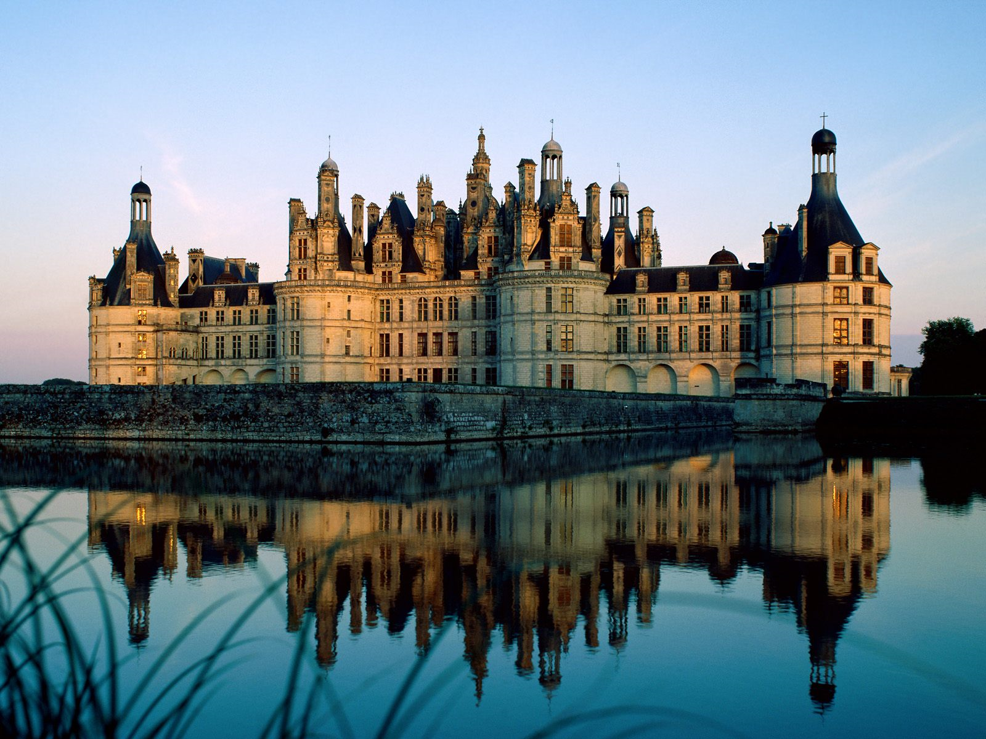

# Bibliography

Auzas, Pierre Marie. *Chambord.* Paris: Caisse nationale des monuments historiques, 1957.

Brown, Lorri. "W. European History, Francois I Renaissance King." *suite101.com.* September 1, 2007. http://weuropeanhistory.suite101.com/article.cfm/francois_i_renaissance_king (accessed November 23, 2009).

Buckley, Priscilla L. "THE LOIRE: ONCE OVER LIGHTLY." *National Review Vol. 29 Issue 22*, June 10, 1977: 681-683.

Chaddock, Gail Russell. "Linger in the chateaux of the Loire." *Christian Science Monitor Vol. 87 Issue 86*, March 30, 1995: pg 13.

Dutton, Ralph. *The Chateaux of France .* London: B. T. Batsford LTD, 1957.

Gascar, Pierre. *Chambord.* New York: Macmillian, 1962.

Gebelin, Francois. *The Chateaux of France.* New York: G.P. Putnam's Sons, 1964.

Guerlin, Henri. *The castle of Chambord.* Paris: H. Laurens, 1929.

Hackett, Francis. *Francois Ier.* Garden City: Doubleday, Doran & Co., Inc., 1937.

*Loire Valley Online.* February 2, 2009. http://www.lvo.com/GB/MAG/CHATEAUX/CHAM/CHAM1.HTML (accessed December 9, 2009).

Moote, A. Lloyd. *Louis XIII, the Just.* Berkeley: University of California Press, 1989.

Sitwell, Sacheverell. *Great Houses of Europe.* New York: G. P. Putnam's Sons, 1961.