Catherine Weening

Professor Delano

PUB 606

16 October 2015

The Seven Elements of Design: How to Communicate More Effectively

The three elements of design that have interested me the most are words that amplify or elaborate an image (or vice versa), words used as an integral part of the message, and when words and images convey an idea together.

            The first, words or images amplifying the other, strikes a balance between showing and telling. Here is the cover design for the book *The Second Plane: September 11: Terror and Boredom*, written by Martin Amis:



The title alone states what the book will discuss. This image is not needed. However, the silhouettes of the Twin Towers from a ground-up perspective add a sense of foreboding and intimidation. The image adds a layer of design which makes the reader of the book (and the viewer of the cover) feel small and powerless, which describes the events of that day more than the title itself does. Even though the book’s title does fine enough on its own, the image helps add more emotion and helps bring out more of a reaction from anyone who sees this cover.

            Words used an integral part of the message is a tactic which combines the interpretations of both words and images together, as seen on *The Microscope and the Eye* cover:

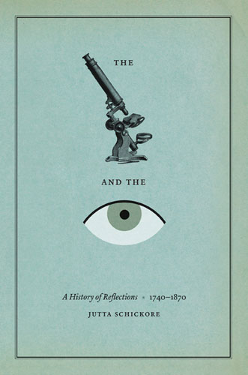

Though it would be simple enough to just have the text on its own, more meaning can be added to the title with the images because a designer has two media at his or her disposal. For instance, the images of the microscope and the eye contrast wildly. The microscope is detailed and scientifically accurate (for the time this book covers). The eye, however, is a modern illustration that is not anatomically detailed at all, marking the time before the improvement of microscopes; eyeballs were seen just as simply. It can also refer to how eyes were clearer and better understood after the innovations of the microscope. Despite the great amount of meaning the images provide, they would be meaningless without the text, which makes this element different from the images or words simply amplifying the other.

            The third element that interests me is “words and image convey an idea together.” They are dependent on each other to elicit an idea. This is seen in this cool advertisement for Norlis Antikvariat Bookstore, which is in Oslo:

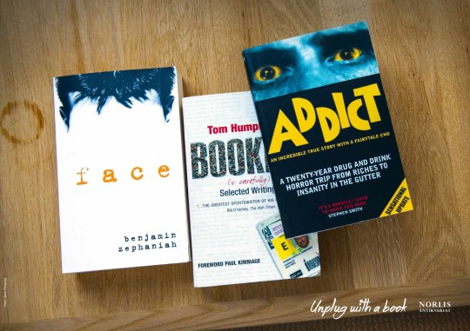

This is part of an ad series encouraging people to “unplug” by reading. With just the books laying there without the “Unplug with a book” caption, “Facebook addict” does not communicate the point of the advertisement. It would look like a PSA for being on social media too much, and the book aspect would not make sense. On the other hand, “Unplug with a book” alone does not convey the message, either. What would “unplug” mean in this context? With just that tagline, a consumer could interpret that as only buying print books instead of getting off social media. Together, the words and the image create the right message.

            These three elements of design, as well as the other four, help designers create the clearest and most effective message possible. These elements also help add multiple meanings so that many different people can take away the central message as well as their own interpretations.