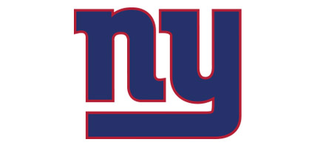

**Rusty Hawley**

Vice President

Marketing

Rewind 87 years ago, an American football team representing the New York metropolitan area was created along with four others that joined the newly found NFL in 1925. The New York Giants played their first game on a crisp afternoon on October 4th, 1925 against All New Britain in New Britain, Connecticut. In front of a crowd of 10,000 fans, the New York Giants defeated New Britain with a score of 26-0, finishing with a record of 8-4 for that season. Two years later, the Giants finished with the best record in the NFL of 11-1-1 and was awarded the NFL title. Fast forward 87 years, to the cold Sunday on February 5th, Mario Manningham ran in a 38-yard reception for the game winning touchdown.

Years of excitement and thrill, the New York Giants never let their fans down, whether it’s the high-performance level, the emotion put into the game or the family on the field, the New York Giants fan gets an exclusive experience. From the signature blue and red colors to the NY logo that is available to fans on signature jerseys, t-shirts and hats, the New York Giants have created a huge fan base that is appreciated beyond the borders of New York. The NFL’s New York Giants allures to all audiences and provides the ultimate fan experience to everyone.

As the time goes on, the Giants have learned to change with their fan group in order to keep their fans satisfied. The New York Giants is not just for men with their pals drinking beer; NYG football has become a family oriented organization that is open to anyone, at any age to join in on the excitement and fun. The Giants have teamed up with organizations to help fund camps for kids, and the WISE organization to get women involved in sporting events. The Giants do a great job of changing with the times and appealing to ALL audiences.

The newly built stadium attracts to ALL audiences with it’s new seating arrangements and modern features such as four flat-screen LED screens that help all fans see every inch of every play, where all fans can enjoy the game no matter where your seat is. The New York Giant’s have also been working on a women’s line for the past few years, and have successfully created a new retail set of clothes, which also feature jerseys, shirts, pants and sweatshirts. Now everyone can represent the well-known and original red and blue colors.

Upon receiving this letter, I encourage you to take part in this year’s season. Tickets are available at newyorkgiants.com or if you call our toll-free number you can purchase tickets for any specific seat you want! Support Big Blue and purchase your authentic jerseys today, to wear to the games as well, there could never be too much support! The Giant’s are a fan-based team on personal levels, so they need their fans! The NYG’s 2013 season will not disappoint you and we guarantee it! The thrilling fan experience you will receive in return will be worth your while and like no other fan experience out there. Your team, managers and of course the players appreciate all the support of our loyal fans.

Sincerely yours,

Rusty Hawley

Vice President