Running Head: Women Leadership Communication

Women Leadership Communication in the Context of Event Planning

Samantha Clarke

Department of Media, Communications and Visual Arts

Pace University

861 Bedford Road

Pleasantville, New York 10570

Introduction

Benefiting the lives of women, a ‘women’s emancipation movement’ so to speak, has made overpowering impressions throughout the past 30 years. In terms of economic, social and political gains, women have been able to make an impression in the workplace. Feminist movements and university women studies have caused a wide range of evaluation in women equality. Although there have been more and more of these movements, sex discrimination in businesses and occupations continues (Clegg, Hardy, Lawrence & Nord, 2006). This is very true when it comes to the area of leadership. Although more and more women are assuming leadership positions within all types of organizations (Jacobson, Palus & Bowling, 2010) their status and job certainty is often taken for granted. One of the tools that women leaders have to draw even during these times is communication relative to their unique intuitions.

Although there has been a great deal of research on women leadership and communication, the majority focuses on general organizational contexts. There have been very few studies that investigate specific organization contexts such as event planning. To begin addressing this gap, the current project seeks to investigate the communication practices of women leaders in the event planning industry. Data from semi-structured interviews of women event planning leaders will be used to explore the consequences of their communication practices. Moreover the data will provide a basis which to analyze how certain women have handled institutionalized structures within the industry to rise to the top of their profession.

Literature

Women leaders

The problem here is that women are not recognized for what they stand out for. Women have to constantly stand up, make impressions, and outwork others in order to be acknowledged. What I have recognized is that in the field of communications women stand out more. There are more and more roles in businesses that require a women’s point of view or a women’s touch. Event planning is career based off of communications and it is currently uprising with recognition. Because this day and age are so technologically equipped and advanced, there are many more ways of communicating and reaching out to the public. Businesses and companies have to find out new alternatives to make them stand out and be unique to the eyes of the public. Because of this, the event planning industry is booming. In order to promote a new product, introduce a new person, advertise your business, or entertain your clients, events are in need. The people who work for finance departments, human resource departments, or even marketing departments cannot do this aspect of the job.

Communication is an essential aspect in the work field and without it organizations and business would not be able to function. Everyone communicates in a different form and have unique interpretations of what type of communication is necessary for different situations. Being a leader in a business, some major skills to have are, being able to think before acting, gathering all information before making a conclusion, focusing on personalities rather than issues, and being direct and clear with whatever you are trying to get across to your team or group (Lewis). In the workplace a manger or even employee must not make things personal. Whether you are getting critiqued, criticized, or questioned, it is beneficial to your work environment. Being able to be emotionally intelligent, and keep emotions that do not belong in the workplace outside of the work place, are essential to being successful. Seeing that women are known to be more emotional then men, this could be a factor as to why they are not seen as high executive material.

Communication can be defined as “ the imparting or exchanging of information or news” (Oxford Dictionary). Studies have shown that women have more neuro-connectors in their brains (livescience.com). Relating to the field of event planning, it is known that women take on these roles more than men. Event planning requires interpersonal skills, communication skills, organization skills, and creativity. When it comes to high executive positions, we generally think of a male figure. In this field this is not the case. These kinds of skills are portrayed through women.

In a world where people automatically think of a male when the term CEO or Executive is expressed, the case may not always be such. The glass ceiling allows for the underrepresentation of women in high executive positions. There are obstacles that women face that men do not necessarily face as often. When it comes to work women may have more “conflict with work and family”. Women can and are being recognized in this field. It is something they are good at and enjoy doing. Because you may see three different generations of people working together in one company, teamwork is a highly recognized quality of a company. It is said that women use teamwork and relationship building skills when they lead more so than men. Being that different generations have different values, being able to make them work well together and as a team is of high importance (Buckalew, Konstantinopoulos, Russell & El-Sherbini, 2012).

According to Martin-Young (date), the three main skills essential to a workplace she found were teamwork, communication, and flexibility. In any workplace environment communication skills are fundamental. Whether it be oral, transcribed, or technological, communication is necessary to get any job or task done effectively. You have to speak with people all day long and be able to speak clearly, get your point across properly, make sure others interpret what you are trying to get across correctly, as well as listen to others and hear their ideas and concerns out.

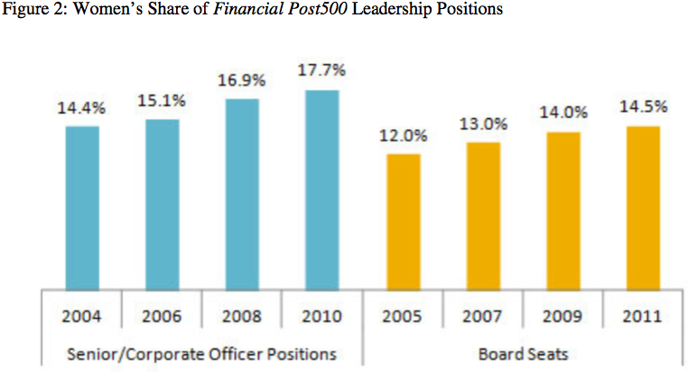Because many women take on more executive titles more often, it could be said that things are changing with equality and discrimination. However, in most business and financial careers, this is not the case. When it comes to event planning and project management, women are taking the lead. Encouraging the stereotype of women being housewives, or decorative and organized, women in event planning is something that seems normal.

There are multiple psychological gender differences between men and women. They differ in communication styles as well as influential styles. Karima Merchant, a senior at Claremont College, wrote in her senior thesis that the main difference in men and women communication skills is that they have different perspectives on the purpose of a conversation. Her studies have shown that men use conversation for a perceptible result, while women use it as a source of “social connection” and to expand relationships. Men use assertion and just try to get their point across while women are polite and patient (Leaper, 1991; Maltz & Borker, 1982; Wood, 1996; Mason, 1994). This is also seen in the context of society: where men strive more for independence and power, women aim for interaction with others. Due to women generally having lower statuses in society, it has been found that women tend to interrupt less, swear less, and use a calmer more patient tone (Thorne & Henley, 1975). These characteristics are beneficial to the work place and building relationships with people in general. Although it is great that women can use these qualities to enhance the comfort of their employees, it is valuable when forming relationships with clients. In the event planning industry your main focus is making your client happy and doing what they need. A woman having these features makes them all the more suited for this position.

Research shows that women have listening skills that allow them to be enlightened to positive and negative vibes in their companies that help them direct business in a better direction. In a work environment, variances in individuals have the ability to be very beneficial to a group or team. It is important that everyone that is working together knows issues that have potential to occur. Women possess qualities that are necessary for conflict management, cooperation, extensiveness, as well as the ability to be just ("What Women Can," 2012).

Common practices

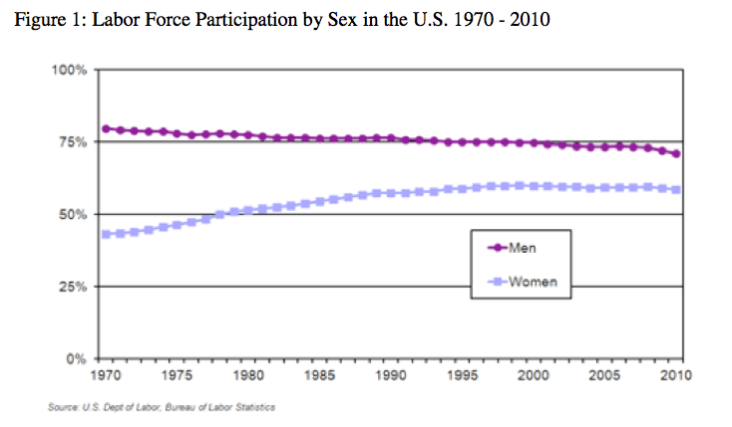More and more women are becoming high-level executives. Rather than the assumptions that they are following in the footsteps of men they have seen succeed, they happen to be leading the path to a new and unique type of leadership. Women are using the skills they already have to become the great leaders they are. This is what is making them succeed – being the feminine women they have always been. Women tend to describe themselves as influential and including. They like to make relationships, help people understand why they are doing what they are doing, and use relational skills to help everyone in a team make their goals a bigger picture that can benefit the goals of a team. Judy B. Rosener explains how after doing research based off of an International Women’s Forum survey, she found that there is a way women use leadership that differs from men, and that they feel is much more beneficial. It is called “Interactive Leadership.” Instead of using “command-and-control” leadership styles that tend to be most used by men, women try to include their employees and make everyone working together feel important. When employees feel needed and useful, they will be useful. Women also manage to influence participation. This way, when employees work together they too form relationships and feel better about where they are working and with whom they work with. Rosener states that women leaders try to infuse this thought of “group identity,” which allows everyone to feel included and as if they share a common knowledge with everyone.

Including employees in management decision-making is also another way some women leaders keep their workforces engaged. Letting them feel like they are a part of a major decision not only makes them feel important but also allows them to gain experience in what management needs to do.

Women have unique leadership characteristics that differ from those of men. It is seen that these traits have a way of benefiting a company and making the whole environment different. Not to say that these qualities are any better than men, but they touch people in a different light and they go about their businesses or companies in ways that are distinctive to women. A profession where women can use the behaviors they have been brought up to use and can function with naturally would be event planning.

Event planning- (add women)

“Events are organized acts and performances, which have their origins in ancient history,” as stated in *Events Management*. The two major components of events are the amount of stakeholders and the objective at hand. More objectives are required when the scope of the event is larger. The amount of stakeholders is also relevant to the size of the event as well. Whether or not there is an actual “event industry” can be debated. However, people who organize music events, weddings, or the production of exhibition potentially all see themselves as working in their own industries rather than in the events industry. Regardless of the title, businesses, small or large, need someone or a department to aid them in putting together conferences, press events, incentives, or any sort of exposition (Raj, Walters & Rashid, 2009).

The book *Events Management* uses the term “event support services.” Whether there is a sporting event, live music performances, small or large business meeting, conference, convention, press event, art gallery, etc. there are certain facets that people in the industry only contact specific people about. The skills individuals may have that stand out from others in their business that make them applicable for the events industry would be being able to change the mood of an environment by lighting, knowing the perfect speaker to present a product to the public, or being able to differentiate between calming colors, and exciting colors for the space of an event. A few particular abilities an event planner must convey are organizational skills, time management, people skills, research skills, commercial awareness, problem solving skills as well as many others (Raj, Walters & Rashid, 2009). Having these qualities are what will make an individual successful in this industry.

The Johnson and Wales University Event Leaders DACUM process indicates the essential aspects and tasks associated with obligation areas such as executing promotions and advertising, and inaugurating strategic conglomerates and partnerships. The outcome of the DACUM, Glodblatt describes is a portrayal of an event leader: “they are strategic thinkers where their essential tools are knowing communication equipment as well as a business developer that has the ability to implement marketing plans.” This reveals that communications is the missing element. It is vital to have the ability to communicate properly and effectively with employees, clients, and stakeholders.

Joe Goldblatt states, in his book *Special Events: Event Leadership for a New World,* leadership skills in individuals are influential in “strategic planning.” Leadership is developed through tactic, and a continuous stream of ideas and action. Communication is the missing element. Skills in event planning are based off of communication (Goldblatt, 2005). The way you speak, your ability to listen, and the way you handle situations with employees as well as clients are all of the communication-based aspects that benefit the workplace of an event planning business. This explains why the event planning field is women dominated.

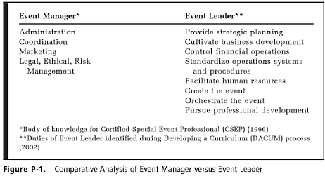There is a difference between event managers and event leaders. A manager does coordinating, marketing, and risk management while a leader provides strategic planning, creating of events, composing, and the business development of events. Goldblatt states that there is developing research authenticating the outcomes of event leaders. During research that Goldblatt conducted with a team at the George Washington University, statistics showed that most event planners he surveyed were majority females with a common 20 or more years of experience in the field. A problem facing the industry and its growth is the economy. Although findings between his researches along with research conducted by *Event Solutions* magazine have found that event planners have high hopes and a positive outlook on the future of the event planning economy.

There is limited research regarding women in event planning. The extent of the research steams from women leaders and what it takes to be successful in the event planning field. The current study elaborates on why and how women are the leaders in this field and what they do differently to make their businesses work.

Methodology

The current study used interviews with four different women who have successful positions in the field of event planning and project management. These women will discuss their job history as well as what they feel are the most important aspects of communication in the work place. Each interview was about 20-30 minutes long and I asked each woman the same questions. With high-level titles in their fields, these women put on large scale campus events, organize all rental and scheduling systems, and deal with a variety of social issues, and developmental issues.

Results

Definition of Communication

When asked to define communication in broad terms, the women came up with a variety of responses. Communications is when a company expresses to the public or whomever they are involved with, what their mission is. This can include media relations, print, events or any sort of public outreach. Communicating with people on a daily basis through phone, email, or media is communications. Being able to be personal with people, having the skills to hold a conversation as well as listen and take in information is communications. Communications is meeting new people every day and forming relationships through engagement on social media, websites, or personal experience.

Essential Event Planning Characteristics

There were major similarities between the three ladies responses to this question. Some common features stated were organization skills, detailed oriented, reliable, flexible, and tolerant. Being a leader does not always mean being on top. You have to be able to listen to others, and always being willing to pull through with grunt work if necessary. Having an ego is something that may get in the way of being a successful leader in this field. You must know when to be a team player as well as when your leadership skills are in need. Respondent 2 stated that you have to have customer service skills: being able to know when the client is right and being patient are essential to the success of your industry. Creativity is one characteristic that goes hand in hand with event planning. Being able to run with an idea or come up with something to alter a mistake or situation is necessary.

Communication Skills in Event Planning

Although much of these characteristics did not differ from the essential event planning characteristics, they are more directly related to the communication that happens between event planners as well as their clients. Respondent 1 stated that you have to be very clear and concise with your communication. It is beneficial to clarify the roles of everyone as well as each individual’s duties. Building and developing relationships with the people you work with create a great environment where everyone feels comfortable. Respondent 2 shares similar thoughts about communications in event planning. Customer service is something that has been reiterated. In order to gain trust or respect from lients, partners, or employees you have to be knowledgeable about the field, the event at hand, and who you are working with. There needs to be a level of understanding between everyone involved and that is done through successful communications. It is essential that when working with employees or clients you are able to manage your attitude and expectations. The phrase emotional intelligence is the entirety of the responses.

Females in the Industry

When asked if they work with more females than males in the industry, it was a common answer that within event planning there are more women to work with. However, when it comes to organizing corporate events and events in the business departments there are more men to be communicated and dealt with. Respondent 1 works in the non-profit business and she believes there are more women in that field as well as event planning as a whole. Nonetheless, like respondent 1, it is noticed that they work with mostly men in relation to government and corporate companies. Like the research found, the head of a firm may be a male but most event planners, a “60 to 40” divide, are women. Overall, women out weigh the men in the event planning field.

Why Women Take on Event Planning

There are many reasons we see more women in this field than men. My interviews have shown that women see women as more organized, more approachable, and more creative. There have been instances where these qualities are what make women successful in the field. They also find that this maybe be why they tend to take on positions like this in the businesses they work for. Women seem to be able to multitask more- they can handle emotions and people without concern. Women use their emotions to their advantage. It helps them deal with other peoples emotions as well. They feel that they are more willing to work with people in situations of need where as men may use their power to avoid those situations.

Uprising in the industry

Not only is communication beginning to be recognized as one of the most essential aspects of any business, but the event planning industry is on its way up. These women feel that their departments and companies are being acknowledged a lot more now. Respondent 1 states that 18 years ago when she started, the industry was no where near what it is now. There are now classes regarding event planning when that was never a class. Resources for event planning have not always been available. Women are also receiving higher levels of executive positions now. The fine line between male and female executives is becoming slimmer.

Discussion

1. Communication is essential to their ability to manage events … theoretically communication is an aspect of control … this is from the theory of design where it explains that communication helps us create things
   1. This then means that these women have developed a skill in designing events through communication …. My results suggest that women have unique leadership qualities and characteristics that they use to benefit the workplace. They are being recognized more as leaders in businesses and taking on advanced level titles. Although the line between men empowerment and women success is not completely faded, it has come a long way. Because women are realizing how they can use their natural talents and characteristics to benefit an environment, they have more confidence when taking leadership roles. This is beneficial to the event planning industry because it seems as though women are more fit for positions in this field.
2. Companies need event planning department …. This study draws this out by explaining that
   1. This information is so essential because this industry is gaining more credibility and awareness. More and more businesses are realizing that they need a department or individual who solely works on organizing events. Having this knowledge can affect the outcome of various corporate decisions. It takes more than a room and some technology to make a conference, product launch, or entertainment display to be successful. Not everyone can be engrossed with this mindfulness. Communication is not something that comes easy to people. Being able to effectively listen to someone or commendably get your point across is never a simple task. Being able to put together an event where people have an experience rather just gain insight on something is talent.
3. Women are leaders in the communications industry and they have specific abilities that make event planning a wise career choice for them
   1. Women have distinctive characteristics and skills that make event planning come easy to them. With skills such as listening, cooperating, be able to be a team player, not focusing on the power thrill, and relationship building qualities women have success leading their business a completely different way. Although the boundary between women and men leaders is not close to equal, it is on the way to narrowing out. With confidence and in the way women work and lead, there will be more of them. Because companies are acknowledging the need for a communications department and an event planning department, more women will be able to show off their talents and skills in something that we do naturally.
4. There was a great deal of limitation regarding literature for this study. There is a small number of respondents but this is mitigated by the fact that there has not been any research on the communication practices of women event planning leaders.
   1. The literature in this study revealed that there is research on different aspects of the event planning industry whether it is the economic aspects, the leadership aspects, or what goes into the planning, the industry is still new and we are finding these things out as we go on. The industry is constantly changing and increasing; therefor, we have more experience and opportunities to research. Now, in the beginning of this production, women are the majority of the leaders running this industry. Multiple research shows females running their event planning companies and taking the lead. These are new opportunities and as women gain more respect in the business industry, they are open to more job prospects. This study shows that women have certain talents that allow them to excel in this field and there is much educational background that contributes to the experience women can retrieve.

Conclusion

I was able to gather a good sample of women as well as women research that allowed me to see in to the business eye of communications and all of the leadership aspects that are not normally portrayed respectively. The event planning industry is on its uprising and businesses are realizing how important communications is to have in their company. There are specific communications tactics and skills that are necessary to the success of a company. Similarly, women are becoming more recognized for the skills they have that are unique to them. Women in the field of event planning are aware of the talents they portray and what makes them stand out when it comes to communication as well as event planning. Research regarding women in event planning is limited because of how new the industry is and the new representation it is gaining. This study was able to allow me to look into the business aspect of women leaders, what it takes to communicate effectively in the event planning workplace, and what it takes to be a women leader using the skills I already distinctively have.

**References:**

Lewis, Michael. "10 Tips to Develop Effective Communication Skills." Money Crashers: Your Guide to Financial Success. Money Crashers, 2013. Web. 12 Nov 2013. <http://www.moneycrashers.com/effective-workplace-communication-skills/>.

Martin-Young, Nancy. "Employers Talk Back." Communication Skills in the Workplace . (1996): n. page. Web. 12 Nov. 2013. <http://www.sandhills.edu/academic-departments/english/teaching/comskills.html>.

Leaper. C. (1991). Influence and involvement in children's discourse: Age, gender, and

Gender Differences in Leadership 59 partner effects. Child Development, 62,797-811.

Maltz, D. N., & Borker, R. (1982). A cultural approach to male-female miscommunication. In J. J. Gumpertz (Ed.), Language and social identity. Cambridge; Cambridge University Press.

Mason, E. S. (1994). Gender differences in job satisfaction. The Journal of Social Psychology,135, 143-151.

Wood, J. T (1996). Gendered lives: Communication, gender and culture (2nd ed).

Belmont, CA;Wadsworth.

Thorne, B, & Henley, N. (1975). Difference and dominance: An overview of language, gender, and society. In B. Thorne & N. Henley (Eds.), Language and sex: Difference and dominance, Rowley, MA: Newbury House Publishers, 5-42. U.S. Constitution, Amendment XIX.

What Women Can Bring to Project Management. (2012, March 12). Retrieved from http://www.prince2.com/blog/what-women-can-bring-project-management

Goldblatt, J. (2005). Special Events: Event Leadership for a New World. Hoboken, NJ: John Wiley & Sons, Inc.

Raj, R., Walters, P., & Rashid, T. (2009). Events Management: An integrated and Practical Approach. (pp. 1-10). London, England: Sage Publications Ltd.

Buckalew, E., Konstantinopoulos, A., Russell, J., & El-Sherbini, S. (2012). The Future of Female CEOs and Their Glass Ceiling. Unpublished manuscript, , Available from Journal of Business Studies Quarterly. (ISSN 2152-1034).

Clegg, S., Hardy, C., Lawrence, T., & Nord, W. (2006). From the Women's Point of View Ten Years Later: Towards a Feminist Organizations Studies. In The Sage Handbook of Organization Studies (Second ed., pp. 283-293). Retrieved from http://books.google.com/books?hl=en&lr=&id=gJBOZ1a8u-4C&oi=fnd&pg=PA284&dq=handbook+of+organization+studies+1996+calas&ots=Y5pEPXLsrh&sig=4Vx5jYvBWf-ENvG5HyRc8NvWasc#v=onepage&q=handbook%20of%20organization%20studies%201996%20calas&f=false