**Propensity for Voluntary Turnover in a Recession-Like Economy**

By: William W. Woodard, III

Advisor: Dr. James W. Russell



Business Honors Program Thesis

Spring 2012

**Abstract:**

Voluntary Turnover (VT) is a situation in which employees choose to leave their job for their own reasons. During a recession or similar situation, one would think that such an occurrence would not be much of an issue. However, recent studies show that substantial proportions of workers are actively seeking new jobs despite a high unemployment rate and slow or no growth in the economy. Voluntary turnover is a very real problem for companies trying to keep their operations going smoothly during a recession-like economy. This study, which included a survey of over 60 workers, confirmed that propensity for voluntary turnover is considerable and is not significantly correlated with age, the fear of losing one’s job, alignment with company vision, or the existence of other job opportunities.

**Introduction:**

One of the biggest concerns in the field of human resources has always been employee turnover. Why exactly do employees choose to leave their jobs? Many researchers have devoted their time and effort to figuring out the answer to that question and how to keep employees from leaving. There have been many theories as to why people leave, but not many of these theories address why someone would willingly choose to leave their job during a recession. When a country is going through harsh economic times many people get laid off from work and the unemployment rate rises to new heights. Many citizens struggle just to keep their lives moving forward. In a situation like this, one would most likely be searching for ways to keep their current job rather than leaving it. In a sense, people are just trying to find and keep a steady paycheck. In the article “To Develop Is To Retain,” Jan Ferri-Reed examines the fact that “more than 80 percent of workers may now be actively seeking new jobs,” and that companies “may be losing some of their best and brightest.” It has also been stated that “many organizations are also increasingly concerned about their ability to retain key employees,” (Aleen, Bryant, & Vardaman). This is a problem that needs to be addressed.

Employee turnover is usually an important issue for any Human Resources Department. When a company starts losing its skilled workers productivity starts to go down. ~~along with it.~~ Employees may start to lose morale and it could become difficult for a company to stay in business. This issue could potentially make or break a company, especially during a recession. Some turnover during harsh economic times could be seen as downsizing by the company, but voluntary turnover of their skilled workers is not the same. Skilled workers are hard to replace, and there are several costs incurred by the company including advertising for the open position, time spent screening and interviewing candidates, pay to cover the responsibilities of the former employee, training for the new employee, whether or not the new employee can effectively replace their predecessor, and the potential loss of morale within the company.

In a world where competition is growing globally, companies need their best employees in order to survive, let alone succeed. When a company begins to expand across the world, they want to use their best and brightest to accomplish this. They send their most successful and trusted employees to lay the foundation for future growth. They cannot do this when key employees leave. Companies with the best retention strategies will be better equipped to engage in successful business operations both at home and abroad.

My study will examine the potential for an employee to leave during harsh economic times. This will be referred to as propensity for voluntary turnover (VT). It will be tested against several variables that may have a correlation with VT. Once any correlations have been found, they will be put into formulas which will hopefully be of use to managers. Another purpose of this study is to just examine how individuals think about their jobs and positions in a recession-like economy. In the event that my hypotheses are proven false, the study could still be used as a reference to determine the thought process of various types of employees.

**Literature Review:**

In “Retaining Talent: Replacing Misconceptions With Evidence-Based Strategies,” the authors found that there are five general mistaken views on employee turnover, (Allen, Bryant, & Vardaman). 1. Many people believe that all turnover is the same despite the situation. 2. Many people think that all people quit because of monetary compensation. 3. Many believe that most people quit because of job dissatisfaction. 4. Many employers think that there is nothing managers can do to change turnover decisions. 5. Many also believe that one retention strategy will be effective in all situations (Allen, Bryant, & Vardaman). Despite all these misconceptions, the authors found evidence to the contrary.

As opposed to the first misconception, they found that there are many different types of turnover and some of it is functional, (Allen, Bryant, & Vardaman). I agree with this because in the current situation of the US, turnover could be a company downsizing, unsatisfied workers, workers leaving for new opportunities, or even some people leaving for no discernible reason. The truth behind the second misconception is that pay is a weak indicator of turnover and that aspects such as job satisfaction and commitment are stronger indicators (Allen, Bryant, & Vardaman). I feel that this is also true because these are the same reasons that I stay at my current job.

Opposition to the third misconception is that job dissatisfaction accounts for less than half of turnover (Allen, Bryant, & Vardaman). I think that most people stay because they are close to their co-workers. The fourth misconception was disproven because managers have been able to effectively influence turnover through the way they manage, (Allen, Bryant, & Vardaman). People like to be motivated and treated with kindness and dignity. They don’t want to be treated like they are lower-grade or less worthy individuals, which is unfortunately how some people manage their workers. The fifth misconception was examined to find that turnover needs to be analyzed and dealt with on a situational basis when it is negatively affecting the company, (Allen, Bryant, & Vardaman).

In “To Develop Is to Retain,” Jan Ferri-Reed develops a few short methods to help with employee retention. The first is to “identify the keepers,” let them know, and develop them, (Ferri-Reed). I think that this is a good strategy because it creates a sense of trust between employees and employers. When a worker knows that you value them and their development, you are essentially saying that you need them. Although this seems like somewhat of a dangerous tactic, it creates trust because you give the employees information that is crucial to the company. The next strategy is to “incorporate learning into an organization’s employment brand,” (Ferri-Reed). This means that companies should try to build employee growth into how the company is viewed by those within and outside the organization. This is like creating a new culture. Who wouldn’t want to work for and stay with an organization that values and invests in its employees? The following part of the strategy is to uncover the organization’s weaknesses through interviews, (Ferri-Reed). This shows that the company is constantly trying to improve upon itself and it values the opinions of its workers. This is extremely important in today’s constantly changing world because if you aren’t improving, then you are falling behind. The last part of the strategy is to “keep in touch with the keepers,” (Ferri-Reed). This basically means that if an employee leaves, it doesn’t have to be the last time they work for the company. This is a very open-minded strategy.

In Jeffrey B. Arthur’s article “Effects of Human Resource Systems on Manufacturing Performance and Turnover,” he categorized human resource practices into control and commitment systems and examined which was better for manufacturing performance. The main theory behind control systems is to basically make employees into robots. They have a set of rules that they must follow and through following those rules they must achieve certain goals (Arthur). I don’t really support this method because this is partially the reason that employees choose to leave a company. They have no room to essentially “color outside of the lines.” With this type of mentality employees can become frustrated because they can’t think for themselves and they have no opportunity to grow. Although this system is supposed to reduce labor costs, I feel as though it would actually increase them. This is because employers will spend more money on supervisors for other workers.

The mentality behind the commitment system is to get employees involved in managerial decisions, (Arthur). I feel that this would be more beneficial than the control system because employees would feel like they are a part of the organization rather than just another worker. Arthur also examined the relationship between “turnover level and manufacturing performance.” Through this study he found two things. 1. Arthur found that commitment systems are overall more effective than control systems. This supports my belief that a commitment system would work better than a control system. 2. Arthur found that more study needed to be done on the relationship between turnover level and performance. This confirms that turnover is an important topic in the world of human resources.

In Sunil Ramlall’s article, “A Review of Employee Motivation Theories and their Implications for Employee Retention within Organizations,” he explains several retention theories and why companies would want to retain certain employees. Sunil and I are in agreement that “the total cost of an exempt employee turnover is a minimum of one year’s pay and benefits, or a maximum of two years’ pay and benefits.” However, I also think that employees are more than just a representation of pay and benefits. Key employees can sometimes represent years of knowledge and built up morale within a company. That “is the knowledge that is used to meet the needs and expectations of the customers,” (Ramlall).

Through Ramlall’s examination of various retention theories, he found that employees stay with a company when their needs are met, when they have a positive work environment, and when their skills are being developed. This seems to be a great deal of company engagement. When employees have particular needs that are being met, such as pay or benefits, they may be more likely to stay. It could also be said that when employees aren’t put under a great deal of negative stress, then they would be less likely to leave their organization. Also, when an employee’s skills are being developed and acknowledged, it adds to their company engagement and the possibility of them staying with their company.

The article “Underlying Labor Market Dimensions of “Opportunities”: The Case of Employee Turner,” written by Alan Kirschenbaum and Rita Mano-Negrin, talks about the relationship between opportunity and employee turnover. These authors believe that the perception of other opportunities for an employee have “become a prime linkage concept in research understanding employee turnover,” (Kirschenbaum and Mano-Negrin). My thought would be that if an employee believed they had job opportunities elsewhere, then they would be more likely to leave their current position. If you have better opportunities, pay and benefits somewhere else, why would you want to stay at your current job? I don’t believe you would.

Kirschenbaum and Mano-Negrin created a multi-part survey of 700 respondents over the course of about a year. The initial part tested for an employee’s perception of their opportunities elsewhere and the likelihood of that individual actually leaving. The next part of the survey, which was about six months later, tested whether or not individuals actually left the company based on previous findings, (Kirschenbaum and Mano-Negrin). The authors concluded that “perceived opportunities are not catalysts in an employee’s *actual turnover* decision,” but “such opportunities seem to augment attitudinal intentions to leave,” (Kirschenbaum and Mano-Negrin). This surprised me because originally I thought that opportunity would be a great indicator of actual turnover. However, this did give me the idea that opportunity has a great deal to do with turnover as a whole.

Charles E. Michaels and Paul E. Spector wrote a response article, titled “Causes of Employee Turnover: A Test of the Mobley, Griffeth, Hand, and Meglino Model,” which went into a discussion about the various causes of turnover. Their response and study were used to test a chain of causes and effects that would eventually lead to turnover. Some of the factors that went into turnover were: age, tenure, job satisfaction, job opportunities, organizational commitment, employment expectations and thoughts of quitting. These authors tried to find a linear relationship between these factors that would lead into actual turnover. Although they were able to find a relationship with some factors, other factors were less supported. However, they did conclude that “when the job market is good…turnover is more likely,” (Michaels and Spector). I don’t necessarily agree with that conclusion. Even in a poor job market, certain key employees would still be able to find jobs. In a sense, part of the workforce would actually have a high likelihood of turnover despite job market conditions.

Terence R. Mitchell, Brooks C. Holtom, and Thomas W. Lee examine turnover in a few different ways in their article “How to keep your best employees: Developing an effective retention policy.” They start off by stating “[t]he competition to retain key employees is intense,” and “[v]oluntary turnover is a huge problem for many organizations,” (Mitchel, Holtom, and Lee). This supports the idea that turnover is a huge topic in the business world. Some of the reasons employees leave may include spouse relocation, other employee turnover, and desire to continue one’s education (Mitchel et al.). This adds the thought that employees quit their jobs for more than just the traditional reasons. It supports the idea that employee turnover still needs to be examined further. The authors determined that the best plan for retention was to keep one’s employees embedded in the company. That is to say that you need to think about more than just pay and benefits if you want to retain your key employees.

**Hypothesis:**

H1: **As age increases, there will be a lower propensity for voluntary turnover.** As people get older, they will be more likely to stay with a particular organization. After acquiring a college degree, we are generally in a position to try a variety of different jobs in various fields. In this situation, propensity for voluntary turnover would be relatively high because we are still unsure of what job(s) best fit our skill set. In a sense we are in the process of figuring out who we really are in the working population. During this time it would be very unlikely that our first job out of college would be the one we retire from.

As we age, we gain wisdom and a better grasp of what we want from the organization we work for and what is required of us. One could say that we just become more knowledgeable about ourselves. As this occurs, we will typically find an organization and position that fits our needs and desires. This will essentially decrease the propensity for voluntary turnover. In addition to this, as one gets older they are more likely to have responsibilities to people other than themselves. This might include a spouse and/or children to take care of. In order to support one’s family, they may be so inclined to keep a steady job.

H2: **As the likelihood of an individual being fired increases, there will be a higher propensity for voluntary turnover.** Of the many reasons people choose to leave their jobs, sometimes the answer is pride. When one hears rumors of their possible termination from a company, whether by downsizing or from poor performance, they may want to change how the situation is seen. Rather than be viewed as the worker who got fired or “downsized”, some find solace in leaving of their own free will. This may also represent a desire to leave one’s company on good terms rather than poor terms.

H3: **As the amount of opportunities other than one’s job increases, there will be a higher propensity for voluntary turnover.** Harsh economic conditions could be viewed as the result of poor practices being used for too long. People could see this analysis as a need for change in the system and a change in their own lives. People sometimes leave for a ‘different’ opportunity. This is not necessarily a better opportunity, but possibly something unlike their current profession. People also leave to follow their dreams. When a recession begins, many people are faced with the problem of keeping a pay check and/or providing for themselves and others. However, many could also see this as an opportunity to follow dreams that were previously put on hold.

During a recession or harsh economic times, an employee will be more likely to leave a company where they have been doing well in order to start something new. Whether this is expanding their education or starting another career, the idea of starting anew is coupled with starting fresh to avoid potential problems at the company due to the recession. If one was able to start something new and get away from the old way of doing things then this could be the first step to ending the risk of future economic distress.

H4: **As the level of company engagement increases for an individual, there will be a lower propensity for voluntary turnover.** I believe that many people choose to stay with their employers because of a combination of three reasons. 1. People stay because they are invested in the company’s vision. When one believes in what their company stands for and want to help it move towards those goals, he or she will be eager to work hard and excel in the work place. 2. People stay because they have a positive work environment. When one gets along with their co-workers and doesn’t have too many work related grievances, they generally have fewer reasons to leave. 3. People stay because their work fulfills some part of themselves. Everyone has dreams and aspirations. When the work they do coincides with some part of their dream, they are more than happy to go to work.

H1: Age

H2: Likelihood of being fired

Actual Voluntary Turnover (VT)

Propensity for Voluntary Turnover (VT)

H2: Other Opportunities

H4: Company engagement

**Methodology:**

I studied the relationship between voluntary turnover (VT) and several factors including: age, likelihood of being fired, other opportunities, and company engagement. While there may be other factors that increase the likelihood of voluntary turnover, I felt these to be some of the most important. I focused on the propensity of a worker to leave their job voluntarily during harsh economic conditions. Because of this focus, I tried to gear my questions to cover a time span of December 2007 to the current day. This is around the time when the most recent recession in America began, (NBER). Although we may have technically come out of the recession, many people and businesses in America are still going through harsh economic times. Even though we are in a period of recovery coming out of the recession, many still think that we are still in a recession because of the high unemployment rate and the lack of available jobs. After the most recent recession ended in June 2009, the unemployment rate stayed around eight to ten percent, and job openings have stayed very low compared to before the recession began, (BLS).

After reading several articles, I created and distributed a survey that tested the relationship between VT and the aforementioned factors. The survey was made through the Qualtrics online survey system and distributed through an informational email which contained a link to the survey. The survey was made up of 46 questions and it took about 20 minutes to complete. The survey was available from February 23, 2012 until March 28, 2012. I was originally hoping to receive somewhere around 40-50 responses, but I ended up with 70. Out of that 70, only about 64 respondents completed the full survey. I based my results off of those 64 responses. I thought that since I am still an undergraduate student, many of my respondents would most likely be other college students and recent graduates. However, I believed that I have made enough connections throughout my time at Pace in order to gather a fair distribution of respondents from both college students and those in their professional careers. I personally emailed the survey to 100 people. Then I also asked two professors to send it out to recent Pace University graduates. They both sent it out to about ten people. Since the survey was sent to about 120 people, I received a 58.3% response rate and a 91.4% survey completion rate.

I wanted to make sure that a fairly diverse group of people responded to my survey so that my results could be applied elsewhere. Although I sent the survey out to family, friends, and business contacts, those three groups are composed of people from various parts of the United States and various backgrounds. This gave me a brief insight into the larger question of why someone would willingly leave their job during harsh economic times.

The questions within the survey were made to examine each hypothesis in several ways wherever possible. Some questions were asked several times and deliberately re-worded, but for the most part, they still asked for the same information. I felt that this would be the best way to figure out what people think about when they consider leaving their jobs.

After I received all the results, I made cross tabulations to see how people responded versus different questions. I made cross tabulations to check results of various groups of questions including: propensity for voluntary turnover, age, likelihood of being fired, other employment opportunities, and company engagement. Within the cross tabulations, I highlighted what results I expected to find based on my hypotheses in yellow and I highlighted what was actually found in light green.

Since I was trying to figure out why people potentially leave their jobs, propensity for voluntary turnover became my dependent variable and my hypotheses became my independent variables. This is meant to show the relationship between propensity for voluntary turnover and my hypotheses and it is not meant to imply causality. Each hypothesis was tested against propensity for voluntary turnover through a regression equation in an Excel spreadsheet. Each regression equation yielded information which included the r2 and the coefficients for the equation. The r2 shows how closely correlated each variable is to propensity for voluntary turnover. The closer the r2 is to 1 (r2=1), the easier it is to use that variable to predict propensity for voluntary turnover. If the coefficient is positive, then the correlation is positive. If the coefficient is negative, then the correlation is negative meaning that the variable and propensity for voluntary turnover are inversely related. For each question that was tested against propensity for voluntary turnover, the answers to that question were assigned values of 0-4 or 0-5 depending on the hypothesis being tested and the number of answers. The point values can be seen in the **Appendix: Point Values**.

**Results:**

The results of the survey can be seen in **Appendix: Qualtrics Results**. The sample was split fairly evenly on gender with 45% of the respondents being male and 55% being female. However, the age distribution was heavy on the younger side. The distribution was as follows: 54% ages 18-24, 27% ages 25-32, 3% ages 33-40, and 16% ages 41 and older. Other results will be discussed in the section on each hypothesis.

H1: Propensity for voluntary turnover (VT) to occur will decrease as age increases. I expected VT and age to have a negative correlation and an inverse relationship. This hypothesis was not supported. Although there was a negative correlation within the regression equation, the results were so scattered that one could not effectively predict propensity for VT based on age. The r2 equaled 0.00599, which means that age and propensity for voluntary turnover were not closely correlated within my study. The x variable coefficient was -0.096, which means that age and propensity for voluntary turnover are negatively correlated within my study. This data is supported below. “Q3” represents question 3 from the survey and “VT” represents propensity for voluntary turnover which is question 23 from the survey. Both questions can be found in **Appendix: Qualtrics Results**. This data is also supported by the cross tabulations found in **Appendix: Cross Tabulations**.

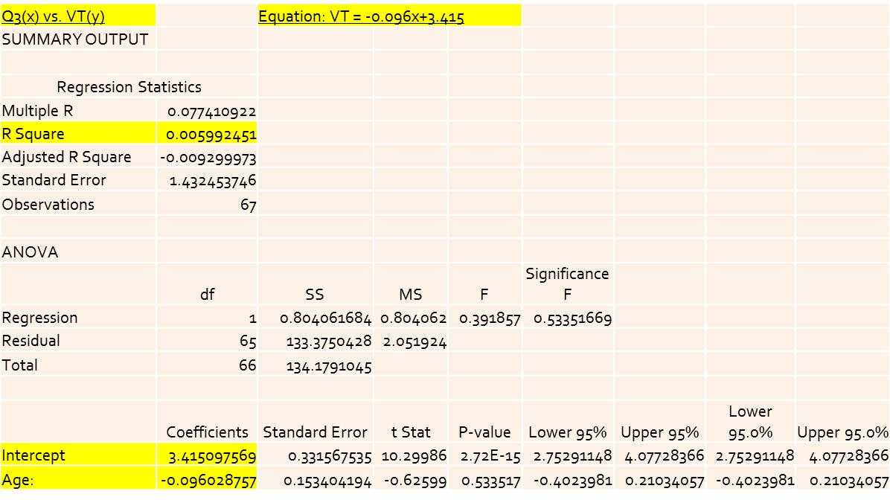

H2: Propensity for voluntary turnover (VT) to occur will increase as the likelihood of an individual being fired increases. I expected VT and likelihood of being fired to have a positive correlation. However, this was not supported. Since there was no single question to determine the likelihood of being fired, I used a multiple regression equation within Excel using questions 43 and 17 from the survey as a basis for likelihood of being fired (See **Appendix: Qualtrics Results**). For question 43, if a respondent felt they were not a “KEY” employee, then they were thought to have a higher likelihood of being fired and a higher propensity for VT. For question 17, if a respondent felt that they would not be at their current job in the next year, then they were thought to have a higher likelihood of being fired and a higher propensity for VT. The r2 equaled 0.1218, meaning that likelihood of being fired was not a good predictor of propensity for VT in my study. However, since the x1 and x2 coefficients were both positive, likelihood of being fired was positively correlated with propensity for VT even though the correlation was low. This is supported by the regression equation results below.

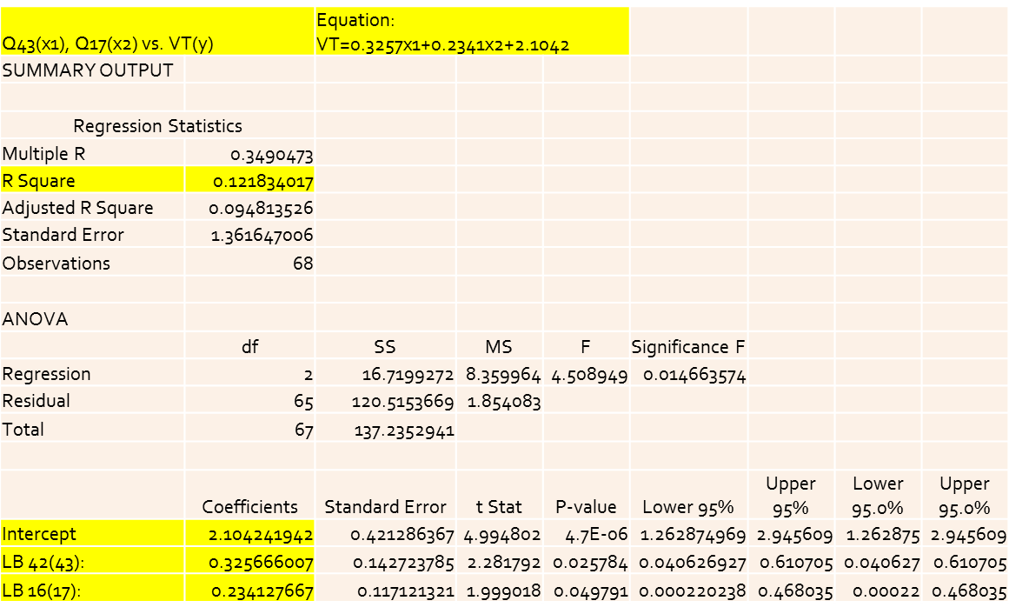

H3: Propensity for voluntary turnover (VT) to occur will increase as the number of other opportunities an individual has increases. I expected the number of other opportunities and the propensity for VT to have a positive correlation. However, this was not supported. I used question 12 from the survey to represent other opportunities, (**Appendix: Qualtrics Results**). If a respondent had more years of experience, then they were expected to have a great amount of opportunities and a higher propensity for VT, (**Appendix: Cross Tabulations**). The r2 equaled 0.006630, meaning that the amount of other opportunities was not a good indicator for propensity for VT in my study. In addition to this, I also found that these two variables were negatively correlated since the x coefficient equaled -0.09127. This data is supported below.

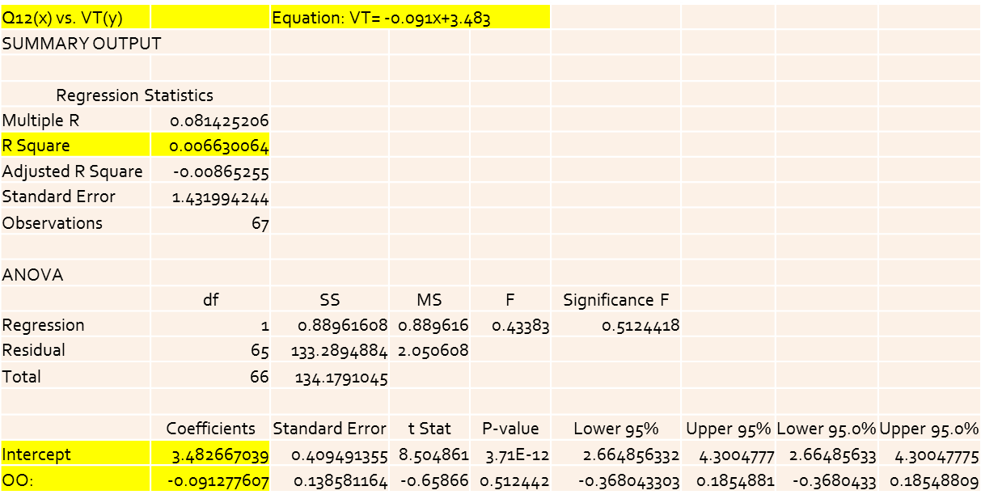

I also examined the correlation between question eight from the survey and propensity for VT, (**Appendix: Qualtrics Results**). However, the correlation was even less than that of question 12. The r2 equaled 0.0009740 and the two variables were negatively correlated since the x coefficient equaled -0.04022. The data is supported below.

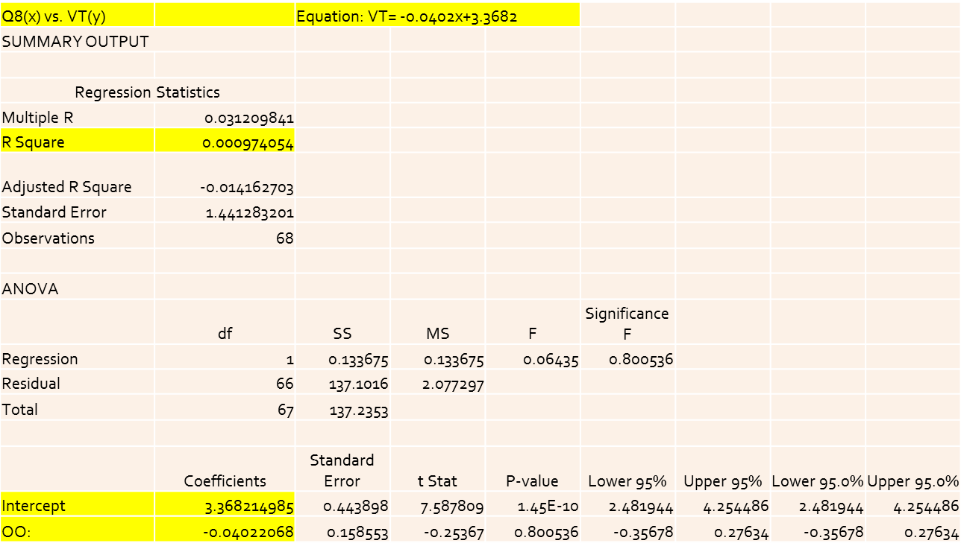

H4: Propensity for voluntary turnover (VT) to occur will decrease as a person’s company engagement increases. I expected company engagement to have a negative correlation with propensity for VT. However, this was not supported. I used question 36 from the survey as a basis for company engagement, (**Appendix: Qualtrics Results**). If a respondent understood and agreed with their company’s mission/vision, then they were expected to have a higher level of company engagement and a lower propensity for VT, (**Appendix: Cross Tabulations**). The r2 equaled 0.005961, meaning that the level of company engagement was not a good indicator of propensity for VT in my study. I also found the level of company engagement to be positively correlated with propensity for VT since the x coefficient equaled 0.08629. This data is supported below.

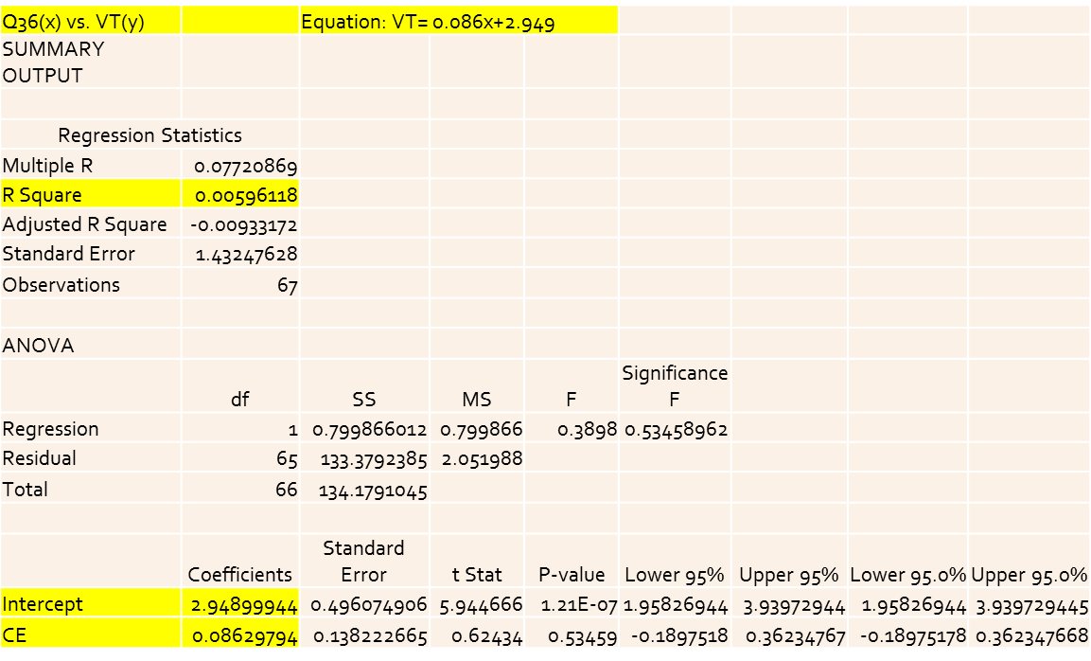

Although none of my hypotheses were supported, I did discover some notable data within the results. About 78% of my respondents believe that we are going through harsh economic times similar to a recession. Fifty one percent of respondents showed some type of propensity for VT, 47% of respondents have had three or more jobs since December 2007 and 79% of those who have had more than one job left their most recent job voluntarily. Only 55% of my respondents felt that they should be paid more money. Thirty eight percent of respondents view the recent economic conditions as a distraction and a cause of stress towards their job and growth as an employee. However, 23% of respondents view the recent economic conditions as an opportunity to further their experience and job growth.

**Conclusion:**

Although it seems that none of my hypotheses were proven true within my survey group, I was able to examine and learn a great deal about voluntary turnover during harsh economic times. I also learned a great deal about how individuals think during such an economic situation. However, there were a fair number of limitations to my research.

Limitations:

1. I was limited as a college student. I am currently a senior pursuing his undergraduate degree. I had a limited amount of resources available to me during my study even though I had a great deal of help. Someone with more time and better resources would’ve been able to examine the topic more thoroughly and make the data more applicable.

2. There were limitations within my findings. Within the Qualtrics Survey system, I received 70 surveys. For some reason, from that 70, only about 67 actually had results in the surveys. Then from that 67, only about 64 were fully completed surveys. Because of this, the data is slightly skewed in some areas. Access to a different survey system or medium may have prevented this from happening.

3. There are limits on applying this information elsewhere. I tried to get a better age distribution, but since I am still in college, many of my contacts who actually took the survey were in the 18-24 year old range. Approximately 54% of my survey takers were in this range. This age group doesn’t represent the typical working population in America. Also, my contacts are not necessarily representative of the global population. My contacts were primarily from the North-Eastern Region of the United States. People might feel differently in other parts of the US and in other countries throughout the world. A few examples could be that workers in certain countries place a greater value on the quality of life and in other countries may value group interests over self-interests.

4. There were limitations within the questions of the survey. Some of the survey questions became less specific before the initial send out. Because of this, it was harder to ascertain exactly what any survey taker’s actual thought process was. Also this research was geared toward finding the reasons for voluntary turnover during harsh economic times such as a recession. It doesn’t necessarily gather information about voluntary turnover during normal economic conditions.

5. There were limitations within the time span of my study. If I had been able to survey the respondents again after a certain period of time, I could see how their responses changed. I would be able to test those responses against the ones I have now. I would also be able to test whether or not respondents with a higher propensity for VT actually left the jobs.

Areas for further Research:

I believe this research could be re-done on a larger and more definitive scale. Rather than being somewhat general in certain questions as to avoid confusing survey takers, one could ask a lot more specific questions. In doing so, one would be able to better grasp the thought process that goes on when an employee is thinking about leaving their current job.

One large aspect that would need to be addressed is that the survey takers need to better represent the working population within the scope of the survey. Not only does the survey need to be sent out to more people in general, but because of the nature of the study, those survey takers need to be primarily part of the working population. On top of that, the survey group may need to be made up of people who have been working for some time. Also this survey group should be an ethnically diverse group in order to better depict the global population we now live in.

The next thought should be how one wants the results to be used and applied. I did not explicitly have this in mind when I conducted my research. If one wants the research to be applied to certain areas of their country, then the survey group must represent those areas. If one wants their research to be applied globally, they will have to distribute it as such. Also, they must keep in mind when wording the questions how they will be read and interpreted in different countries

Implications for Managers:

Although managers couldn’t use this research directly based on the tests of my hypotheses, they could still use it to protect their employee interests. My research supported the notion that people think about leaving even during difficult economic times. This means that managers shouldn’t hold on to the misconception that employees won’t leave their jobs because they need the money during a recession. My study also supported the idea that employee retention isn’t necessarily tied to how much an employee is paid. This research also showed that about 39% of respondents enjoyed going to work because they love what they do, there is a positive work environment, there is a feeling of accomplishment, and there is a flexible lifestyle within the workplace.

With all that being said, I feel that my research was beneficial. I found out that employees really do consider leaving during a recession-like economy for reasons other than pay and benefits. I found out that management needs to realize that harsh economic conditions will not keep employees from leaving their jobs voluntarily. Lastly, I found that not everyone views harsh economic conditions as entirely unfortunate.

**Bibliography:**

Allen, David G., Phillip C. Bryant, and James M. Vardaman. "Retaining Talent: Replacing

Misconceptions With Evidence-Based Strategies." Academy Of Management Perspectives 24.2 (2010): 48-64. Business Source Premier. Web. 10 Nov. 2011.

Arthur, Jeffrey B. “Effects of Human Resource Systems on Manufacturing Performance and

Turnover.” The Academy of Management Journal, Vol. 37, No. 3 (Jun., 1994), pp. 670-687. JSTOR. Web. 10 Nov. 2011

BLS. "The Recession of 2007–2009." *U.S. Bureau of Labor Statistics*. U.S. Bureau of Labor

Statistics, Feb. 2012. Web. 01 May 2012. <http://www.bls.gov/spotlight/2012/recession/>.

Ferri-Reed, Jan. "To Develop Is To Retain." Chief Learning Officer 10.8 (2011): 28-35.

Business Source Premier. Web. 18 Nov. 2011.

Golden, Karen, and Vasudevan Ramanujam. "Between a Dream and a Nightmare: On the

Integration of the Human Resource Management and Strategic Business Planning Processes." Human Resource Management (pre-1986) 24.4 (1985): 429-. ABI/INFORM Global. Web. 10 Nov. 2011.

Harter, James K., Frank L. Schmidt, and Theodore L. Hayes. "Business-Unit-Level Relationship

Between Employee Satisfaction, Employee Engagement, And Business Outcomes: A Meta-Analysis." *Journal Of Applied Psychology* 87.2 (2002): 268-279. *PsycARTICLES*. Web. 9 Apr. 2012.

Huelid, Mark A. “The Impact of Human Resource Management Practices on Turnover,

Productivity, and Corporate Financial Performance.” The Academy of Management Journal, Vol. 38, No. 3 (Jun., 1995), pp. 635-672. JSTOR. Web. 10 Nov. 2011.

Kirschenbaum, Alan, and Rita Mano-Negrin. "Underlying Labor Market Dimensions of

"Opportunities": The Case of Employee turnover. "*Human Relations*  52.10 (1999): 1233-1255. ABI/INFORM Global, ProQuest. Web.  24 Apr. 2012.

Michaels, Charles E., and Paul E. Spector. "Causes Of Employee Turnover: A Test Of The

Mobley, Griffeth, Hand, and Meglino Model." *Journal Of Applied Psychology* 67.1 (1982): 53-59. *PsycARTICLES*. Web. 9 Apr. 2012.

Mitchell, Terence R., Brooks C. Holtom, and Thomas W. Lee. “How to keep your best

employees: Developing an effective retention policy.” The Academy of Management Executive; Nov 2001; 15, 4; pg. 96. ABI/INFORM Global. Web. 10 Nov. 2011.

NBER. *US Business Cycle Expansions and Contractions*. Rep. The National Bureau of

Economic Research, 20 Sept. 2010. Web. 15 Apr. 2012. <http://www.nber.org/cycles/sept2010.html>.

Ramlall, Sunil.  "A Review of Employee Motivation Theories and their Implications for

Employee Retention within Organizations." *Journal of American Academy of Business, Cambridge*  5.1/2 (2004): 52-63. ABI/INFORM Global, ProQuest. Web.  24 Apr. 2012.