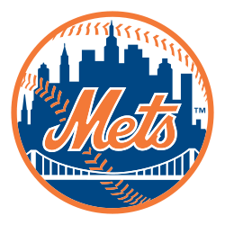

**Contact Information:**

Brittany Predmore, Media Relations

(718) 507-1234

Mobile: (718) 555-1234

[bpredmore@nymets.com](mailto:bpredmore@nymets.com)

For Immediate Release

**Mejia released from Mets and banned from the MLB**

FLUSHING, New York—Mar. 30, 2016 – The Mets have dismissed relief pitcher, Jenrry Mejia, from the 2016-2017 team. This week, Mejia tested positive for performance-enhancing drugs. This is his third failed drug test in the past 10 months. In addition to dismissal from the Mets Mejia received a lifetime ban from the MLB.

Mejia has had two other positive drug tests where he’s been suspended for games, 80 in April and 162 in July. Major league players and teams agreed in November 2005 that a third positive test for performance-enhancing drugs (PEDs) would result in a lifetime ban. No other players have been banned for life under the rules, which were put in place under pressure from Congress to toughen their drug program. “We fully support MLB's policy toward eliminating performance enhancing substances from the sport. As per the Joint Drug Program, we will have no further comment on this suspension,” said Mets owner, Fred Wilpo.

Mejia may apply one year from now to baseball Commissioner Rob Manfred for reinstatement, and Manfred at his discretion has the power to let Mejia back in baseball, however the reinstatement would not take place until after the 2018 season.

###