Consumer Attitudes: Apple Versus Windows

Jennifer Cusack, Briana Finelli, Angelina Galbo, & Lauren Haskins

MAR 322: Marketing Research

15 April 2015

(2) Executive Summary

(a) This study was designed to aid in better understanding consumer buying decisions in terms of operating systems and company of preference. In order to fully understand what prompts a consumer to choose a specific brand, in addition to how much knowledge the consumer has of that particular brand, a series of questions were devised to quantify this information. The problem addressed in this study was whether consumers have real knowledge of their preferred device and operating system capabilities in addition to whether they would consider switching to a different operating system if they had more knowledge. The hypothesis of this study was that consumers lack real knowledge of the capabilities of their preferred operating systems, and Apple users’ buying decisions are based mostly on brand name as opposed to device capability, as Windows devices have greater capability and features than Apple devices, comparatively.

(b) In order to collect data for the study, there was a focus group arranged to determine if students were aware of Apple and Windows capabilities. The final survey was submitted to participants after receiving the results of this focus group. The results of this focus group supported the original hypothesis; when participants answered the question, “What are the device’s capabilities? (Please select all that apply.),” none were able to specify further capabilities other than the minimal answer choices.

(c) Apple’s marketing should continue as it currently stands, as Apple leads in sales and has strong brand recognition. Apple’s continuous flow of new products, minimalistic yet effective advertising, and strong demographic database promote operational marketing strategies. As supported by this study, consumers who purchase Apple products report higher levels of satisfaction, report capabilities more accurately, and have stronger brand loyalty, answering that they would not switch operational systems if given more information about the competitor, Windows. As a result, Apple’s market research should focus on the demographics that tend to purchase Windows products by evaluating the reasoning behind this decision. The Windows marketing plan, on the contrary, does not breed a strong consumer base. Windows does not have a strong brand loyalty, as demonstrated in this study, as many Windows users report that they would consider switching operation systems with more information. The Windows marketing plan should focus on those aspects that draw users to Apple products in examining the same decision-making process among consumers. Although Windows products have greater capabilities than Apple products, consumers are unaware of these advantages, as demonstrated in this study, as Windows users underreported those capabilities. Additionally, Windows products are strongest in affordability, so it is important that Microsoft capitalizes on this opportunity without appearing to be the “cheaper” option as opposed to more inexpensive. It is possible that consumers could switch brands if Microsoft examined these markets and allow consumers to understand the benefits of using a Windows product.

Consumer Attitudes: Apple Versus Windows

(3) Background and Objectives

The products in question for this study are Apple and Windows operating systems. Apple has become increasingly more popular since the mid-2000s and is now the most popular operating system, including on Pace University’s Pleasantville campus.

In terms of hypotheses, it is projected that students do not know their operating systems’ capabilities. Terms of purchase for college students (aged 18-23, generally) focus on brand name as opposed to capabilities. Apple produces tablets, smartphones, and laptops with limited, basic functions, whereas Windows maintains the same product types with greater flexibility and more capabilities, like convertible tablets and laptops, tablets as separate entities from laptops, and gaming rigs. According to PC Advisor, Mac computers get malware, which will most likely become a greater concern as the Apple market share increases. Moreover, the vector of attack in present-day tends to be social over technical. Consumers are more likely to be “phished” for bank details or persuaded to click a faulty link on Facebook than they are to be attacked by a malware exploit. The focus group results showed that consumers are unaware of these potential threats to Apple computers, claiming that Apple products are nearly 100% safe in terms of virus protection. In addition, the focus group yielded results that demonstrated consumer unawareness of the additional costs associated with Apple purchases, as one would have to purchase all the software that comes pre-loaded on Microsoft computers, like Microsoft Office. Consumers would also need to purchase new versions of Microsoft Office each time they update their Apple software and operating system, whereas Windows systems will run all versions of Office. It is predicted that participants who primarily use Apple devices will express main reasons for purchase as brand or appearance and will not express interest in switching devices.

**(4) Method**

*(a) Subjects*

Participants (N = 62) in this study are undergraduate college students enrolled at Pace University’s Pleasantville campus, ranging in age from 18 to 23. Participants were divided into two groups: Apple users (*n* = 32) and Windows users (*n* = 30).

*(b) Materials*

The survey questionnaire contained ten total questions. The first question asks for the participant to dictate what type of device he or she uses most often. Participants then select their operating systems, or the software run on this particular device. Third, participants are asked to rate their satisfaction with this operating system on a five-point Likert scale. Next, participants were asked for their purchasing motive and were given a list of five potential reasons for device and operating system selection with a write-in option: affordability, brand name, capabilities, appearance, and virus protection. Participants are then asked about device pricing. Next, participants dictate device capabilities from a list that contains a write-in option: email, word processing, Internet access, virus protection, and video editing. Participants then disclose how long they have used this particular device. Finally, participants are asked to evaluate their device performance by dictating whether they have experienced any software or hardware issues, if they have used a different operating system as of recently, and whether or not they would consider switching operating systems if given more information.

*(c) Procedure*

Participants were recruited specifically for this study by online communication. The survey link, located online within the Survey Monkey server, was included in emails to Pace University students. These students were informed that the survey would take less than 5 minutes to complete fully. Once the students choose to become participants, they complete a ten question survey. Upon completion, participants are brought to a landing page thanking them for their participation in this study.

**(5) Results – Summary of Findings**

A majority (*n* = 42, 69.35%) of participants in this study primarily use laptop computers over tablets (*n* = 12, 19.35%) or desktop computers (*n* = 7, 11.29%). Thirty-two (51.61%) of these participants use Apple as their operating system on this particular device. Average rate of satisfaction (see Figure 1) for Apple users (4.22/5.00) did not deviate greatly from that of Windows users (3.80/5.00), but a larger majority of Apple users ranked their satisfaction as a 4 (31.25%) or a 5 (46.88%) as opposed to Windows users with a higher ranking of 4 (63.33%) than 5 (13.33%). Reasoning for choosing a specific operating system varied among users (see Figure 2). Almost every Windows user (93.33%) cited affordability as a reason for choosing the operating system, while only 18.75% of Apple users made this selection. More Apple users (62.50%) chose capabilities as the prime reason for choosing Apple products, but a greater number of Windows users (80%) cited this reason. Least cited for Windows users were virus protection (16.67% as opposed to Apple users’ 43.75%) and appearance (16.67% as opposed to Apple users’ 50%). An eighth of Apple users selected the “Not sure” option when asked for an approximate price for their device, and another eighth of the participants incorrectly cited the price for their specific product. In this category, Windows users more accurately conveyed the price of their products, which are generally cheaper than Apple products. Conversely, Windows users inaccurately conveyed the capabilities of their devices, as only 67.67% claimed their product had virus protection software and 40% claimed video editing software. Almost all Apple users accurately conveyed device capabilities based on their selected device. When prompted about whether they would switch operating systems if given more information about device capabilities and otherwise, more than half (56.67%) of Windows users conveyed that they would consider switching to an Apple device. More than three-fourths of Apple users said they would not switch to a Windows device under the same prompt.

**(6) Discussion – Detailed Findings**

*(a) Contacts categorized*

Sixty-two students participated in this study. All participants completed the study in full. Each participant was qualified to participate in this study and fit the target demographic of a college student at Pace University’s Pleasantville campus, as this was the only pool of potential participants with access to the survey. In terms of data collection issues, this online survey was sent to students a multitude of times before the goal of sixty participants was reached. In the future, researchers can incentivize participation to encourage more students to complete the survey in order to have a larger participant pool. Distributing the survey to large amounts of students simultaneously, rather than sporadically, would also be a more effective method.

*(b) Evaluation of hypothesis*

Overall, the initial hypotheses presented prior to data collection were supported by the results of this survey. Although Apple users can more accurately articulate the capabilities of their devices and operating systems, they are unaware of the capabilities of other devices and operating systems. More Apple users cited brand name and appearance as main reasons for choosing this particular device or operating system, while Windows users cited capabilities and affordability as their top reasons for choice. It was predicted that consumers of Apple products would cite appearance and brand name as reasons for choosing Apple more than Windows users. Apple users also reported higher brand loyalty, as predicted, without citing that they would potentially switch devices given more information about capabilities.

*(c) Other findings of interest*

College-age students were the sole demographic for this study. Majority of this study’s participants (51.6%) primarily use Apple products, as opposed to those who use Windows (48.3%). Users of Windows, specifically, were recruited for participation in this study to ensure reliable data collection.

**(7) Implications of Findings**

Marketers can gain a greater understanding of this specific demographic purchasing decisions and the factors that determine these decisions in order to better market products and devices. For example, majority of Windows users cited affordability as a main reason for choosing this operating system, which could flag Apple marketers to advertise lower-cost items to attract these specific consumers. It is evident that Apple leads in terms of satisfaction rankings and brand loyalty among its consumers, and this specific group did not express interest in considering another device or operating system with more information. Apple marketers can feel secure in their consumer base because of this high brand loyalty and the results of this survey, even if just a small sample size. Apple should focus mainly on marketing and offering incentives to new customers, as retaining customers is not the issue. Windows can attempt to capitalize on those areas in which it usurps Apple, like in affordability and capabilities. For the few Apple users who reported that they would consider switching devices, it is possible that exposing these opportunities with Windows products could attract the skeptical Apple users. Windows can use these comparative techniques to become a competitive brand in this era in which Apple continues to market its innovative products.

**References**

Five reasons why PCs are better than Macs: Mac vs. Windows PC. (2015). *PC Advisor News.*

How to choose between an Apple Macintosh and other PCs. (2014). *WikiHow.*

Figure 1

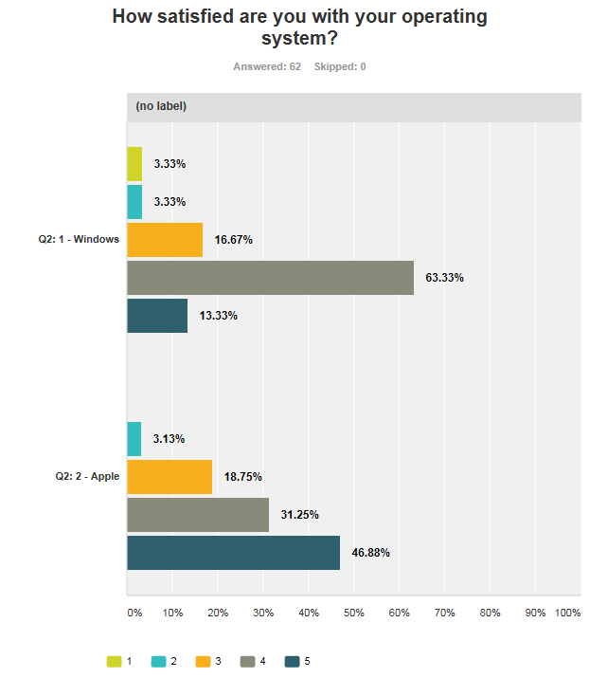

Figure 2

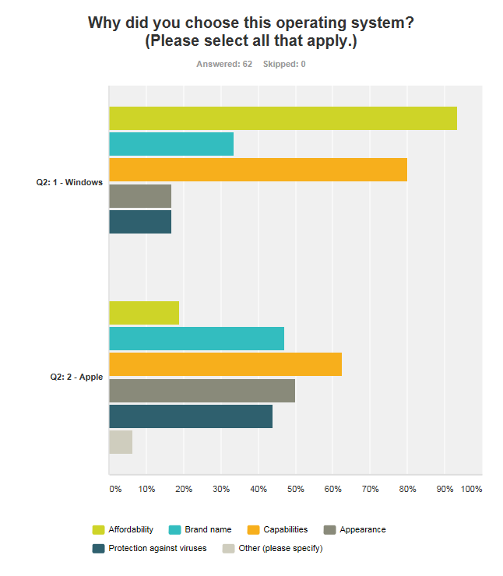

Figure 3

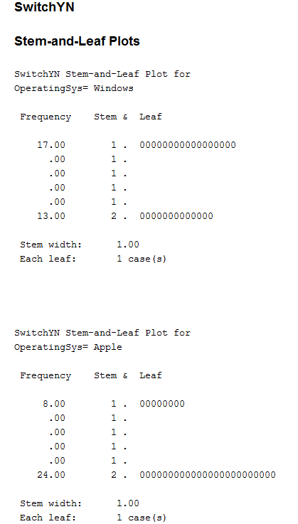

(8) Appendix

Blank Copy of Survey

1. Which of these do you use most often?
   * Laptop
   * Tablet
   * Desktop
   * None of these
2. What operating system do you use?
   * Windows
   * Apple
   * Other. Please specify: __________
3. How satisfied are you with your operating system?
   * 1 – Not at all satisfied
   * 2
   * 3
   * 4
   * 5 – Very satisfied
4. Why did you choose this operating system? (Select all that apply.)
   * Affordability
   * Brand name
   * Capabilities
   * Appearance
   * Protection against viruses
   * Other. Please specify: _________
5. How much does your device sell for?
   * Under $99
   * $100 - $500
   * $500 - $1,000
   * More than $1,000
   * Not sure
6. What are your device’s capabilities? (Select all that apply.)
   * Email
   * Word processing
   * Internet access
   * Virus protection
   * Video editing
   * Other. Please specify: _____________
7. How long have your been using your device?
   * Less than one year
   * 1-2 years
   * 2-3 years
   * 4+ years
   * Other. Please specify: ___________
8. Have you had any software or hardware issues?
   * Yes, software issues
   * Yes, hardware issues
   * Yes, both software and hardware issues
   * No issues
9. Recently, have you used another operating system?
   * Yes
   * No
10. If you had more information, would you consider switching operating devices?
    * Yes, I would consider switching
    * No, I prefer my current operating system