|  |
| --- |
| Capstone Project |
| Social Studies Lesson- The Great Compromise |
| [Type the document subtitle] |
|  |
| Professor Alfonso |
| 4/1/2012 |

Stephanie Moody

Professor Alfonso

Capstone Project

Math Lesson- Symmetry

April 2012

**Pre-Instruction Assessment:**

This lesson was near the middle of a unit on United States government so students came into this lesson with a wealth of prior knowledge. My mentor teacher and I have both assessed the students on their progress throughout this unit through discussion, review, teacher-prompted and open-ended questions, written assignments and homework assignments.

Other than this work completed throughout the unit, I did not supply students with further assessment before this lesson. This lesson was intended to be an experimental lesson in which students would learn from acting out a specific scenario. By asking specific questions about the content of this lesson to evaluate prior knowledge, I might be compromising the intended results of this exercise.

This being said, I do believe that it is important that I am aware of student understanding on each sub-topic within the unit before moving on to the next idea. If I do not test knowledge before moving on, many students will be confusing and as each topic passes, the student will fall further behind.

**Description of Instructional Experience:**

As the students were transitioning back into the classroom after lunch, the teacher asked them to setting on the rug. She counted down from five in order to get attention from the class. The teacher then reviewed what information was being covered in the Government unit that was started before the Mid-Winter break saying, “We’ve had a big break since our last lesson. What have we been working on?” The teacher then took comments from the students who recalled that the last social studies lesson that they received before break was about the Articles of Confederation which supported a weak national government in fear of a ruler gaining too much power like Great Britain’s king.

The teacher then used this review as a segue into the lesson she would be teaching on the Great Compromise. The teacher reminded the students that the Articles of Confederation were not working for the colonists, so they needed to come up with a new form of government and plan it out. She then explained that the students would be helping to plan out the government and then broke the students up into two groups. One group had twelve students while the other had six. The teacher then added that the larger group would represent Virginia while the smaller group would represent New Jersey and split them onto two separate areas of the rug. This transition, or movement, caused some noise and loss of focus but the teacher reeled the students back in, asking for quiet by counting down from five. The teacher instructed these groups to take on the roles of their state for the remainder of the class.

The teacher then introduced the term ‘representative’, explaining what they are used for in terms of voting and the law-making process. The teacher then asked the students in each state to decide how many representatives there should be in their state. The teacher split the groups up into two areas of the room; Virginia stayed in the rug and met in a circle while New Jersey sat at the tables. Each group was led by a teacher who helped facilitate the conversation and guide student thinking by asking probing questions.

The Virginia group came to a consensus that they should have five representatives while New Jersey should only have three. Virginia felt that since they had more people, they should have more of a say, or pull, in the government than the small states like New Jersey.

The New Jersey group however, felt that all states should have three votes regardless of its size. Because they are a smaller state, they felt that they should still have an equal say in the government’s decisions.

The teacher then facilitated a full class discussion hearing the views and conclusions from both states, asking them to back up their opinions. The teacher asked probing questions to get students to think and consider both sides of the argument. The debate became quite heated and students started getting agitated with the other group. The teacher used this as a teachable moment and asked the students how they were feeling with the exercise. Many students said they were getting angry or annoyed and a few even said they would go to war. The teacher then asked if they thought the colonists themselves were feeling the same way and they agreed. The teacher asked the students to raise their hand if they thought their ideas were the *right* ideas. Every student in the class raised their hands. The teacher then asked, “What can we do about that to make sure all states will be happy?”

The teacher then handed out a worksheet called “Virginia Plan vs. New Jersey Plan” and read through each bullet with students, stopping occasionally to debrief. The teacher asked if the real plans that the states came up with matched the ideas of the students and they agreed.

The teacher then asked how the two groups could resolve this problem and one student offered the word “compromise”. The teacher asked, “How would this work? How can we compromise here?” Students were given a few minutes to turn and talk with a peer close to them on the carpet and then share with the class.

Then the class turned to the second side of the worksheet and the teacher read through the “Great Compromise” sheet and drew a rough sketch of the plan on the whiteboard for visual learners. The teacher also pointed out how the House of Representatives met the needs of the larger states like Virginia while the Senate met the desires of smaller states like New Jersey. The teacher then led the students in a short discussion about the fairness of the compromise and asked how students felt about the issue.

Knowing that the students had very strong feelings about the exercise, students were asked to jot down their thoughts about the lesson, the compromise and feelings in their social studies notebooks. The teacher wrote these key questions on the board and gave students five minutes to write. Then the teacher asked students to discuss these thoughts with their table and select a representative to share what they learned as a group. After several minutes the teacher asked each table to share one thing they learned from the lesson. Common answers were that the government was a challenge to form, government officials have tough debates over hot issues and it can be a challenge to make everyone happy in decisions.

|  |  |
| --- | --- |
| Your Name: | Stephanie Moody |
| Length of Lesson: | 2 class periods |
| State & National Standards Addressed: **Standard 1**  **Standard 5** | History of the United States and New York Use a variety of intellectual skills to demonstrate their understanding of major ideas, eras, themes, developments, and turning points in the history of the United States and New York  **Key Idea 3:** Study about the major social, political, economic, cultural, and religious developments in New York State and United States history involves learning about the important roles and contributions of individuals and groups.  **Key Idea 4:** The skills of historical analysis include the ability to: explain the significance of historical evidence; weigh the importance, reliability, and validity of evidence; understand the concept of multiple causation; understand the importance of changing and competing interpretations of different historical developments. Civics, Citizenship, and Government Use a variety of intellectual skills to demonstrate their understanding of the necessity for establishing governments; the governmental system of the U.S. and other nations; the U.S. Constitution; the basic civic values of American constitutional democracy; and the roles, rights, and responsibilities of citizenship, including avenues of participation.  **Key Idea 1:** The study of civics, citizenship, and government involves learning about political systems; the purposes of government and civic life; and the differing assumptions held by people across time and place regarding power, authority, governance, and law  **Key Idea 4:** The study of civics and citizenship requires the ability to probe ideas and assumptions, ask and answer analytical questions, take a skeptical attitude toward questionable arguments, evaluate evidence, formulate rational conclusions, and develop and refine participatory skills. |

|  |  |
| --- | --- |
| **The Big Ideas:** | |
| Essential Understandings and/or Skills for this lesson: | Critical Thinking  Debate-Style Discussion  Basic Understanding of Government |
| Essential Question(s) for this lesson: | What was the debate between the states regarding representation in government? How was this debate resolved?  What was the Great Compromise and how did it affect representation amongst the states? |
| Evidence of Student Understanding (Assessment) in this Lesson: | Class discussion  Teacher prompted questions |

|  |  |
| --- | --- |
| **Lesson Preparation:** | |
| Materials Required: | White Board  “New Jersey Plan Vs. Virginia Plan” Worksheet  “The Great Compromise” Worksheet  Student Social Studies Notebook |
| Specific purpose(s) or Objective(s):[1] | During this lesson, students will be able to debate their view on representation to the government by providing reasoning for their opinion.  By the end of this lesson, students will be able to define the Virginia Plan and the New Jersey Plan and explain, in brief, what these plans entailed.  At the completion of this lesson, the students will be able to explain what the Great Compromise entailed and how it affected representation amongst our states.  Students will also be able to express how this event in history has affected our current government. |

|  |  |
| --- | --- |
| **Lesson Sequence:** | |
| Anticipatory Set or Hook: | **Experiment/Exercise:**  Students will be broken up into two groups. One group will represent “Virginia” and one group will represent “New Jersey”. The group representing Virginia will be larger than the group representing “New Jersey”.  The teacher will explain to the students that it would not be possible for every citizen’s vote to be counted for all government decisions, so each group will need to pick an appropriate number of “representative/s” who will make decisions for the group as a whole. How will it work?  The students will have 15 minutes to deliberate.  Following the group time during which students will be planning the number of representatives appropriate for their state, the teacher will ask each group to share their findings.  The teacher will also allow students to debate briefly about their ideas. From this activity, students should begin to understand the challenges that early colonists faced when forming a government.  The teacher will then offer a “compromise”.  The teacher will day, “What if we have two representatives from each group who makes some of the governments decisions and then we have other representatives, based on the state’s size, the make the other government decisions?”  Students will vote on this “compromise.  The teacher will say, “You just voted on what we call “The Great Compromise”. This is the only reason that we have a constitution, and the only way that we can all agree. |
| Step by Step Explanation of Activities/Strategies (include time anticipated): | **Mini-Lesson (at rug):**  These two plans were called the Virginia plan and the New Jersey plan. The teacher will pass out a worksheet to the class listing the differences between the two plans. The teacher will then read this with the class and discuss.  The teacher will then hand out another worksheet explaining the Great Compromise, read with the class and discuss. |
| Closure: | Review of the two plans (Virginia vs. New Jersey)  Why couldn’t they agree?  What was the compromise? |
| Accommodations for Students with Disabilities or Diverse Learning Styles: | * Notes will be written on easel paper or the white board as visual reminders of discussion points and/or instructions. * All material will be read, and discussed, as a class. * Teacher will scaffold learning by leading instruction initially, then encouraging group work and lastly, individual work. |

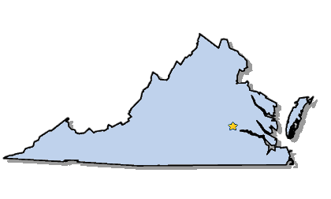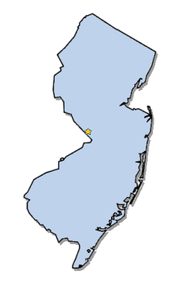**The Virginia Plan vs. The New Jersey Plan**

|  |  |
| --- | --- |
| **The Virginia Plan** | **The New Jersey Plan** |
| * Called for a **strong national government** * There would be **two** parts, or **houses**, of Congress: * The executive branch to enforce laws * A court system to guarantee justice under the law * In both parts, or houses, of Congress, each state would be **represented according to the number of people** who lived in the state. Each representative would be given one vote. So, a state with many people would have more representatives—and more votes—in both houses of Congress than a state with fewer people. * Delegates from large states, such as Virginia and Pennsylvania, liked this plan because it would give them a strong voice in Congress. | * There would be only **one** house of Congress in which each state would have **just one vote**. * In this plan, **the population of the state would not affect the number of representatives**. All states would have one vote. * This plan also called for an executive department for the national government with more than one person in power. The plan also included a national court. |

**Student Work Sample:**

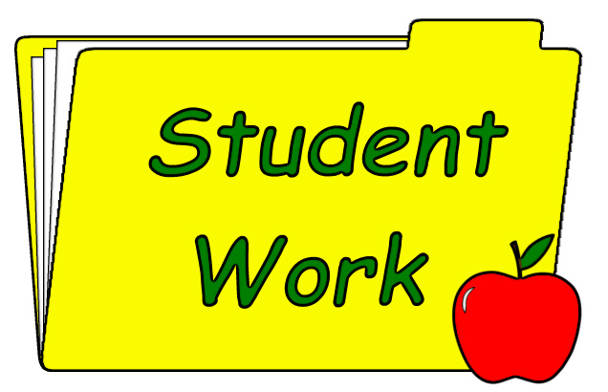

**Post-Instruction Assessment:**

I wanted to give students time to reflect on what they learned. While discussion-based learning is a great tool for some students, other students are able to express themselves in a different way; perhaps through drawing or writing. In a class discussion, it can sometimes be difficult to accurately gauge the understanding of each individual student. This is why I included an assessment using written reflection.

At the end of this lesson, I asked each student to take out their Social Studies notebook and take ten minutes to write an in-class reflection/opinion about the class experiment or scenario that they were asked to act out. Responses were to be at least half of a page, edited for spelling, punctuation and capitalization.

Upon reading the responses, I observed a great range of conflicting emotions and opinions about the exercise. This helped me, as a teacher, to understand different students learning styles and preferences for future lesson planning. This lesson was geared toward a specific kind of learning style, so the next lesson may be geared toward a different group of students.

Students also included information that they learned and took away with them from this lesson. This helped me to evaluate what information students retained and their ability to apply the core concepts to other aspects of history.

**Analysis of Student Learning:**

Overall, I believe this was a very successful lesson. Because of its experimental and discussion-based nature, students were actively engaged in the learning process. They were applying their knowledge as they acquired it while helped them, ultimately, to retain the information.

I was impressed with the responses to questions and discussion that my students were supplying me with. Their answers were rich and well thought out. Each student connected their response to the previous comment which helped the discussion stay fluent. Also, the fact that students needed to debate and defend their side of the argument, meant that they needed to truly understand ***both*** sides of the argument.

Because most of the assessment for this lesson was verbal and discussion based, it made it a challenge for me to include the quieter and more reserved students. This is why I added in the written reflection assessment at the end.

In retrospect, I see that I should have included a broader range of assessment so that I could more accurately gauge the understanding of all students, not just the students who are more outspoken. If I were to teach this lesson again, I would take the next day to set up three different learning-centers in which students would be completing different activities, each based on a different learning style. This way I could more accurately assess students without bias.

1. For TCH 412, we modify this to have students include a specific literacy objective.