Planned Parenthood Hudson Peconic, Inc.

4 Skyline Drive

Hawthorne, NY 10532

July 5th, 2016

New York State Health Foundation

1385 Broadway, 23rd Floor

New York, NY 10018

Dear NYSHF Representative,

I write to you as a representative of Planned Parenthood Hudson Peconic, Inc. As a branch of Planned Parenthood, we provide many services related to reproductive healthcare. We have decided to seek a grant from you because you have provided grants to Planned Parenthood of New York City before. Even without that, your goals of building healthy communities and empowering patients align well with our own. We wish to request a grant for the purpose of giving assistance for the prevention of various STDs to the uneducated and those below the poverty line in the Suffolk, Westchester, and Rockland counties. We hope that you will consider what is outlined within to be a worthy cause, as we certainly believe it to be one.

Sincerely,

Jared Butowsky, Financial Planner

Grant Proposal for Planned Parenthood Hudson Peconic

Jared Butowsky

Planned Parenthood Hudson Peconic, Inc.

July 5th, 2016

Table of Contents

Executive Summary ii

Organization Information 1

Introduction 1

Problem Description 2

Work Plan 3

Evaluation 4

Budget 4

References 5

# Executive Summary

This is a proposal for a grant on assisting the poor and uneducated in fighting STDs. A look at statistics shows that there is a sizeable amount of poor people living within the area PPHP provides services to, and that the poor and the uneducated are at higher risk of getting an STD than others. The methods proposed include handing out free condoms, helping stores in poor neighborhoods have a good supply of them, and providing education regarding STDs. The overall amount of money requested within is $111,000.

# Organization Information

Planned Parenthood Hudson Peconic, Inc., founded in 1933, is a branch of Planned Parenthood. As a branch of Planned Parenthood, PPHP specializes in providing reproductive health services to the designated communities. Planned Parenthood Hudson Peconic has ten centers, located in Suffolk, Westchester, and Rockland counties. Last year, they gave their services to over 34,000 patients, taught 30,000 people on various subjects relating to reproductive health, and answered 153,000 phone calls.

Though Planned Parenthood as a whole receives over 500 million dollars from the federal government per year, each branch, including PPHP, only receives a relatively small portion of this money. It is for this reason that they need money from grant-making institutions such as yourselves in order to perform research in various areas.

# Introduction

A significant portion of citizens in New York State live below the poverty line. This is true not only for the state as a whole, but for each individual county as well. The counties covered by PPHP are no exception to this.

In Rockland County, 14.8% of the population of 318,064 citizens live below the poverty line. That means 46,388 impoverished individuals, 5,845 of whom do not have a high school education. In other words, 12.6% of those below the poverty line in Rockland County lack a basic education, and therefore, because of basic sexual education typically being a subject in school, likely do not have the knowledge necessary to avoid STDs. In addition, 18,828 people above the poverty line also lack a high school education.

Westchester County fares both better and worse at the same time, having a poverty rate of 9.9%. On the other hand, Westchester has a population of 962,233 people, which means 92,413 below the poverty line. 17,271 of those people do not have high school educations, meaning 18.7% of the poor community in Westchester may not be capable of battling STDs. This is also ignoring the 60,943 people above the poverty line who lack a high school diploma.

Suffolk County has a poverty rate of 6.8%, with a population of 1,470,373. This means that 100,531 people living in Suffolk are impoverished, and of those people, 15,886, or 15.8%, do not have a high school degree. 84,142 people above the poverty line in Suffolk also lack high school educations. (New York State Community Action Association, 2015)

In total, out of the 2,750,670 people living in the counties PPHP has centers in, 239,332 people live in poverty, which is 8.7% of the population. 39,002, or 16.3% of people below, and 163,913, or 6.5% of people above the poverty line lack high school educations. It is important to provide assistance to these groups in the prevention of STDs.

# Problem Description

A person with no education is unlikely to be aware of how to avoid being infected with an STD, if they are even aware of the existence of such diseases. The poor will also probably have difficulty being able to prevent them, even if they know how.

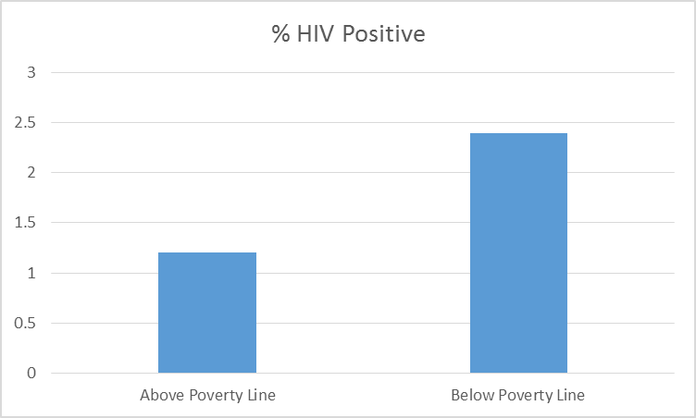As a result, it is very important to know the infection rates for various STDs in poor areas. Indeed, last year the CDC performed a study of HIV infection rates among heterosexual members of various demographics living in urban poor areas around the entire country. The study ended up with 9,078 participants who fit all of the necessary criteria (Denning & DiNenno, 2015). This included a comparison of the infection rates for those who were above and below the poverty line among the 8,905 who were willing to disclose their status in that regard. 6,825 of them were below the poverty line. 162, or 2.4%, were found to have been infected with HIV. While this may not seem like much, there were only 24 who had HIV among the 2,080 who were above the poverty line. While this may not seem like a fair comparison because of the number of people below the poverty line being more than triple the number above it, multiplying the number of people in general above the poverty line, as well as the number with HIV, by the amount needed still will not bring the number of infected people for the two groups anywhere close.

It is also important to know the infection rates among those with varying levels of education. All 9,078 of those surveyed were open to the idea of giving the relevant information. 3,011 were at less than a high school graduate level, and 80, 0r 2.7%, were infected. There were 3,955 people with a high school education, and among them, 81 people had HIV. While that is one more infected person than those who did not go through high school, it is only a 2% infection rate among those who have, so it is actually a lower rate of infection. The remaining 2,112 went through at least college, with 27 having HIV for a 1.3 infection rate, which shows an interesting trend in that the more educated are less likely to be infected with HIV.

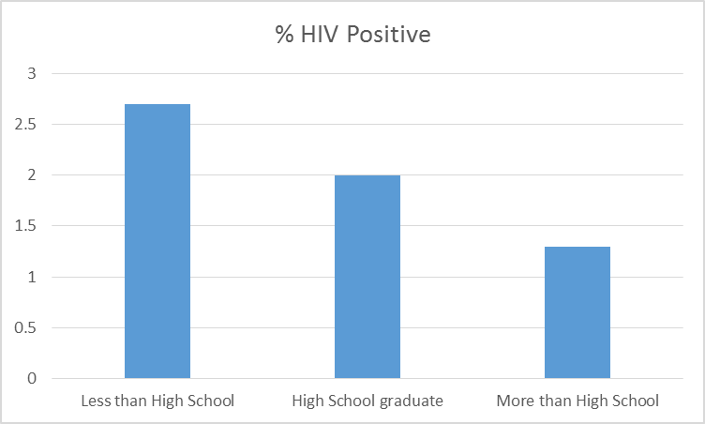

# Work Plan

The first thing to do, for the purposes of evaluation later on, will be to figure out the infection rates for various STDs in the counties PPHP’s services cover, for this year, and for previous years. The purpose of this is to know how the efforts described herein will have affected the infection rates, if at all.

There are many methods which can be used to assist those living in impoverished areas on STD prevention. A relatively simple method would be for us to personally hand out condoms to those living in these places. This would require driving a truck or a car through the neighborhood and handing out free condoms through the window. This would be a little effective for a time, but due to the time-consuming nature of this task, as well as the single-use limit for each condom, it would eventually be necessary to find a different solution. Therefore, actually doing this would be unwise.

A related, and far better, solution is to stock stores in poor neighborhoods with condoms, perhaps on a weekly basis. This would be far more effective, assuming the stores in question are stocked well enough. There are plenty of challenges for this method. One such challenge would be finding stores in these areas which do not already have a decent supply of condoms (there would be little point in doing this for stores which already have plenty of them. Another challenge is to figure out how often PPHP should supply these stores with new batches of condoms. Of course, they also need to make sure the owners of these stores are willing to carry condoms at their shop. If a store already has condoms in stock, PPHP can offer to supply them with condoms themselves at no charge. Of course, this would only be a step towards solving the problem, as several stores in poor communities most likely already have condoms in stock, but when combined with another step, it should ultimately prove very effective.

That other step is to, in addition, educate people in these areas about STDs. As PPHP already does a lot of work in educating people on reproductive health, it makes perfect sense to bring that education to those who need it the most. This would be effective for educating those without a high school education on STD prevention. As a fair number of people above the poverty line lack a decent education, it would be sensible to educate people outside of these areas about this, as well. This will require mapping out a plan for these classes, choosing a location to hold them at, creating promotional material for them, and finding people willing to teach the lessons themselves.

# Evaluation

It will be possible to tell this venture was successful if, by the following year, the infection rates among the poor and uneducated have increased by less than in previous years. This will help determine whether or not the efforts of PPHP have had any effect. It is unrealistic to expect the infection rates to decrease.

# Budget

The budget for this mainly revolves around the shipment of condoms to various stores, as well as the creation of an education plan.

A single condom typically costs between 50 cents and a dollar. Therefore, shipping 200 condoms to a single store can cost anywhere from $100-$200 before shipping costs are applied. This may end up getting pricey, so $11,000 should be a good amount for shipping to between 50 and 100 stores, depending on the prices of the condoms and the shipping fees.

As for the creation of an education plan, whoever comes up with it should be paid overtime for it. Promotional costs and (possibly) building rentals should also be taken into account. Because of all of these factors, $100,000 are requested for this part of the plan. This means $111,000 are being requested in total. It is hoped that you will look this over and approve of the plan.

# References

Denning, P., & DiNenno, E. (2015, June 23). *Economically Disadvantaged | HIV by Group | HIV/AIDS | CDC*. Retrieved from Centers for Disease Control and Prevention: http://www.cdc.gov/hiv/group/poverty.html#2

New York State Community Action Association. (2015, March). *New York State Poverty Report.* Retrieved from http://nyscommunityaction.org/wp-content/uploads/2014/03/2015-Poverty-Report-w-50th-logos-for-online.pdf